Trainer’s Guide for Leading a
Half-Day Workshop on:
Using the DRDP (2015)
for Special Education
Ninth Edition, July 19, 2016

© 2016 Desired Results Access Project, Napa County Office of Education.
Funded by the California Department of Education (CDE), Special Education Division
This publication was produced by the Desired Results Access Project to support the implementation of the DRDP (2015) for the Special Education Division of the California Department of Education.
Permission is granted to reproduce the document in its entirety for the purpose of professional development.
Suggested Citation:
Edelman, L. & Salcedo, P. (Editors) (2016). Trainer’s Guide: Using the DRDP (2015) for Special Education (Ninth Edition). Rohnert Park, CA: Desired Results Access Project, Napa County Office of Education
For information contact:
Web site: www.draccess.org
E-mail: info@draccess.org
Phone: (800) 673-9220
Contents
Introduction 5
Qualifications for Trainers 6
Preparing to Lead the Workshop 7
Arranging the Workshop Space 9
Checklist of Materials and Equipment 10
Technical Tips for Showing the Videos 11
Agenda-At-A-Glance 12
Trainer’s Notes 13
Welcome 13
Background 15
General Requirements 19
Understanding the DRDP (2015) 22
Step 1: Collect Documentation 30
Step 2: Rate the Measures 37
Rating Practice Exercises Part 1 and 2 42
Using Adaptations 40
Step 3: Finalize the Assessment 48
Resources and Other information 50
Wrap-Up 52
Instructions for Leading the Rating Practice Exercises 53
Part 1 (IT): Lydia in the Kitchen 54
Part 1 (PS): Said on the Playground 57
Part 2 (IT): Tylor Playing on the Floor 60
Part 2 (PS): Cody at Breakfast 63
Part 3 (IT): Morgan Playing with Blocks 66
Part 3 (PS): Angel Playing with Playdough 69

Introduction
This publication, Trainer’s Guide: Using the DRDP (2015) for Special Education, provides step-by-step instructions for leading a half-day workshop for special educators on using the DRDP (2015). This Trainer’s Guide is part of a comprehensive set of trainer’s materials that include PowerPoint slides, handouts, and video clips.
The past editions of the Trainer’s Guide provide a history of many of the significant changes made in how the California Department of Education’s Special Education Division (SED) has implemented the Desired Results Developmental Profile (DRDP) Assessment System.
- Beginning in 2007, the Trainer’s Guide has been used as the foundation for a number of professional development activities that support the SED’s preschool special education programs to implement the DRDP Assessment System. Early in 2007, the first edition of the Trainer’s Guide was used by Desired Results Access Project trainers to provide one-day training sessions throughout the state to assist preschool special education teachers and service providers in knowing how to use the DRDP instruments.
- In 2008, the second edition of the Trainer’s Guide was shared with SELPA-level training teams through a number of Train-the-Trainer Institutes to prepare them to lead the one-day training sessions for preschool special education teachers and service providers in their respective SELPAs. Also in 2008, the Desired Results Access Project began using the information in the Trainer’s Guide to create and post a number of online learning modules on the use of the DRDP instruments for preschool special education at www.draccess.org.
- The third edition of the Trainer’s Guide included several essential updates including the policy change announced that beginning September 1, 2009 all new preschool-age children with Individualized Education Programs (IEPs) would be assessed using only the DRDP access.
- The fourth edition included only the change in data reporting from SEDRS to CASEMIS.
- The fifth edition was a major revision that reflected policy changes as well as improvements in how we have learned to describe the use of the DRDP access.
- The sixth and seventh editions were significantly revised to focus on both infant/toddler and preschool special education programs, and herald the policy change that beginning in fall 2013, all infants and toddlers with Individualized Family Service Plans (IFSPs) who are reported in the CASEMIS system would be assessed with the DRDP access. Another significant change in the seventh edition was to address requests to provide instructions for leading a half-day, rather than a full-day, workshop.
- The eighth edition of the Trainer’s Guide represents a major shift: beginning in fall 2015 all eligible children in California will be assessed using one DRDP instrument, the DRDP (2015).
- This ninth edition of the Trainer’s Guide includes guidance on using the new DRDP (2015) Preschool Fundamental View for all preschool children with IEPs beginning in fall 2016 as well as revised guidance for trainers on playing the training videos.
We truly appreciate the expertise all of the Desired Results Access Project staff and consultants who have contributed over the years to the ongoing development of this Trainer’s Guide.
Larry Edelman and Patty Salcedo, Editors
Desired Results Access Project, Napa County Office of Education

Qualifications for Trainers
This Trainer’s Guide and accompanying materials were developed to be used by qualified trainers to present workshops on the use of the DRDP (2015). Trainers might include program specialists, special education directors, and lead early intervention or early childhood special education teachers –particularly those with responsibilities for the implementation of the DRDP (2015). We recommend the following qualifications for trainers.
Trainers should possess one of the following:
- Early Childhood Special Education credential or graduate degree
- Special Education graduate degree with early childhood emphasis
- Special Education credential with early childhood experience
- Early Childhood Education graduate degree
- Graduate degree in a related services field
Trainers should have experience:
- Working in an early intervention or early childhood special education settings for at least 3 years
- Administering developmental assessments to young children, especially assessments based on naturalistic observation/authentic assessment
- Having used the DRDP (2015) at least once with an infant or toddler or with a preschooler, either as part of a study, or if not, as an exercise
- Working with young children who are Dual Language Learners
- Attending a Desired Results Access Project workshop on using the DRDP (2015) (in fall, 2015)
- Leading professional development workshops and providing coaching and technical assistance
Trainers should have effective skills in:
- Organizing professional development programs
- Presenting information
- Facilitating group activities
- Communicating effectively, in both written and verbal formats
- Using computers and audio-visual equipment
Should have knowledge and competence in:
- Developmentally appropriate practice with young children with disabilities
- Collaborating with families and general early care and education programs
- Early childhood curricula
- Authentic assessment practices
Administrative Supports:
- Release time to practice using the DRDP (2015)
- Release time to attend training
- Release time to plan and conduct training
- Access to audio-visual equipment, copy/printing facilities to prepare materials, and rooms for training
Preparing to Lead the Workshop
Following are recommended activities that trainers should complete in order to develop the expertise required to lead this half-day workshop.
Attend a TTT workshop
- If at all possible, attend a Train-the-Trainer workshop presented by the Desired Results Access Project.
Get to Know the DRDP (2015)
- Become very knowledgeable regarding the DRDP (2015).
- Become familiar with www.draccess.org and the resources to be found at this site.
- Practice using the DRDP (2015) with at least one child before leading the workshop.
Get to Know the Workshop Material
    - It is extremely important that you lead the training as described in the Trainer’s Notes in order to help assessors learn to use the instrument with fidelity and rate with reliability.
    - Review the Agenda-At -A-Glance in this Guide to understand the big picture of the half-day session.
    - Become comfortable and skilled in leading each of the activities. The session uses a variety of activities including short presentations, small group exercises, large group discussions, and video-based exercises. Practice introducing and leading each activity.
    - Carefully read through the Trainer’s Notes and the handout materials so you can lead each activity in a relaxed manner and know what to say. Please remember – make the points outlined in the Trainer’s Notes genuinely in your own words; these points should not be memorized or read.
    - Spend a significant amount of preparation time mastering how to lead the Rating Practice Exercises. The guide for leading these exercises appears on pages 49 – 60 of this document.
- Watch the video clips in context of the activities in which they will be used and become familiar with all of the clips so you will be able to lead discussions around them.
    - For each of the three video-based activities you will need to choose whether to show a video clip of a toddler or a preschooler, and organize the slides and handouts to align with your decision.
Practice Using the Audio-Visual Materials and Equipment
    - Practice presenting the short presentations using the accompanying PowerPoint (PPT) slides.
    - Learn how to “mute the projector” (darken the screen). There are a few easy ways to do this:
      - While in “Slide Show” mode in PowerPoint, simply press the “B” on the keyboard to darken the screen and press “B” again to return to the PowerPoint image.
      - Many (but not all) projectors have a “Mute” button on either the projector or the remote control for the projector.
      - Remote control devices for advancing PowerPoint slides have “AV Mute” buttons.
    - Learn how to use the audio-visual equipment. Practice setting up and using your laptop computer with a projector and speakers. Practice toggling back and forth between using PowerPoint slides and the video clips. Practice showing the video clips and adjusting the volume of them.
Plan How to Work Together with your Co-Trainer Effectively
- It is sometimes useful to have a team of two trainers present the workshop. Meet with your co-trainer and support staff in advance to plan: who will lead which activities; how you can support each other; ways to ensure the activities will be delivered accurately; and, for all the logistical arrangements that need to be made.
Add Engagement – Spice up the Presentation!
- The materials provided have been regarded as engaging and enjoyable by participants. Trainers who have delivered this workshop have reported that they have further increased the engagement, enjoyment, and effectiveness by:
  - sharing personal stories, experiences, and anecdotes to illustrate key points;
  - adding a few pertinent cartoons to the slides; and
  - showing videos that creatively and humorously illustrate key points.

Arranging the Workshop Space
It is important to establish an environment that will be comfortable for the participants and will facilitate effective learning. Below are some tips for setting up the workshop space.
    - Arrive early to arrange the room and complete all of the preparations so that you will be available to meet and greet the participants as they arrive. Arranging the room just about always takes more time than anticipated. One or more room set-up challenges are common; begin setting up at least one hour prior to when the participants are expected to arrive for registration (as opposed to one hour before the workshop is scheduled to begin).
- If you are expecting a large group, consider setting up a registration table outside the room. Organize the sign-in procedures and the handout materials.
- If possible, set up the audio-visual equipment before the tables and chairs because the optimal location for the screen, projector, laptop, and audio speakers often determines how the seating and tables need to be arranged. Be sure that the projector is set far enough back in the room so that the image fills the screen. If the tables and chairs are arranged before you arrive, they may need to be rearranged after the audio-visual equipment is set up (another good reason for setting up early).
- Learn how to adjust the room lighting and the volume of the speakers. If you will be using microphones, learn how to control the volume and check the volume before the participants arrive.
- Arrange the tables and seating to support interactive learning and the exchange of ideas in both small and large group discussions. Do all that you can to arrange the room so that the participants will have enough room to sit comfortably and move about easily. Once the space is arranged, sit in various parts of the room to make sure that everyone will be able to see and hear the trainer and the audio-visual presentations. Make adjustments as necessary.
- Place the handouts and related materials at tables or on the registration table.
- Prepare a sign-in sheet at registration to include key information, e.g., names, signature, and email.
- If you can provide the following optional materials, place them on each table:
  - Post-It notes (so assessors can tab certain pages in the materials or jot down notes for the Parking Lot).
  - Highlighters (these are useful for assessors who want to highlight specific components of the materials).
  - In addition to the above materials, some (but not all!) trainers like to provide a range of toys on the table for tactile learners, e.g. squishy toys, a smooth ball, etc. Avoid noisy or distracting items such as puzzles and toys that that make sounds.
- Write the Ground Rules on chart paper and post them on a wall (see instructions for the Introduction Activity in the Trainer’s Notes).
- Place a sheet or two of chart paper labeled “Parking Lot” on one or two walls of the room (see instructions for the Introduction Activity for how the Parking Lots might be used).
Note: The Parking Lots are helpful when you don’t have sufficient time to address everyone’s questions or don’t have immediate answers to complex problems that arise with uniquely different agencies or types of programs.
- Optional: Prepare displays of examples of resources available at www.draccess.org
Checklist of Materials and Equipment
Trainer’s materials
- Trainer’s Guide
- PowerPoint File (PPT)
- Video clips
Equipment
- Laptop computer with:
    - Free software for playing the videos. On both PCs and Macs we recommend you use VLC Media Player (http://www.videolan.org) or UMPlayer (http://www.umplayer.com/). Additionally, on Macs, you might also use QuickTime Player (www.apple.com) however QuickTime is NOT recommended for PCs. If you have QuickTime installed on a PC, the United States Computer Emergency Readiness Team recommends that you uninstall it (https://www.us-cert.gov/ncas/alerts/TA16-105A).
    - Microsoft PowerPoint version 2010 or more recent for PC or version 2011 or higher for Mac.
    - Microsoft Word version 2010 or more recent for PC or version 2011 or higher for Mac.
    - The most recent version of the free Adobe Reader, available at http://get.adobe.com/reader
- LCD projector (including remote control device) – the projector should be bright enough to fill a ten-foot screen. 3000 lumens or higher is recommended.
- Projection screen (for a group of 100 participants, at least a 10 foot screen is recommended – this is very important since the session relies heavily on visuals in all activities).
- A way to amplify the sound from your laptop so that the sound from the videos can be heard throughout the room. In a small room, a good set of desktop or portable computer speakers works fine. For large groups, work with the facility’s AV support person WELL IN ADVANCE. The activities will be seriously compromised if there is not clear amplification of the sound from the videos.
- Tables for the laptop and projector
- Surge protector(s)/power strips
- Extension cord(s)
- Cable to connect the laptop to the LCD (this usually requires a longer than standard cable)
- Cable to connect the laptop to the amplification system (this might require a longer than standard cable)
- Easel, colored markers, and chart paper
- Masking tape and/or push pins for affixing chart paper to the wall
Materials that need to be copied prior to the session
- DRDP (2015) Assessment Manual (the Rating Record/Information Page is included in the Manual)
- PowerPoint Thumbnails
- Rating Practice Exercise Worksheets (NOTE: You will need to copy only the worksheets for the videos that you plan to use)
- Key Rules to Remember When Using the DRDP (2015)
- Evaluation Form
Technical Tips for Showing the Videos
During the workshop you will be showing a number of video clips that are required for leading the activities. Be sure to practice well in advance of your first workshop to learn how to use your equipment and make sure that everything is working together.
Copy the video clips to your computer’s hard drive. To play the videos, on both PCs and Macs we recommend you use VLC Media Player (http://www.videolan.org) or UMPlayer (http://www.umplayer.com/). Additionally, on Macs, you might also use QuickTime Player (www.apple.com) however QuickTime is NOT recommended for PCs.
Important Note: Even if you have these media players on your computer, download the most recent versions and practice using them with the video clips prior to the session so that you learn how to use the player well and are confident that everything is working well.
Useful Tips
- Cables: Depending on the equipment that you will be using, you might need various cables to connect the different pieces of equipment (e.g. laptop, projector, audio amplification system). Our advice: 1) Do a practice run of setting up the equipment to be sure you know what equipment you’ll need and how to use it; and 2) If you have any doubts about figuring this out, find an audio-visual technician who can help you.
- Make sure the audio from your computer is amplified. It is essential that the audio signal from your laptop is amplified so that the participants will be able to clearly hear the videos. Remember that the amplification system needs to be able to accommodate the size of the room and the number of people attending. A pair of desktop computer speakers may be sufficient for 15 – 20 people, but not for 100. For large rooms, work with the contact person from the facility and/or an audio-visual technician well in advance to assure that you will have an adequate sound system.
- Practice showing the clips. Practice showing the clips well in advance of your first workshop. In addition, try the videos out whenever you are using new equipment because occasionally different laptops, projectors, and audio systems don’t work well together.
- Remember: When in doubt, secure the services of an audio-visual technician who will provide and configure all the necessary equipment, set it up, and help you learn how to use it.
- Videos clips (in the order in which you will show them):
Activity | Choose one of these
 | Infant/Toddler | Preschooler
Observing for Multiple Measures Exercise | Harper Hope at Snack Time | Aundon at Breakfast
Rating Practice Exercise Part 1 | Lydia in the Kitchen (SED 5) | Said on the Playground (PD-HLTH 2)
Rating Practice Exercise Part 2 | Tyler Playing on the Floor (PD-HLTH 4) | Cody at Breakfast (PD-HLTH 7)
Optional: Rating Practice Exercise 3 | Morgan Playing with Blocks (ATL-REG 1) | Angel Playing with Playdough (SED 4)

Agenda-At-A-Glance
The following agenda is a suggested design for a half-day workshop (four hours or less). The information might also be delivered in other ways, such as at periodic staff meetings or in coaching sessions with individuals or teams.
Time  (Approximate) | Activity | Learning Goals – These sections of the workshop will assist assessors to:
7:00 – 8:00 a.m. | Set up the equipment and materials and fine tune the room arrangement
8:00 – 8:30 a.m. | Coffee and Registration | - Feel welcome and comfortable
8:30 – 8:45 a.m. | Welcome | - Understand the goals and agenda
8:45 – 8:55 p.m. | Background | - Understand the basis of the DRDP (2015)
8:55 – 9:05 a.m. | General Requirements | - Understand responsibilities in using the DRDP (2015)
9:05 – 9:20 a.m. | Understanding the DRDP (2015) | - Understand the instrument
9:20 – 9:50 a.m. | Step 1: Collect Documentation | - Conduct accurate observations and collect other information
9:50 – 10:05 a.m. | Break | - Replenish energy!
10:05 – 10:20 a.m. | Step 2: Rate the Measures | - Rate the measures
10:20 – 10:50 a.m. | Rating Practice Part 1 | - Become familiar with the DRDP (2015) and practice using the rating procedures
10:50 – 11:20 a.m. | Rating Practice Part 2 | - Become familiar with the DRDP (2015) and practice using the rating procedures
11:20 – 11:35 p.m. | Using Adaptations | - Understand the use of adaptations
11:35 – 11:45 p.m. | Step 3: Finalize the Assessment | - Finalize the assessment
11:45 – 11:55 a.m. | Resources and Other Information | - Know where to go for more information
11:55 a.m. – 12:15 p.m. | Wrap-up (Questions and Answers and Evaluation) | - Understand more about the DRDP (2015) and offer their feedback on the session
12:15 p.m. | Adjourn | - Go home!
Optional Activity If You Have Time
30 minutes | Rating Practice Part 3 | - Become familiar with the DRDP (2015) and practice using the rating procedures
Trainer’s Notes:
Leading a Half-Day Workshop on Using the DRDP (2015) for Special Education

Welcome (15 minutes)
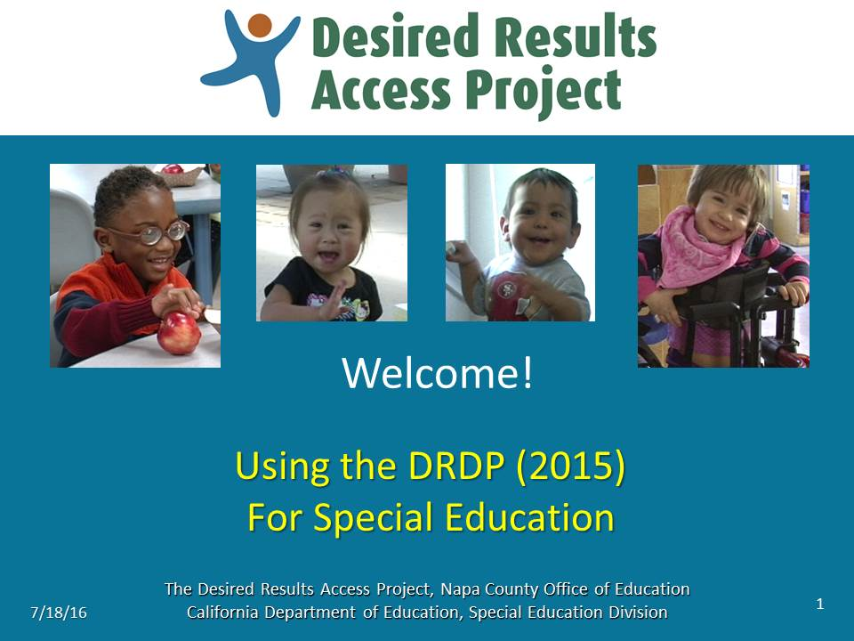 | Slide 1: Review the information on this slide and make these points:  - Welcome the participants to the workshop on using the Desired Results Developmental Profile (2015) Assessment, or, DRDP (2015) for short.  - Thank the participants for their commitment to the field and their implementation of the DRDP (2015) with children with IFSPs and IEPs.
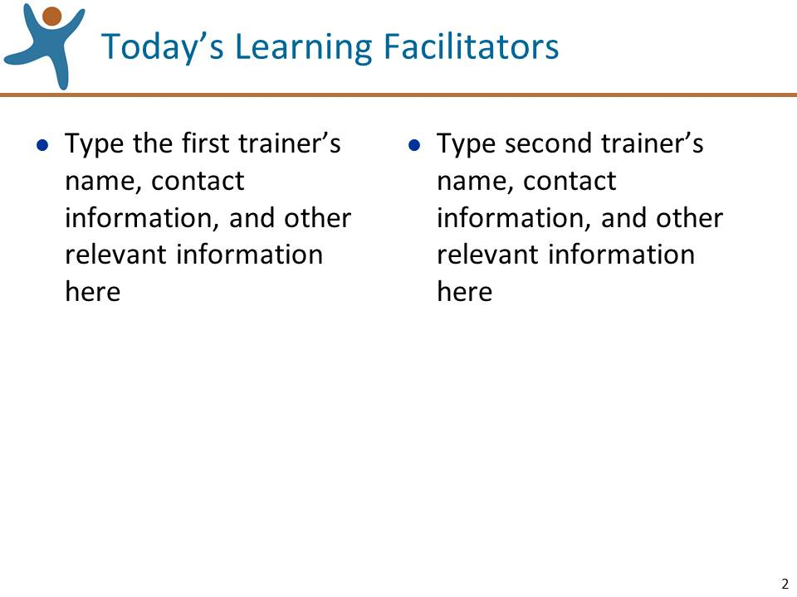 | Slide 2: Review the information on this slide and make these points:  - Briefly introduce the trainers, other staff, administrators, or guests.  - If the participants do not know one another, if the number of participants is low enough, and if time allows, ask the participants to BRIEFLY introduce themselves.
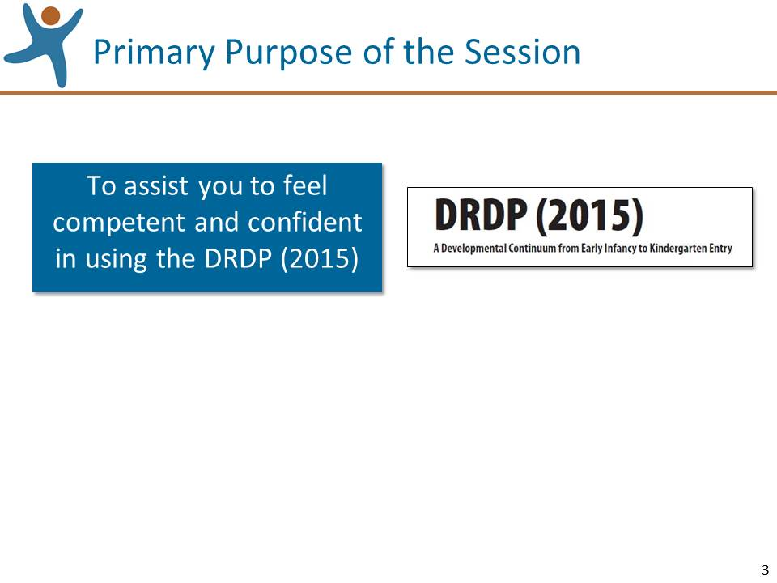 | Slide 3: Review the information on this slide and make these points:  - The workshop is focused on assisting you to use the DRDP (2015).  - The Desired Results Developmental Profile (2015) Assessment is a mouthful, so we will use the shorthand terms “DRDP (2015) or just “DRDP” for short.
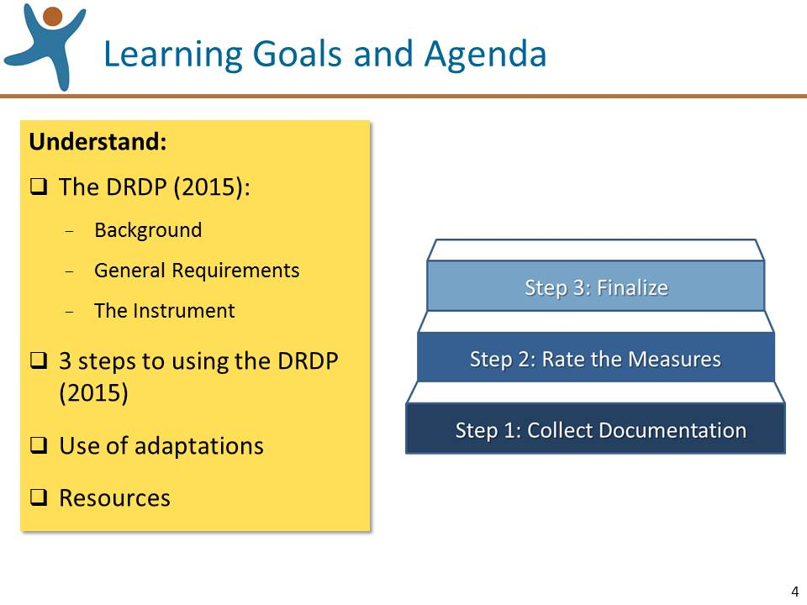 | Slide 4: Review the information on this slide and make these points:  - Because of time limitations this workshop will focus on the most foundational information and skills needed to use the DRDP (2015).  - We will refer you to guidance materials and other resources that address more specific topics.
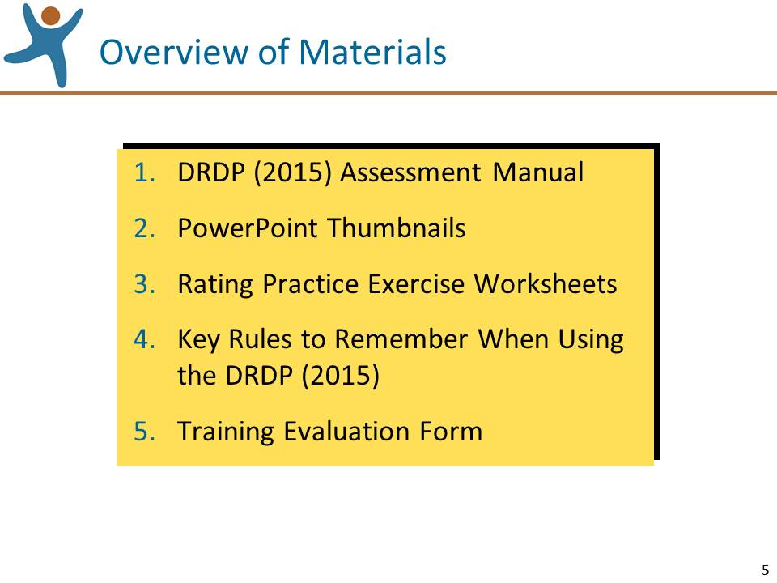 | Slide 5: Review the information on this slide and make these points:  - Mention that the manual, and other resources, are available for free at www.draccess.org  Note: If you plan to distribute handouts other than the ones listed on this slide, you may want to add them to this slide.
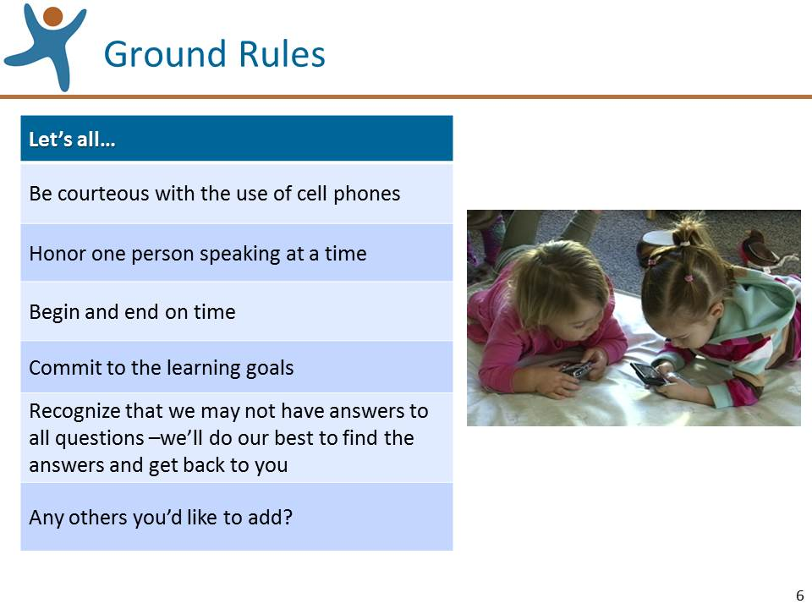 | Slide 6: Review the information on this slide and make these points:  - Ask if anyone has any other ground rules to suggest.  - If everyone pitches in, we’ll have a great day.
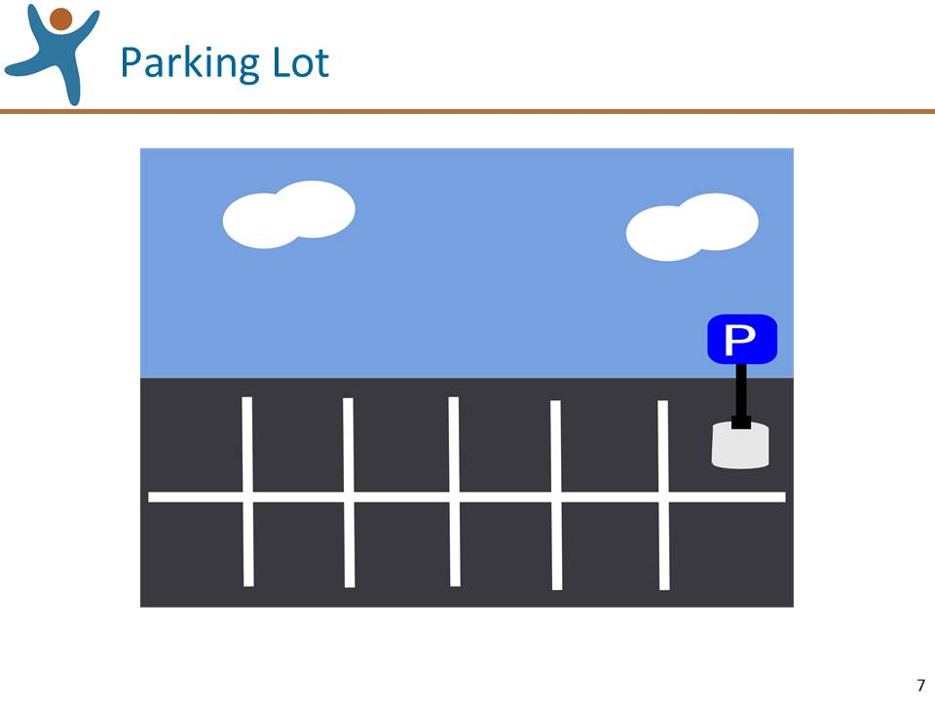 | Slide 7: Review the information on this slide and make these points:  - All questions are welcome, but there may not be time to get to some of them and there may not be immediate answers to others.  - If we can’t answer certain questions, we’ll do our best to find the answers and get back to you. In addition, you can, and should, contact your local administrators and/or the Desired Results Access Project for answers.  - Toward the end of the workshop we’ll review where to turn for more information.

Background (10 minutes)
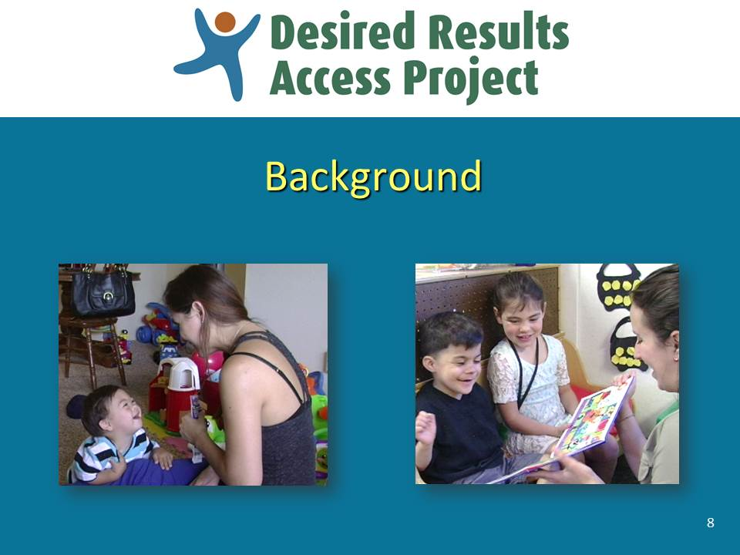 | Slide 8: Review the information on this slide and make these points:  - Before we dive in to using the instrument, let’s briefly review some background information about the DRDP (2015).
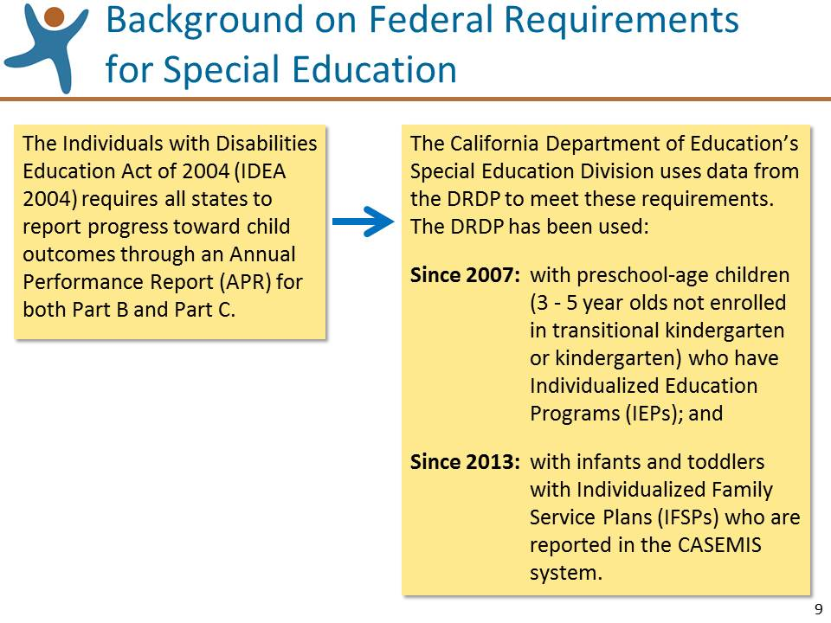 | Slide 9: Review the information on this slide and make these points:  - The California Department of Education, Special Education Division (CDE/SED) compiles DRDP data to meet these requirements.  - The Department of Developmental Services (DDS) also collects and reports information related to infants and toddlers who receive Part C services gathered through the Early Start Report (ESR) and does not use the DRDP (2015).
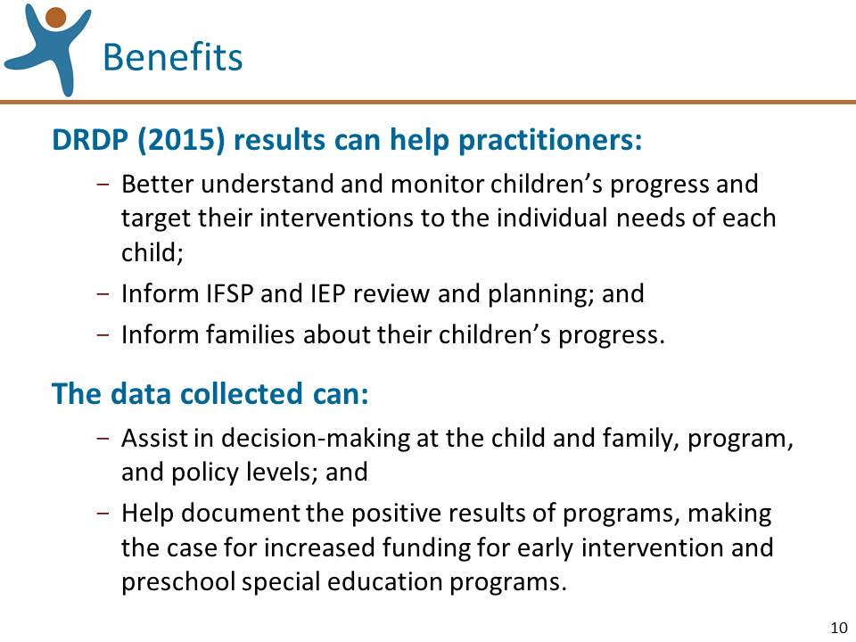 | Slide 10: Review the information on this slide and make these points:  - Using the DRDP (2015) enables CDE, SELPAs, county offices of education, and school districts to comply with IDEA 2004 requirements. But the use of the DRDP (2015) Assessment accomplishes much more than compliance with federal law.  - This slide describes a number of benefits of using the DRDP (2015).
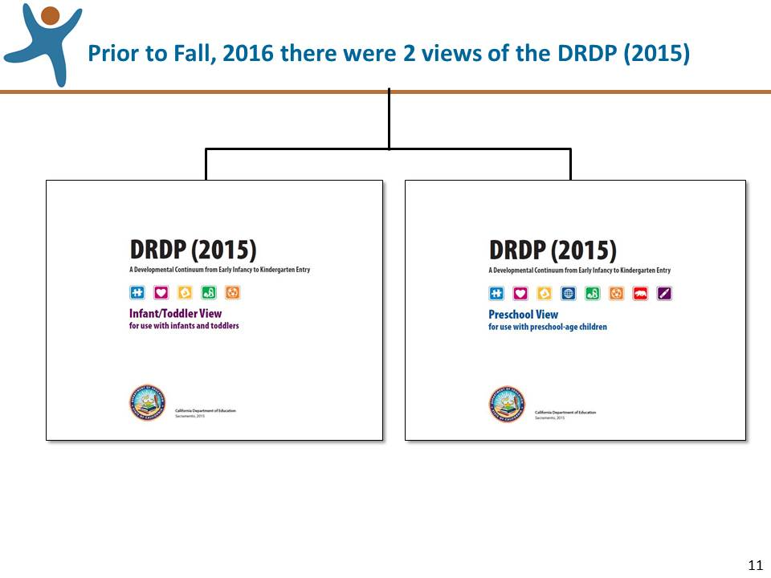 | Slide 11: Review the information on this slide and make these points:  - The DRDP Assessment has been a collaborative effort between CDE’s Early Education and Support Division (EESD) – formerly called the Child Development Division (CDD) – and Special Education Division (SED) since its inception so that the system will include ALL children in California’s state-funded early care and education programs.  - In the past, the DRDP was a family of assessment instruments, all based on observations of a child’s skills within typical routines and activities.  - EESD used three versions of the DRDP: infant toddler, preschool, and school age, and SED used the DRDP access.
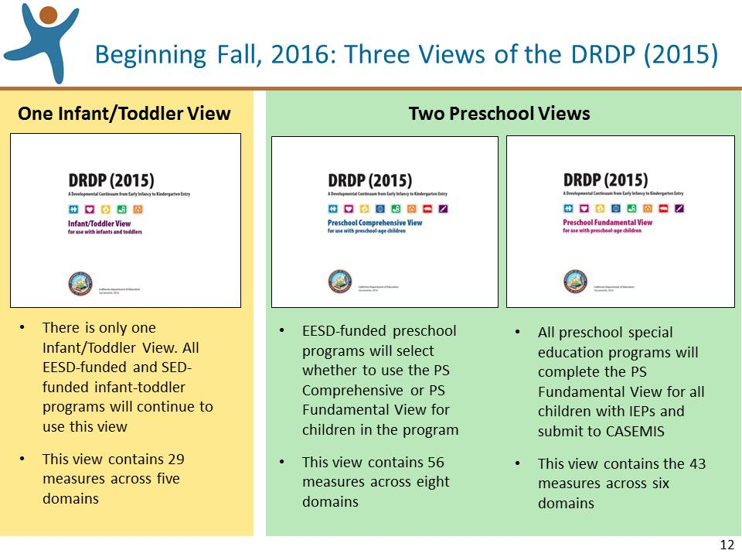 | Slide 12: Review the information on this slide and make these points:  - Beginning in fall 2016, there are three views of the DRDP (2015), one for infants and toddlers and two for preschoolers, referred to as the Preschool Comprehensive View and the Preschool Fundamental View.  - Special education assessors use the Infant/Toddler View with children receiving Part C/Early Start services and the Preschool Fundamental View for preschoolers with IEPs. Note: if asked, preschool-age children with significant disabilities are not assessed with the Infant/Toddler view.
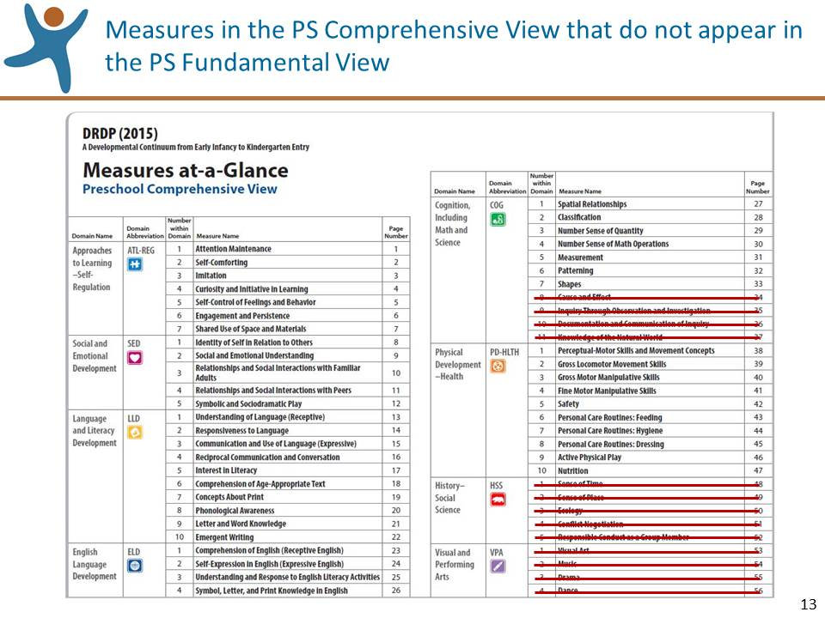 | Slide 13: Review the information on this slide and make these points:  - This illustration shows the measures on the DRDP (2015) Preschool Comprehensive View. The 13 Measures in red strikethrough remain part of the DRDP (2015) Preschool Comprehensive View but do not appear on the DRDP (2015) Preschool Fundamental View. These measures include 4 science measures from the COG domain and the History/Social Science and Visual and Performing Arts domains.  - While these measures were removed from the DRDP (2015) Preschool Fundamental View, they are still part of a comprehensive early childhood curriculum.
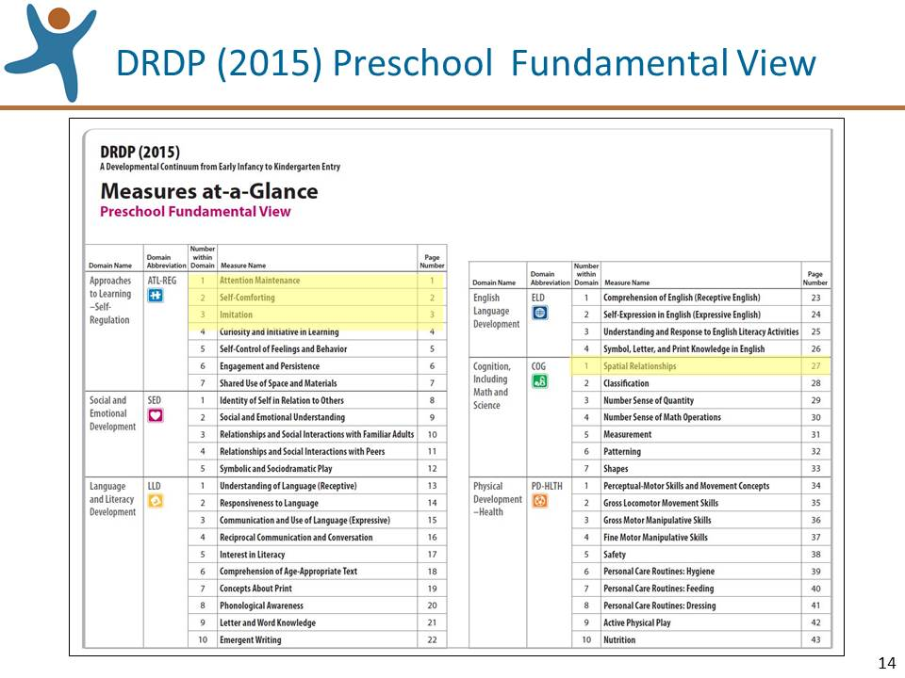 | Slide 14: Review the information on this slide and make these points:  - Note that COG now is comprised only of math measures.  - Also note that ATL 1, 2, and 3 and COG 1, which were previously conditional, are now required for children with IEPs; these are highlighted in yellow.
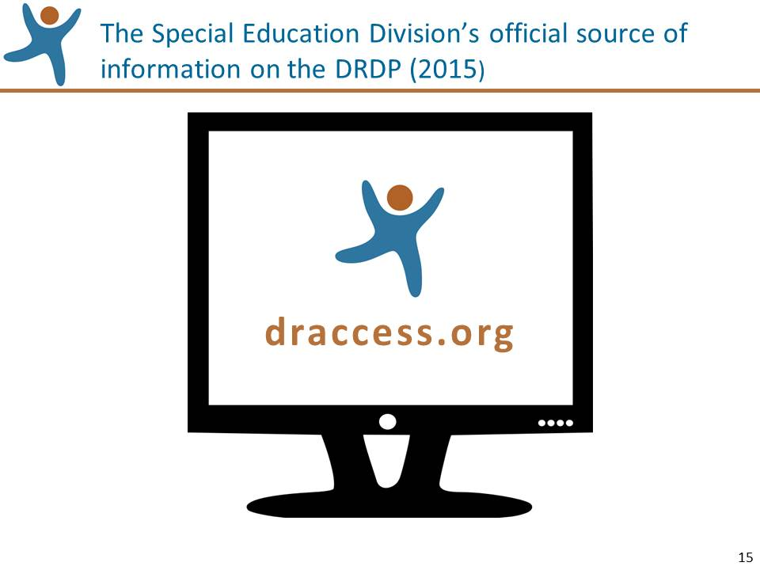 | Slide 15: Review the information on this slide and make these points:  - www.draccess.org is SED’s official site for information related to the DRDP (2015) for special education. On this site you can find answers to questions as well as guidance documents, videos, online modules, the DRDP (2015) instrument, and much more.  - Please take some time to visit the site, look around, and bookmark it.  - The site is frequently updated, so visit it from time to time.  - INVITE A BRIEF DISCUSSION: Ask the participants for questions specifically about the background of the DRDP and answer them. If questions are asked that you know will be addressed in upcoming sections of the workshop, let them know that the question will be addressed shortly.

General Requirements (10 minutes)
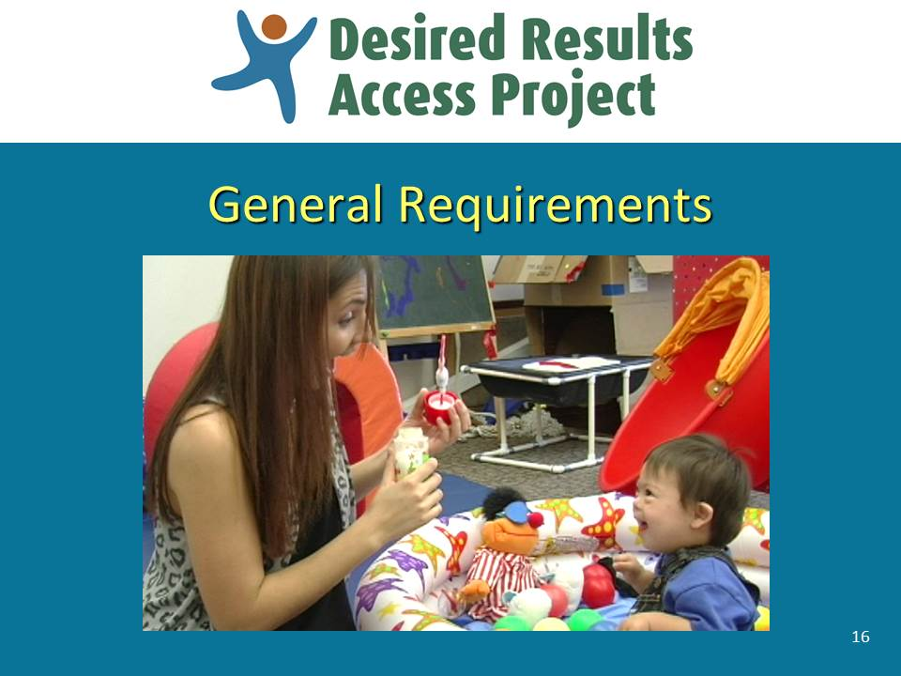 | Slide 16: Review the information on this slide and make these points:  - Over the next handful of slides we’ll review the general requirements for using the DRDP (2015).
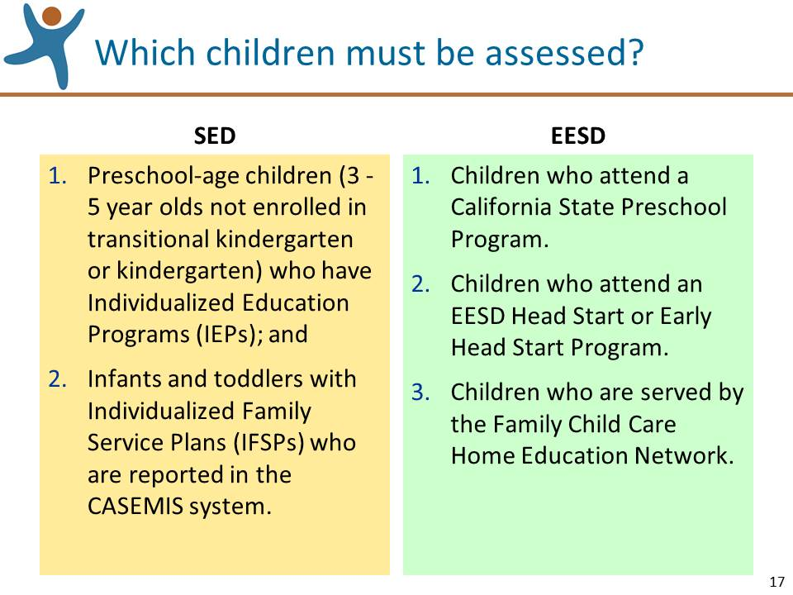 | Slide 17: Review the information on this slide and make these points:  - The CDE’s Early Education and Support Division (EESD) and Special Education Division (SED) have different criteria for which children must be assessed.  - Infants and toddlers served by a Local Education Agency (LEA) under a regional center vendor contract are not included in the DRDP (2015) assessment as they are not reported to CASEMIS.
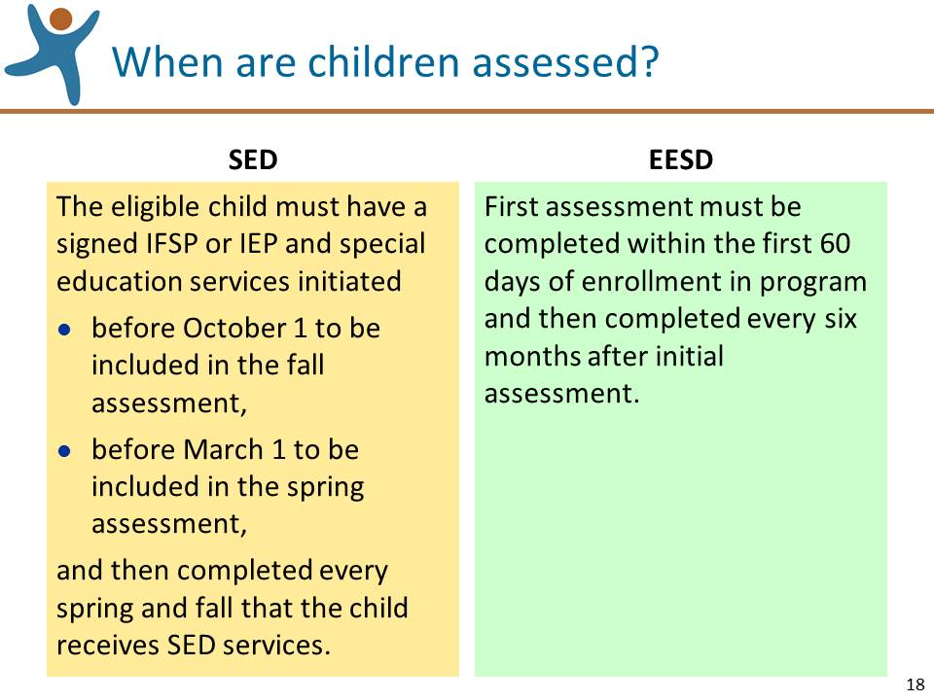 | Slide 18: Review the information on this slide and make these points:  - Remember that the child must have a signed IFSP or IEP and special education services initiated before these dates, not on these dates.  - Remember that observing children and collecting documentation are ongoing activities, but when you rate the DRDP (2015) your ratings should be informed by observations made within 6 weeks of when the data is due.
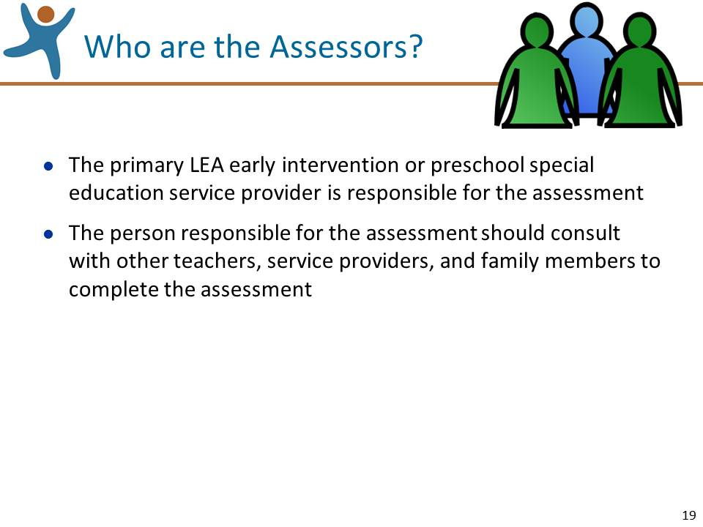 | Slide 19: Review the information on this slide and make these points:  - In special circumstances special education administrators will determine whom the assessor will be, e.g., for a child served only by CCS or a Non-Public School.
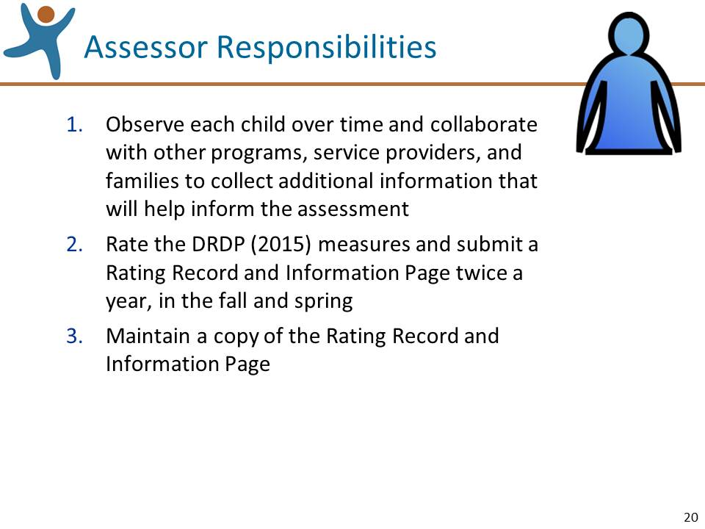 | Slide 20: Review the information on this slide and make these points:  Emphasize that the primary service provider does not need to gather all the information for the assessment; recommended practice is to collaborate with others.  The next slide will describe the reporting periods.
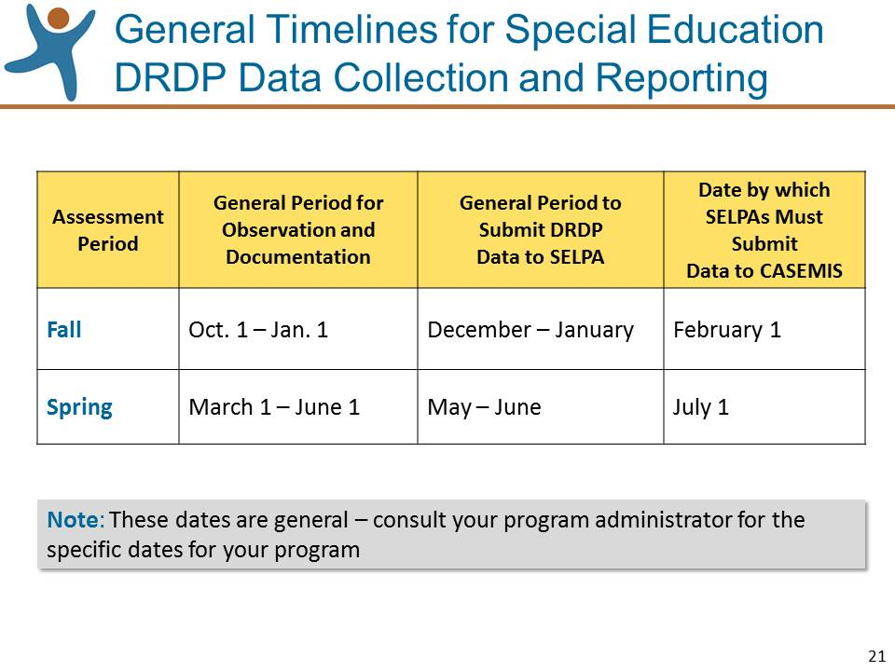 | Slide 21: Review the information on this slide and make these points:  - The SELPA data submission and certification date is not general; DRDP (2015) data is always due on February 1 and July 1.  - The periods for assessors for observation, documentation, and submission of data are more general as SELPAs set the dates that data are due to them. Ask your administrator or SELPA office when DRDP data are due.  - Remember that for children who are dually enrolled, only one assessment should be completed (and completed collaboratively), but both the general and special educator will each need to submit their Rating Records to their respective systems.  - Whichever assessor has the earlier due date, collaborate to help complete the assessment by that date.
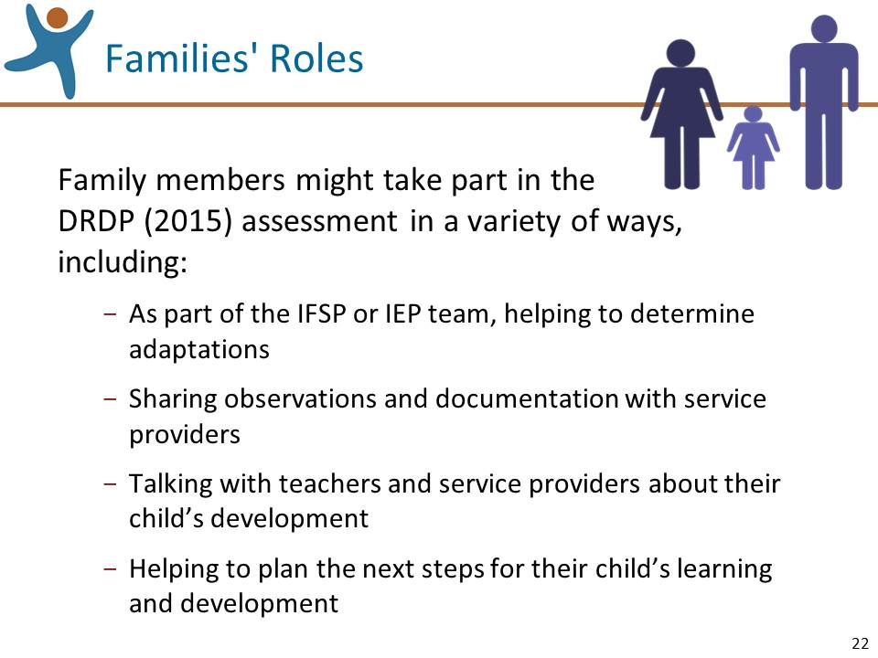 | Slide 22: Review the information on this slide and make these points:  - It is up to family members to decide how they might take part in the assessment; on this slide are a few examples of how they might choose to participate.  - Naturally, families would also talk about the results of the DRDP (2015) with providers in IFSP and IEP meetings and parent conferences. We will talk about reports of DRDP (2015) results towards the end of the workshop.
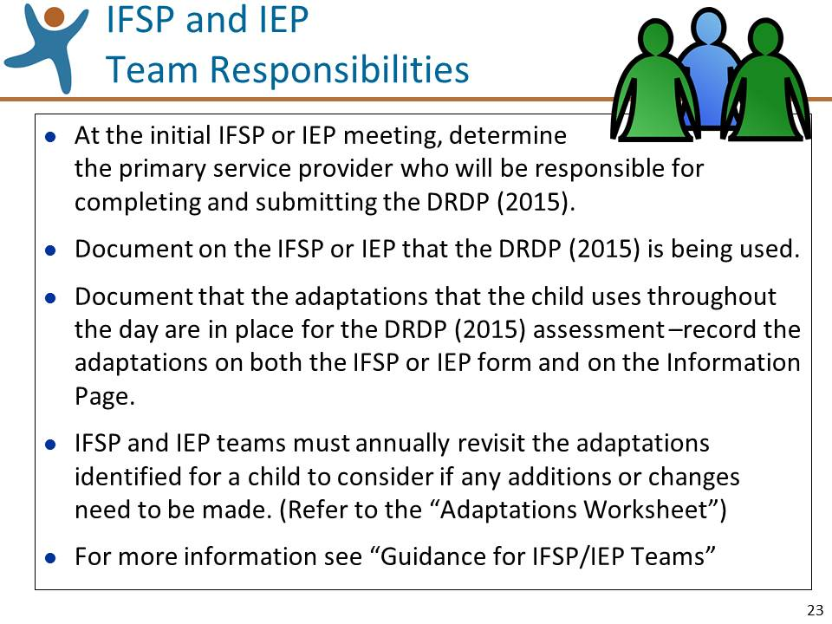 | Slide 23: Review the information on this slide and make these points:  - At the IFSP or IEP meeting, the primary service provider who will conduct the assessment should be identified.  - For more information, refer to “Guidelines for IFSP/IEP Teams” in the section for teachers and service providers at www.draccess.org.
Mute the projector | Mute the projector (see p. 7 for tips):  - Ask the participants for questions specifically about the basic requirements for the DRDP (2015) and answer them. If questions are asked that will be addressed in upcoming sections of the workshop, acknowledge that the question will be addressed shortly.

Understanding the DRDP (2015) (15 minutes)
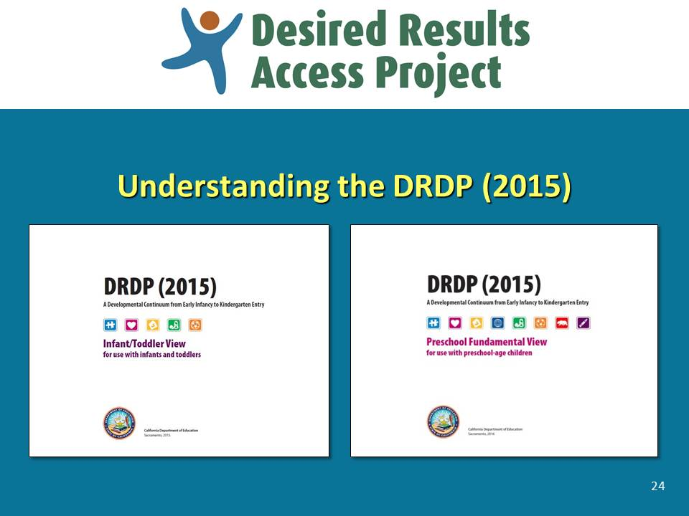 | Slide 24: Review the information on this slide and make these points:  - Now we move on to the fun part, actually learning about how to use the DRDP (2015).  - Ask the participants to take a couple of minutes to scan through the DRDP (2015) Assessment Manual.
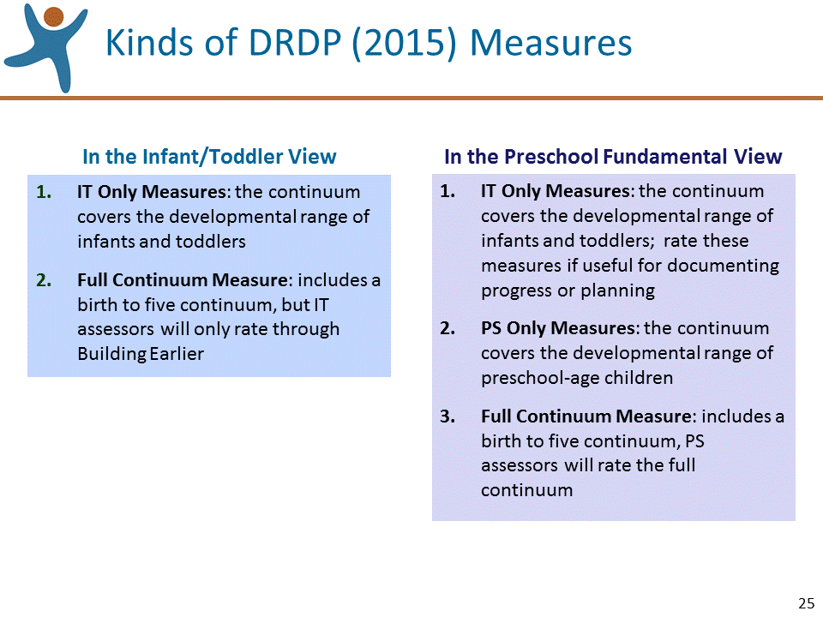 | Slide 25: Review the information on this slide and make these points:  - Remember that infants and toddlers are only assessed with the Infant/Toddler View and preschoolers are assessed only with the Preschool Fundamental View.  - Most of the measures in the Infant/Toddler view contain full continuum measures that run from early infancy to early kindergarten.  - The Preschool Fundamental View contains all of the measures in the IT view, plus some additional measures just for preschool-age children.
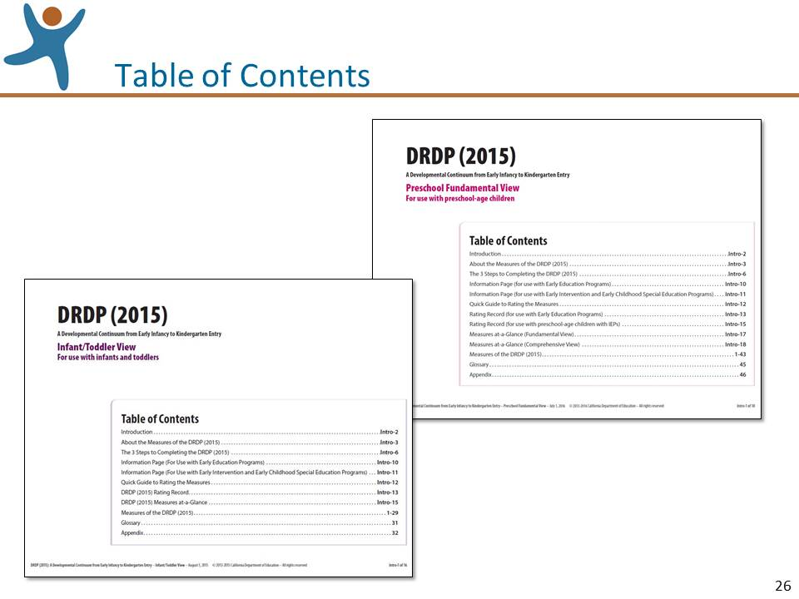 | Slide 26: Review the information on this slide and make these points:  - There is some preliminary guidance in the beginning of the Assessment Manual followed by the Rating Record and Information Page.  - And there are some important appendices at the end of the Manual, but the bulk of the Manual is devoted to the measures.
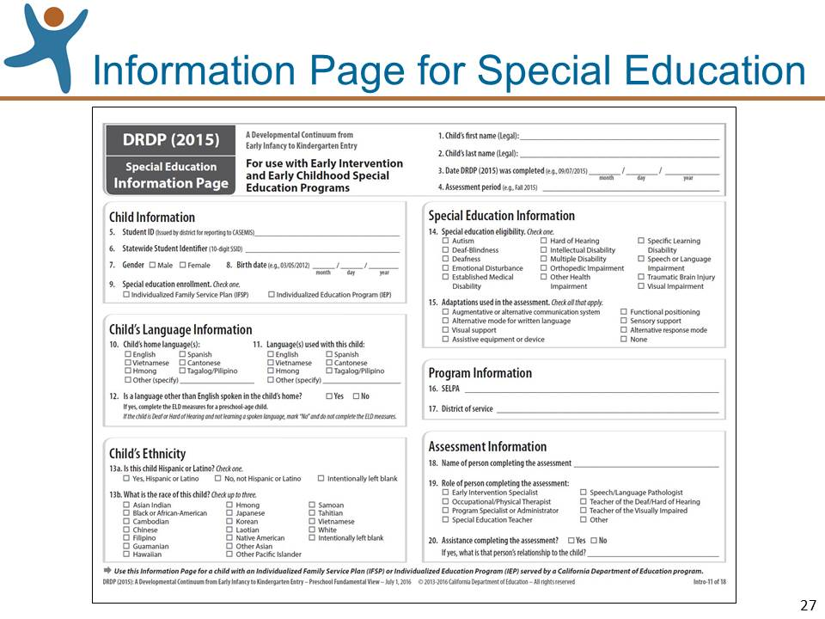 | Slide 27: Review the information on this slide and make these points:  - There is a copy of the Information Page in the Manual that we’ll review in a bit.  - Be sure you are using the correct version of the Information Page—the EESD Information Page precedes ours in the Assessment Manual.  - Occasionally, there are changes made to the Information Page. For example, in fall 2016 there was a change in Question 12 about the child’s home language. The best way to make sure that you are using the most current version of the Information Page and Rating Record is to download the version at draccess.org.
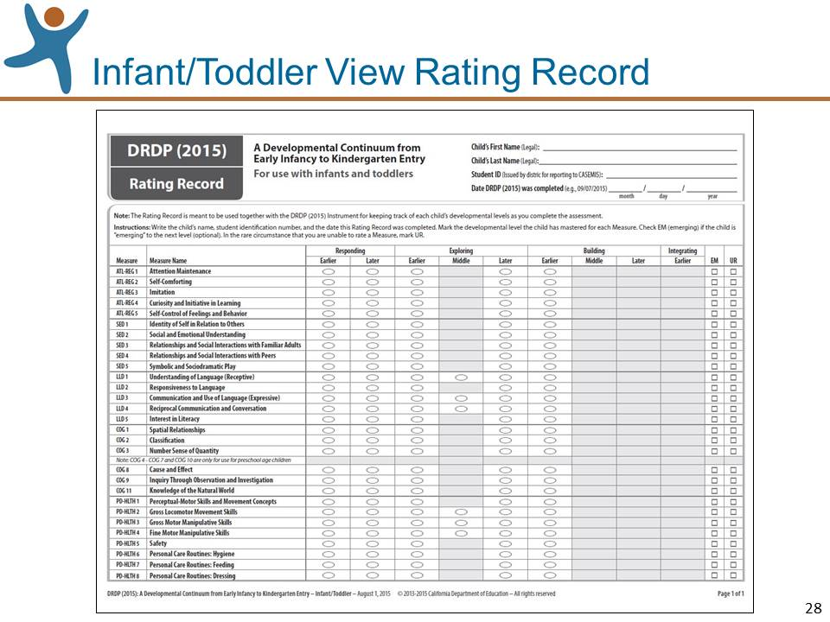 | Slide 28: Review the information on this slide and make these points:  - Special Education assessors will be using 2 Rating Records: one for the Infant/Toddler View which includes 29 measures and one for the Preschool Fundamental View which includes 43 measures. Both versions appear in their respective Manuals.  - The version on this slide is for the Infant/Toddler View.  - Like the Information Page, there are occasionally changes made to the Rating Record and the best way to make sure that you are using the most current version is to download a copy at draccess.org.
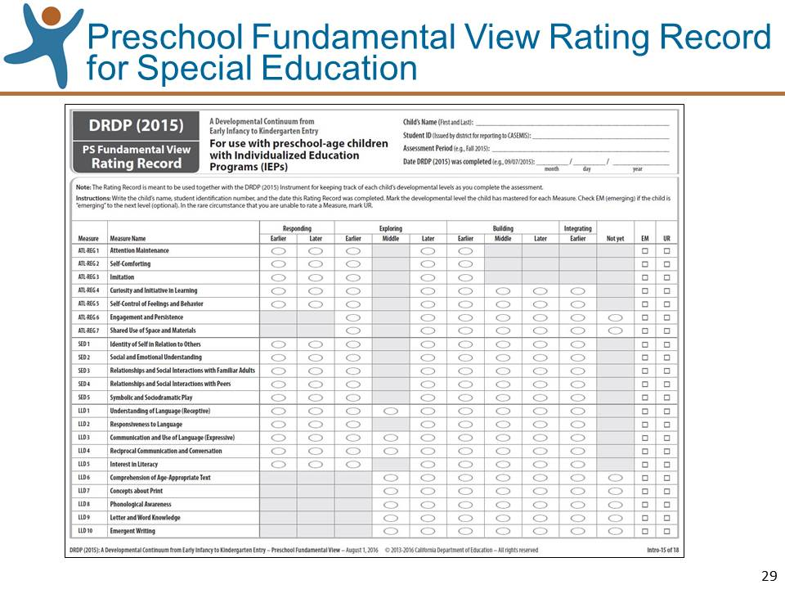 | Slide 29: Review the information on this slide and make these points:  - The version of the Rating Record on this slide is for the Preschool Fundamental View.  - This is the first time there has been a specific rating record for preschoolers with IEPs on the DRDP (2016).  - Note at the top of page 2 that the ELD measures look different; we will cover these a little bit later.
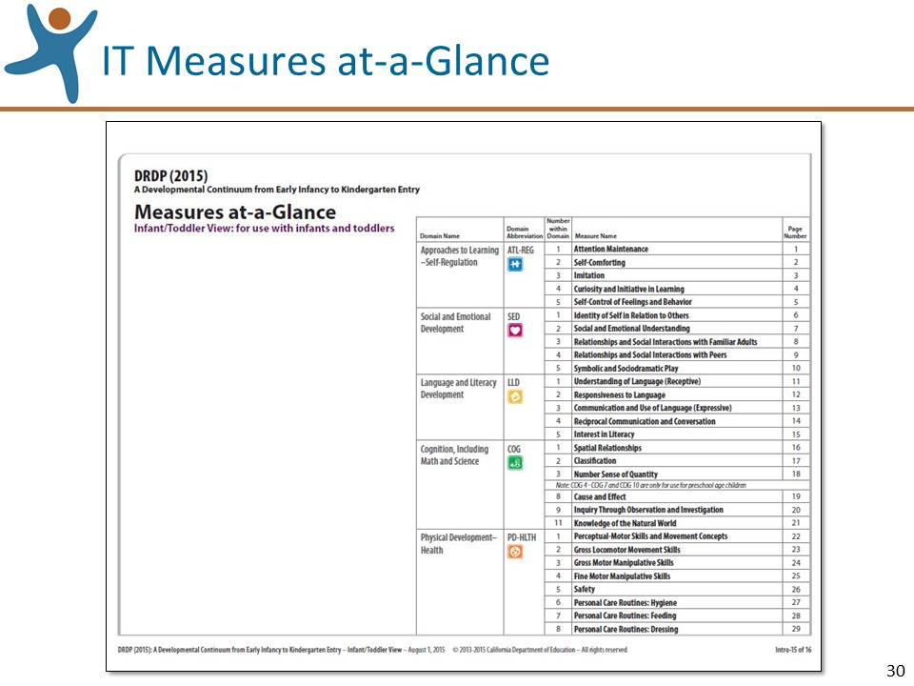 | Slide 30: Review the information on this slide and make these points:  - Walk the participants through this IT version of the Measures at-a-Glance highlighting the organization and relationship among the domains and the measures.
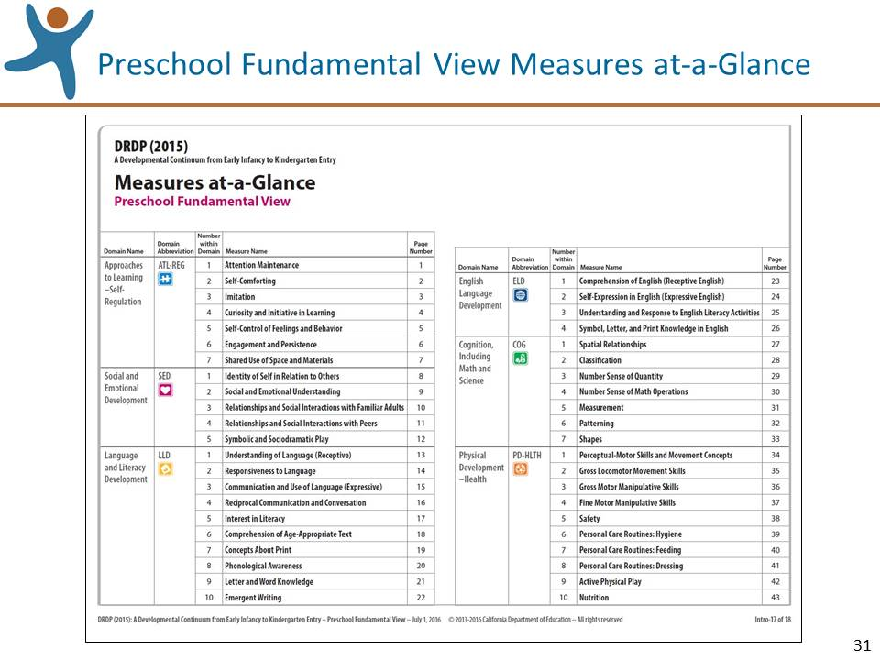 | Slide 31: Review the information on this slide and make these points:  - Walk the participants through the Preschool Fundamental View of the Measures at-a-Glance highlighting the organization and relationship among the domains and the measures.
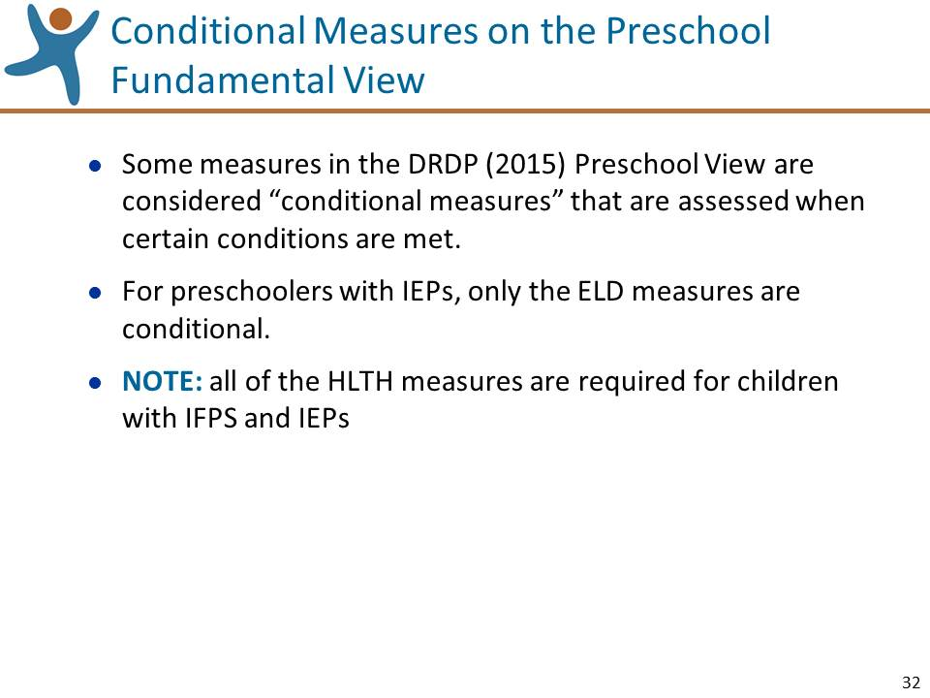 | Slide 32: Review the information on this slide and make these points:  - Conditional measures apply to preschool-age children only.  - In the Preschool Fundamental View, you will see the conditional measures clearly marked in the upper right hand corner and on the Rating Record.  - The conditional measures are now also designated, required for children with IEPs except for the ELD measures.
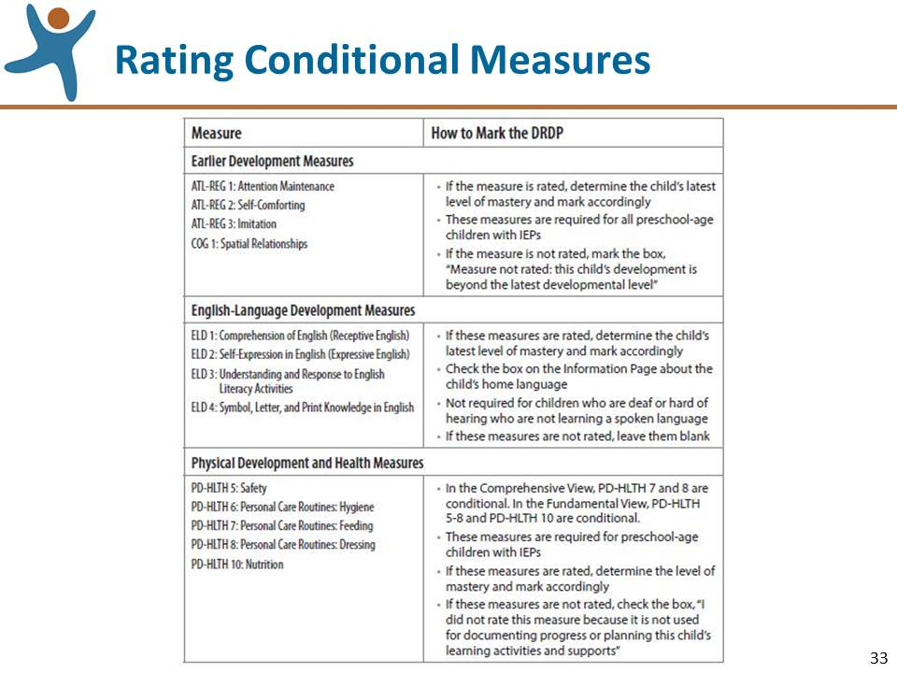 | Slide 33: Review the information on this slide and make these points:  - In the left-hand column of this table, you will see the list of conditional measures for preschool. The right-hand column describes when, and with whom, to use these measures.  - The earlier development measures are required for children with IEPs and are used for preschool children in EESD programs who are still at that earlier developmental level.  - The ELD measures are only used if you answer “yes” to question #12 on the Information Page.  - The PD-HLTH measures are required for all children with IEPs. They are only optional for children in EESD programs.  - This information appears in the Introduction section of the Manual.
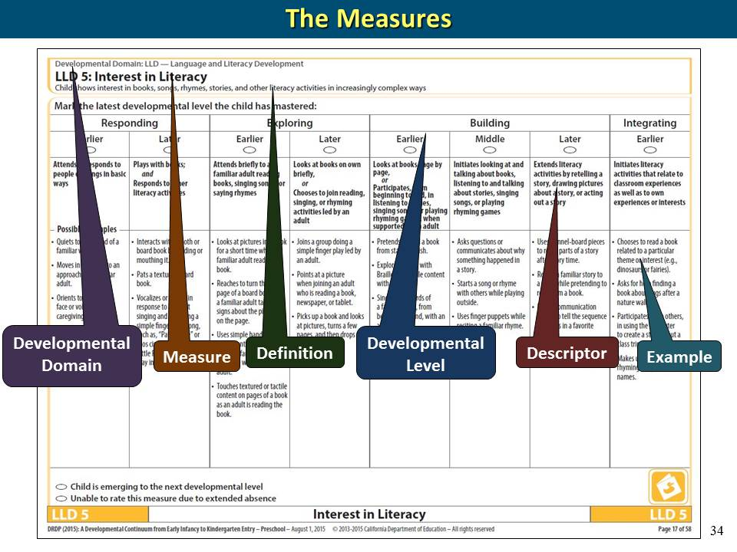 | Slide 34: Review the information on this slide and make these points:  - The next series of slides will review the components of the measures.  - Ask the participants to open their Manuals to Measure LLD 5: Interest in Literacy so they can follow along.
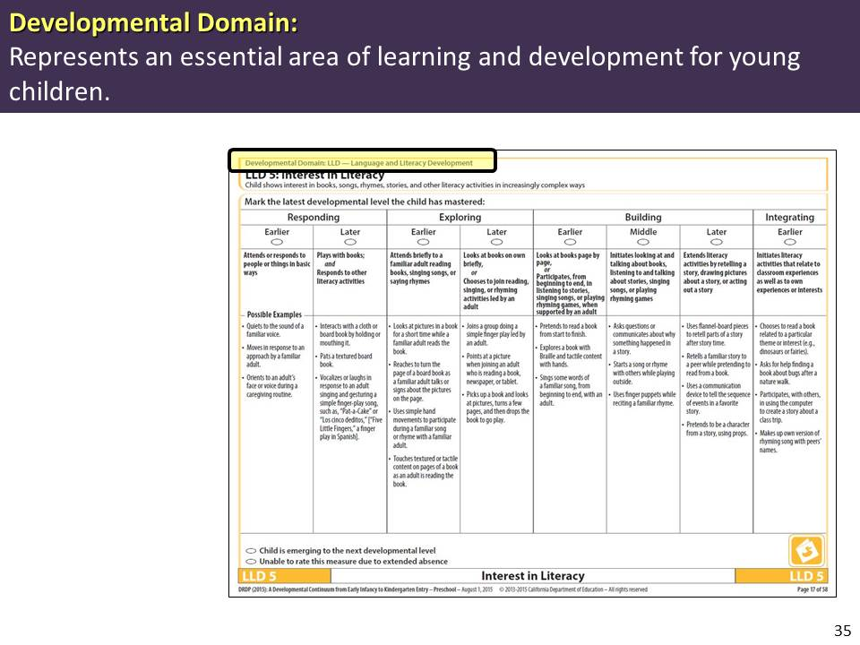 | Slide 35: Review the information on this slide and make these points:  - The measures in the DRDP (2015) are organized into broad developmental dimensions referred to as Developmental Domains.
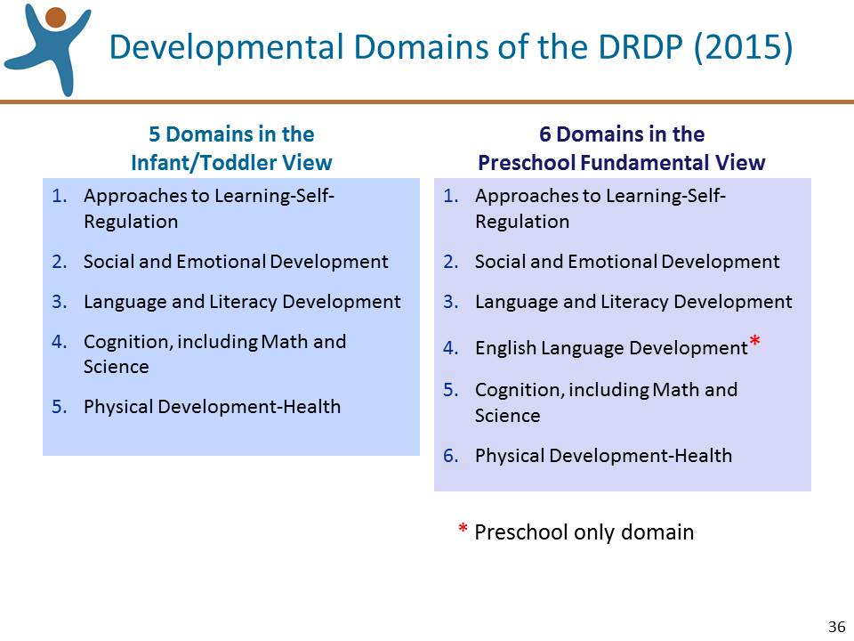 | Slide 36: Review the information on this slide and make these points:  - As you see there are 5 Infant/Toddler 6 Preschool domains.  - All of the Infant/Toddler domains appear in the Preschool Fundamental View.  - The Preschool Fundamental View contains three additional domains: ELD, HSS, and VPA.
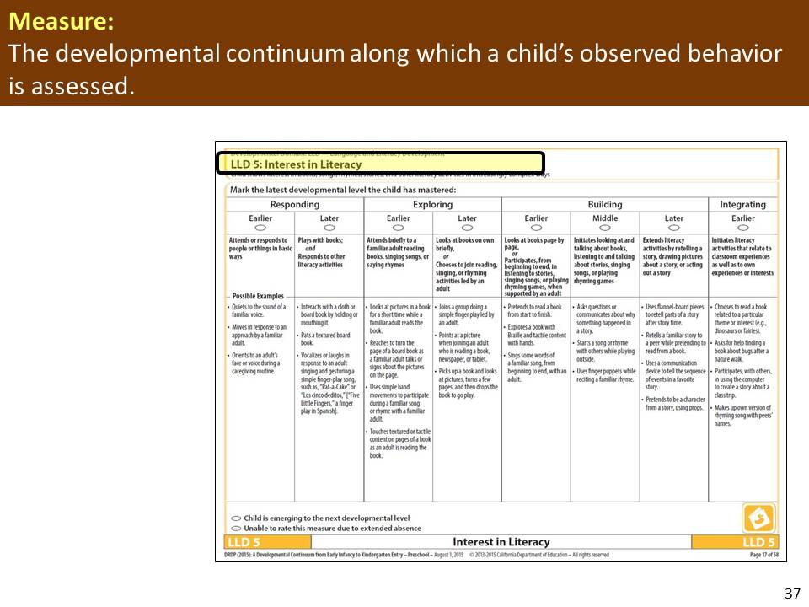 | Slide 37: Review the information on this slide and make these points:  - The measure is the developmental continuum along which a child’s observed behavior is assessed.
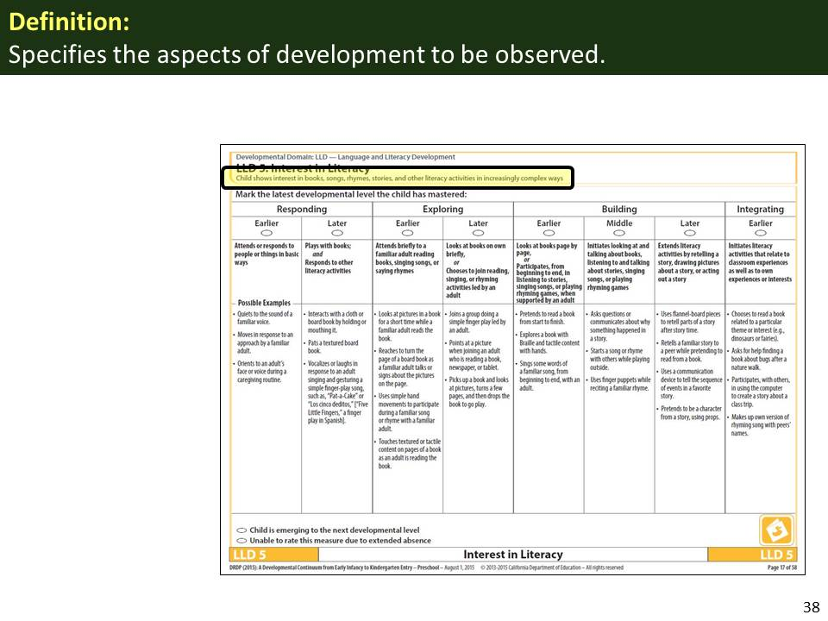 | Slide 38: Review the information on this slide and make these points:  - The Definition gives us more information about the area of development described in the measure.
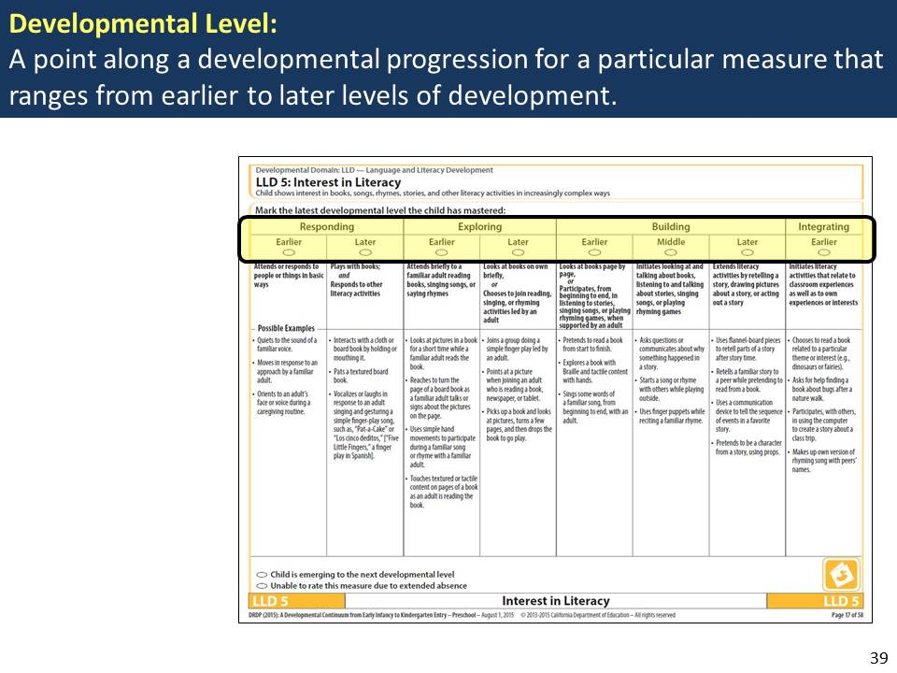 | Slide 39: Review the information on this slide and make these points:  - Note that the row of levels has two parts.  - The levels run from earlier development on the left to later development on the right.  - This is an example of a “full continuum” measure, with levels from early infancy to early kindergarten.
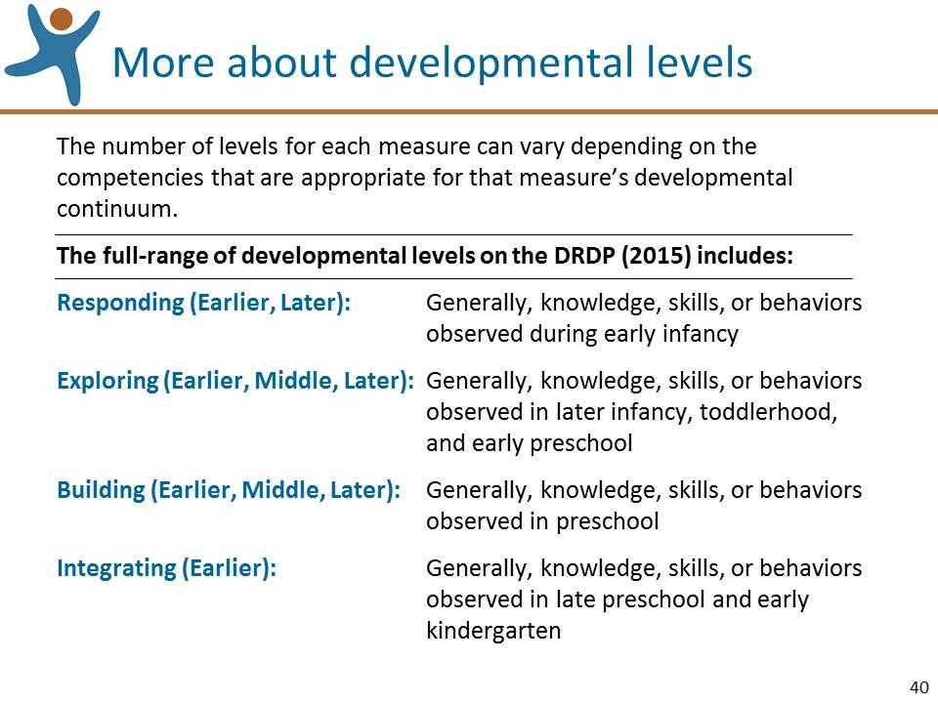 | Slide 40: Review the information on this slide and make these points:  - The levels are organized under four categories: responding, exploring, building, and integrating.  - Under each category, you may see a range of sub-levels: early, middle, or later.  - The broad ages associated with these four categories tells us approximately when we might typically expect to see these skills.
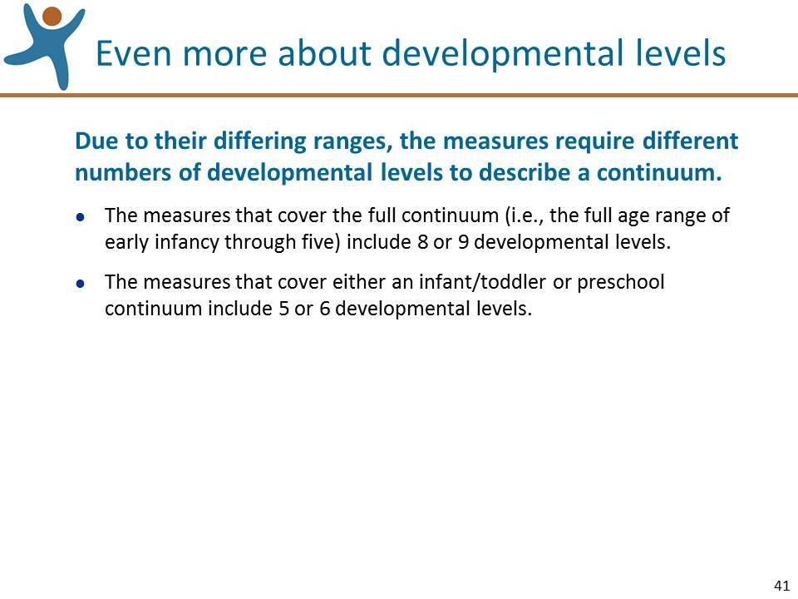 | Slide 41: Review the information on this slide and make these points:  - This information is provided just to give you a sense of how the measures are structured.  - You can find this information in the Introduction to the Manual and we’ll look at this more closely in a while.
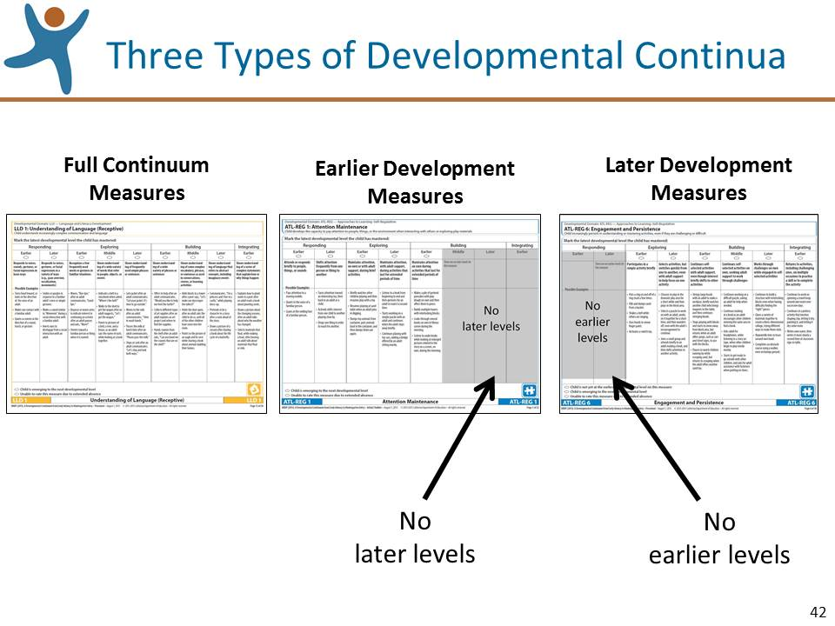 | Slide 42: Review the information on this slide and make these points:  - Most of the measures in the DRDP (2015) cover an early infancy to early kindergarten range. These are named, “Full Continuum measures.”  - A few measures of the DRDP (2015) address children at the early levels of development (called Earlier Development measures) and some apply to children at the later end of the developmental range (called Later Development measures).  - We’ll look at these three types of measures one at a time and the information appears in the Introduction of the Manual.
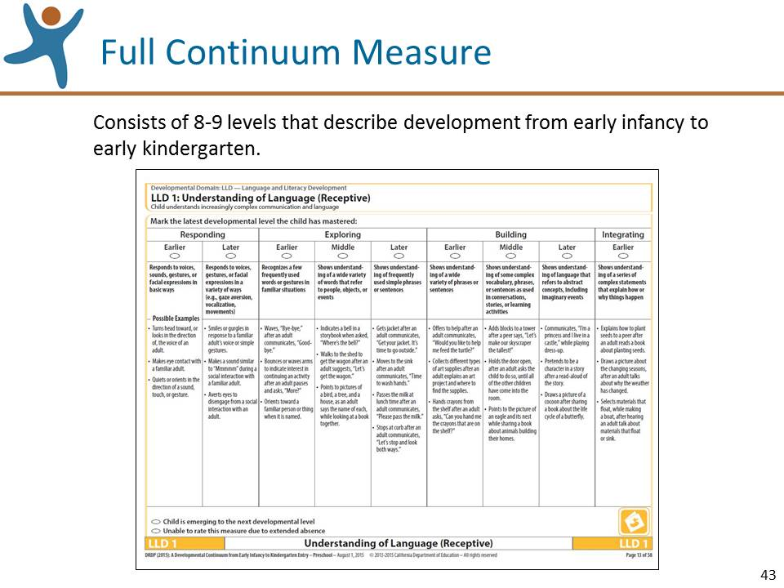 | Slide 43: Review the information on this slide and make these points:  - This measure, LLD 1, is an example of a full continuum measure, early infancy to early kindergarten.  - You will find full continuum measures in both the Infant/Toddler and Preschool Fundamental Views of the instrument.  - Note that in the Infant/Toddler View, full continuum measures can only be rated through “Building Earlier.”  - The remaining levels indicate “N/A” under the level names that can’t be rated for infants and toddlers.
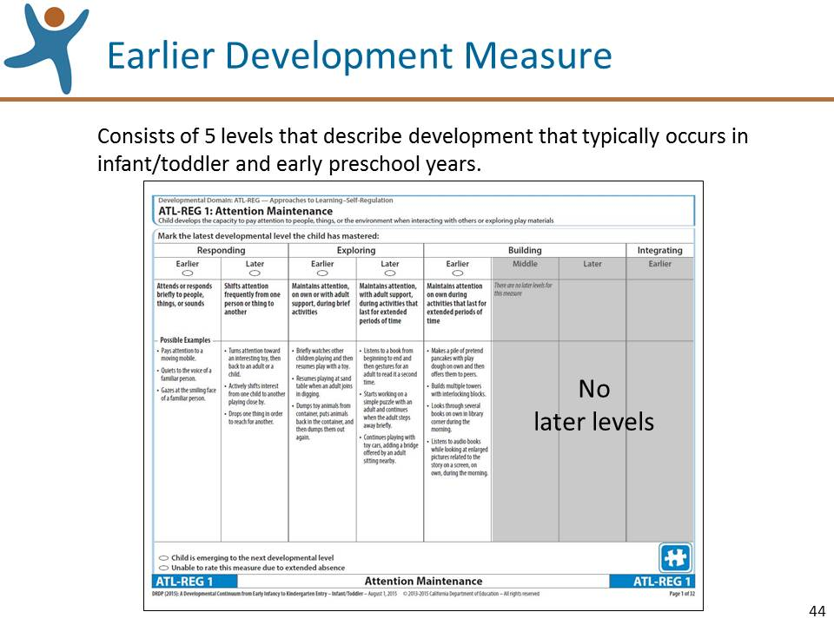 | Slide 44: Review the information on this slide and make these points:  - Earlier Development measures describe development that typically occurs in the infant/toddler and early preschool years.  - Notice that these measures only have developmental levels up to “Building Earlier”.  - The DRDP (2015) only contains four earlier developing measures. The majority of the measures are early infancy to kindergarten entry.  - You will find the Earlier Development measures in the Preschool Fundamental View as well; we’ll discuss this in more detail later.
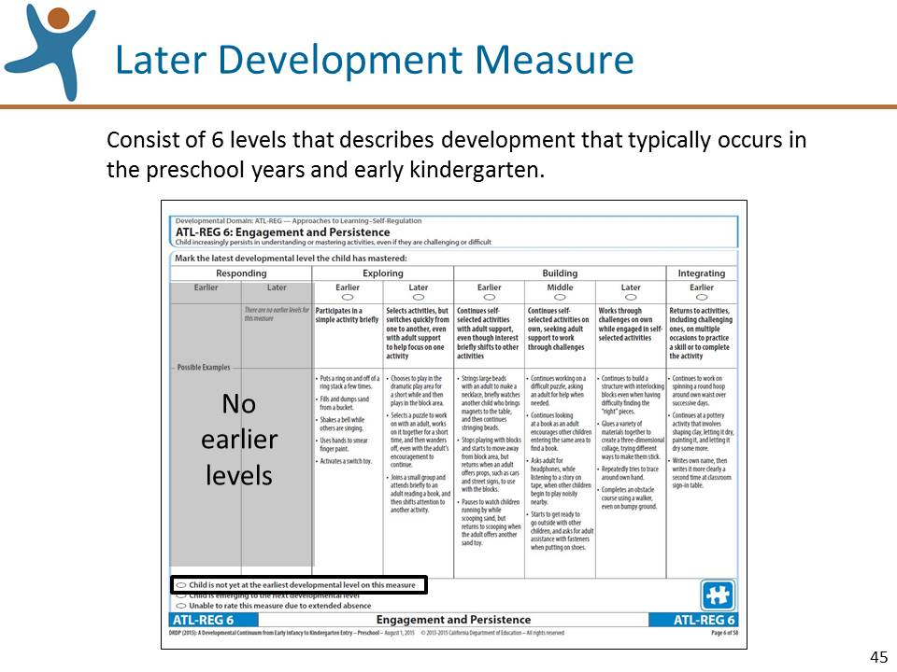 | Slide 45: Review the information on this slide and make these points:  - Later Development measures describe development that typically occurs in the preschool years and early kindergarten.  - Notice at the bottom of the page, a choice to select, “Child is not yet at the earliest developmental level.” We will discuss this further when we talk about the rating process.
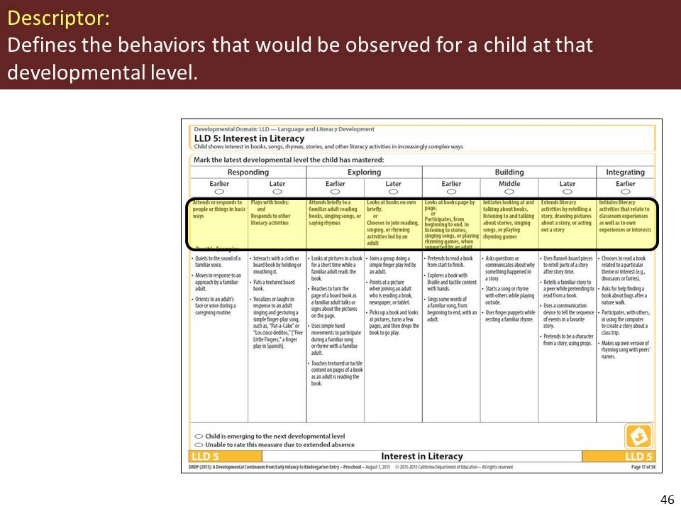 | Slide 46: Review the information on this slide and make these points:  - When we rate the measures, we are assessing the child's skills related to these descriptors.
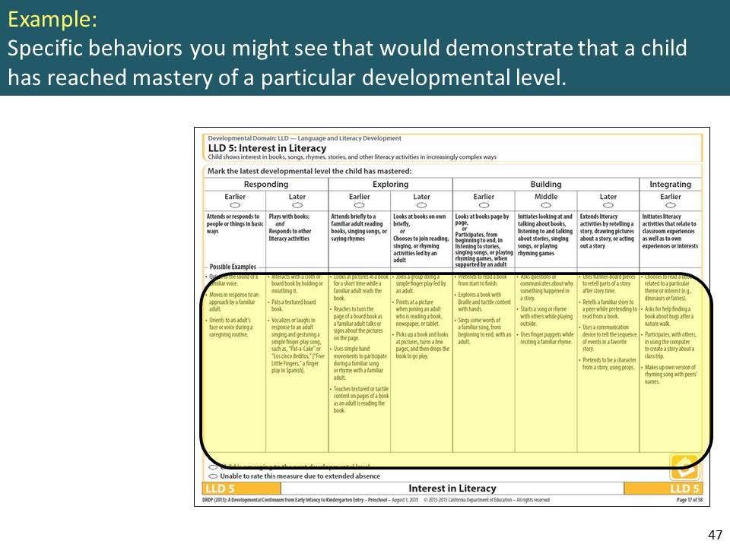 | Slide 47: Review the information on this slide and make these points:  - The examples in the DRDP (2015) function just as they did in the DRDP access: they should help you understand the descriptor and should not be used as a checklist.  - Some of the examples have been translated into languages other than English. For example, see LLD 3 Exploring Later.
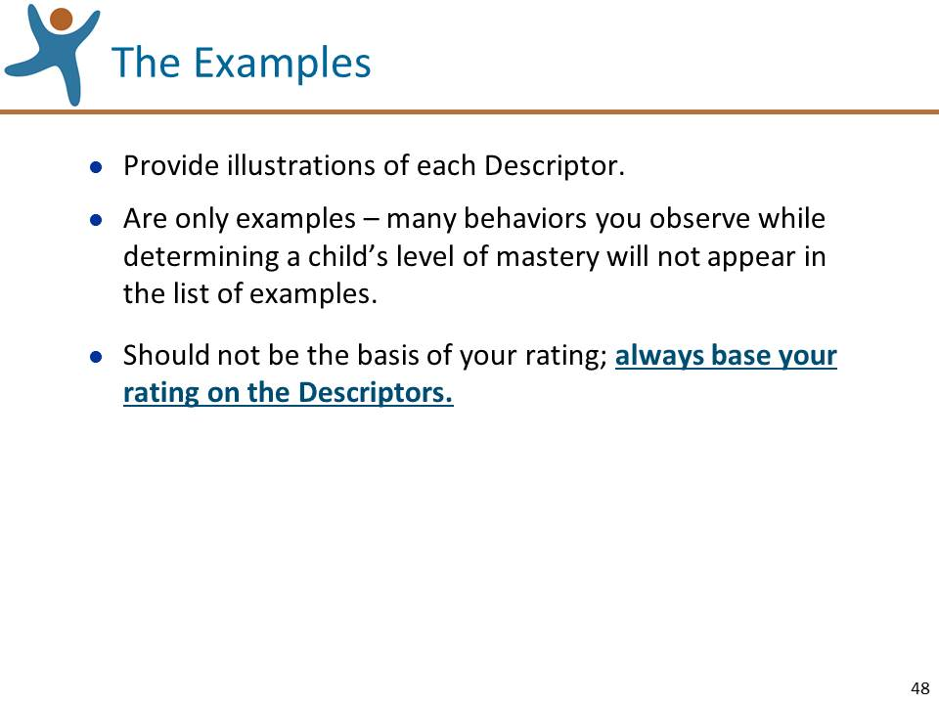 | Slide 48: Review the information on this slide and make these points:  - KEEP IN MIND: the examples are just examples! When observing a child, you may not actually observe any or all of them.  - Very few examples contain specific adaptations. You will, however, see them in your observations of a child’s mastery.
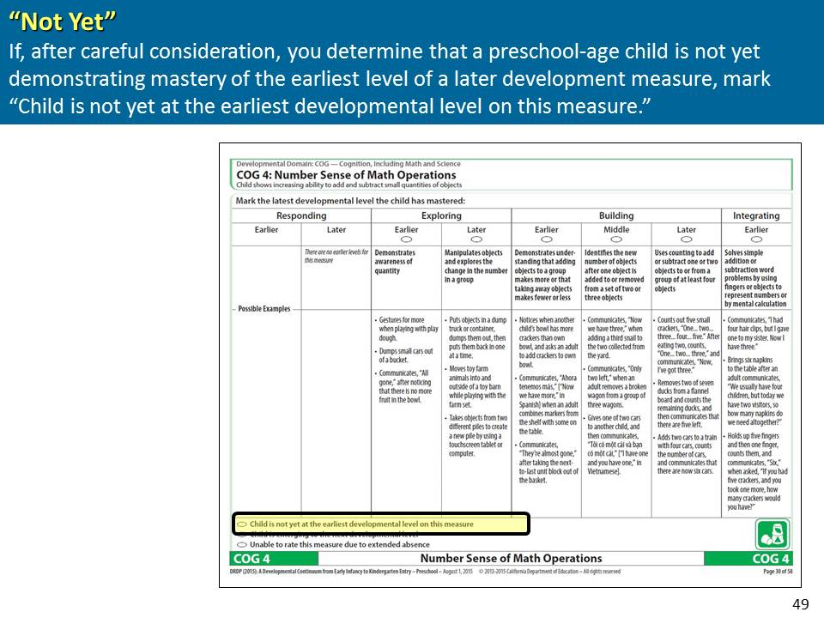 | Slide 49: Review the information on this slide and make these points:  - Ask the participants to locate the COG 4 measure to illustrate a measure that has the "Not Yet" option.  - We’ll talk more about this when we discuss the rating process.
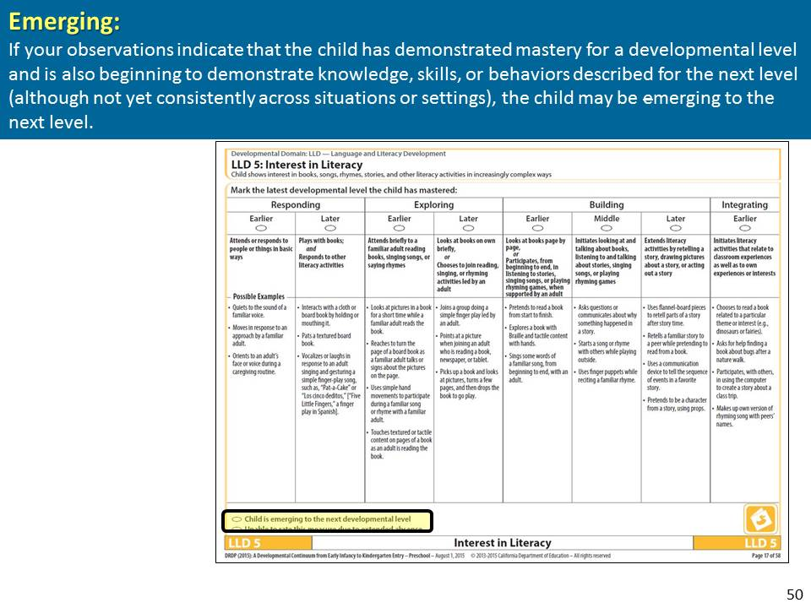 | Slide 50: Review the information on this slide and make these points:  - Emerging indicates the child demonstrates skills consistently at one level, but also demonstrates some skills at the next higher Level but has not yet mastered it.  - We will discuss this in more detail when we talk about the rating process.
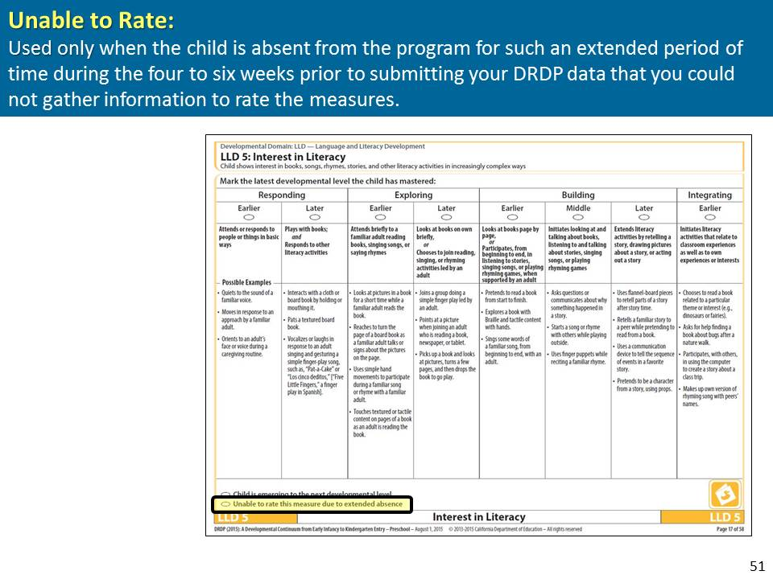 | Slide 51: Review the information on this slide and make these points:  - Unable to rate should hardly ever be used.  - It should only be used in the rare situation in which the child is absent from the program for such an extended period of time during the four to six weeks prior to submitting your DRDP data that you could not gather information to rate the measures.
Mute the projector | Mute the projector (see p. 7 for tips):  - Ask for questions specifically about the components of the measures; in order to stay on time, keep the questions focused on the components of the measures.  - If questions are asked about the rating process, tell them the rating process will be reviewed in depth shortly.

Step 1: Collect Documentation (30 Minutes)
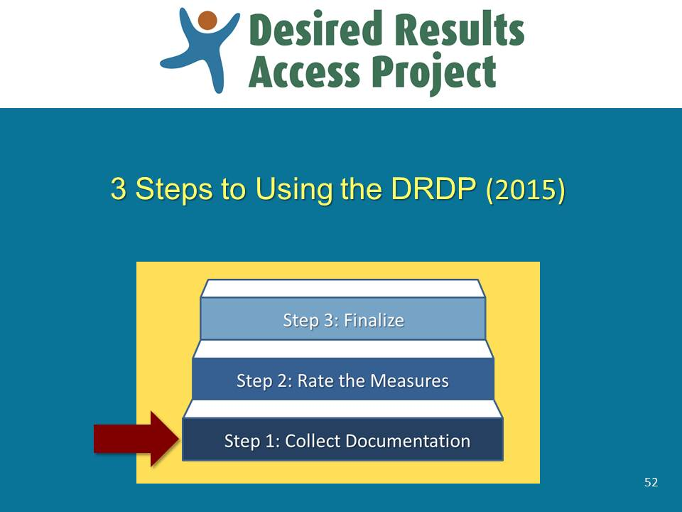 | Slide 52: Review the information on this slide and make these points:  - Now that we know how to navigate the instrument, we can explore how to use it.  - This slide lists the three steps to using the DRDP (2015). We’ll focus on the first step, collecting documentation in order to rate the measures on the DRDP (2015).
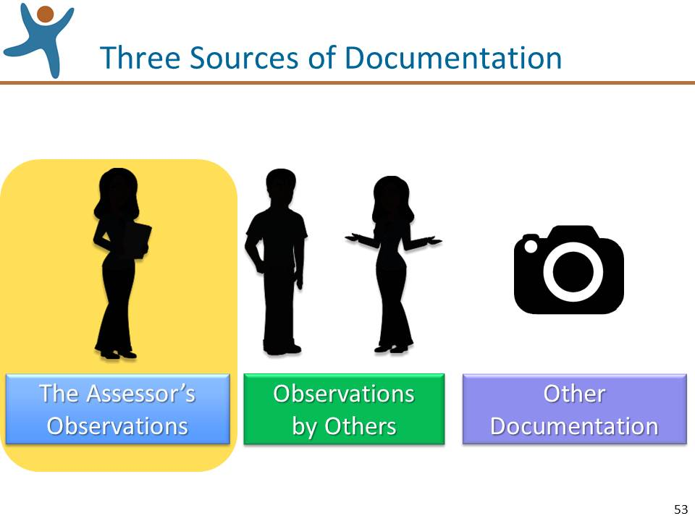 | Slide 53: Review the information on this slide and make these points:  - There are three primary sources of information that can be used to support rating a measure.  - Let’s begin with direct, naturalistic observation.
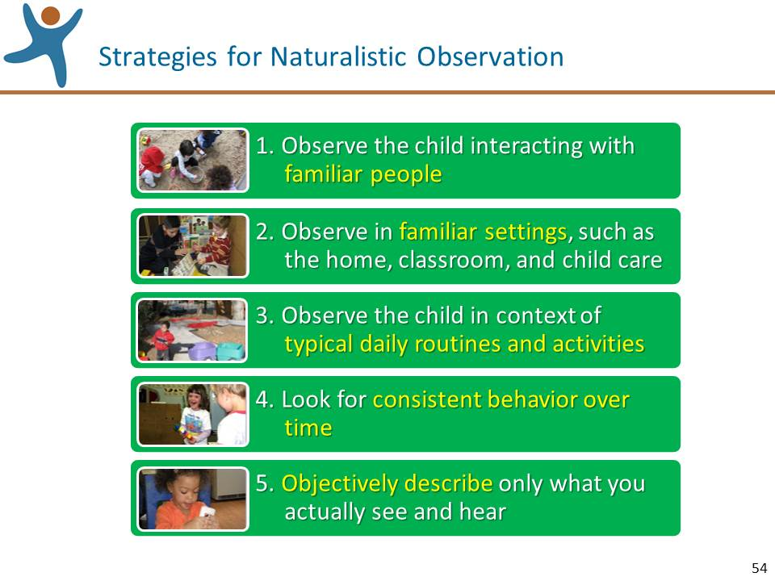 | Slide 54: Review the information on this slide and make these points:  - The DRDP (2015) is based on naturalistic observation and this slide lists 5 key strategies we should use when using naturalistic observation.  - Children demonstrate their best skills when operating from a secure base with familiar people they trust and in familiar places.  - Rather than test under artificial conditions, we should observe the child’s skills in natural settings, such as preschool classrooms, the child’s home, and child care settings.  - Typical daily routines and activities provide a meaningful context in which children can best demonstrate their skills.  - One observation may not give us a true picture of the child’s developmental levels. If a child is tired, under stress, or not feeling well during one observation, the results may not accurately reflect the child’s best skills. We are looking for mastery, which by definition is consistent behavior over time.  MUTE THE PROJECTOR AND LEAD THE FOLLOWING EXERCISE (Keeping the projector muted).  Mute the projector  - Tell the group that you’re going to lead a brief, fun exercise.  - Ask the participants to stand up and find one partner.  - Once they locate a partner, ask them to stand face to face and observe their partner for 30 seconds.  - After 30 seconds, ask them to turn back to back with their partner and “re-arrange” or change five things about themselves.  - After the “change-over” ask them to face their partner and identify the five changes that their partner had made.  - Debrief the activity by asking questions such as:  - Who found all five changes? Four of them? Three of them? (Ask these playfully – not to shame!)  - What lessons can we learn from this little exercise about making accurate observations?  - Summarize the activity.  Observations are more accurate when we:  - Take note of specific details;  - Know the person we are observing;  - Make observations over time;  - Apply our full attention and focus; and  - Give sufficient time to the observation.  With the projector still muted, ask the participants to find a piece of blank paper.  Tell them that you will show them a photo of three children and that they should work by themselves to write down their observations of the child in the middle.
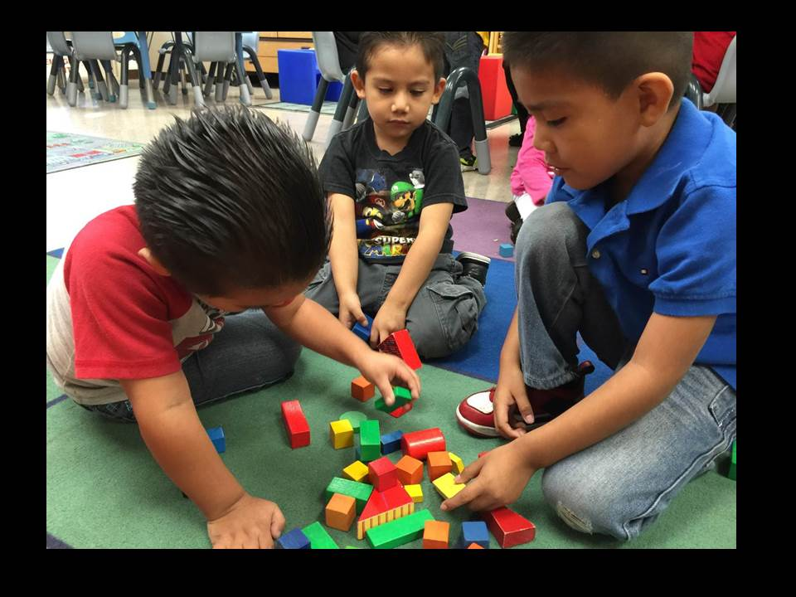 | Slide 55: Review the information on this slide and make these points:  - When they’ve finished writing, ask everyone to find a partner and trade papers.

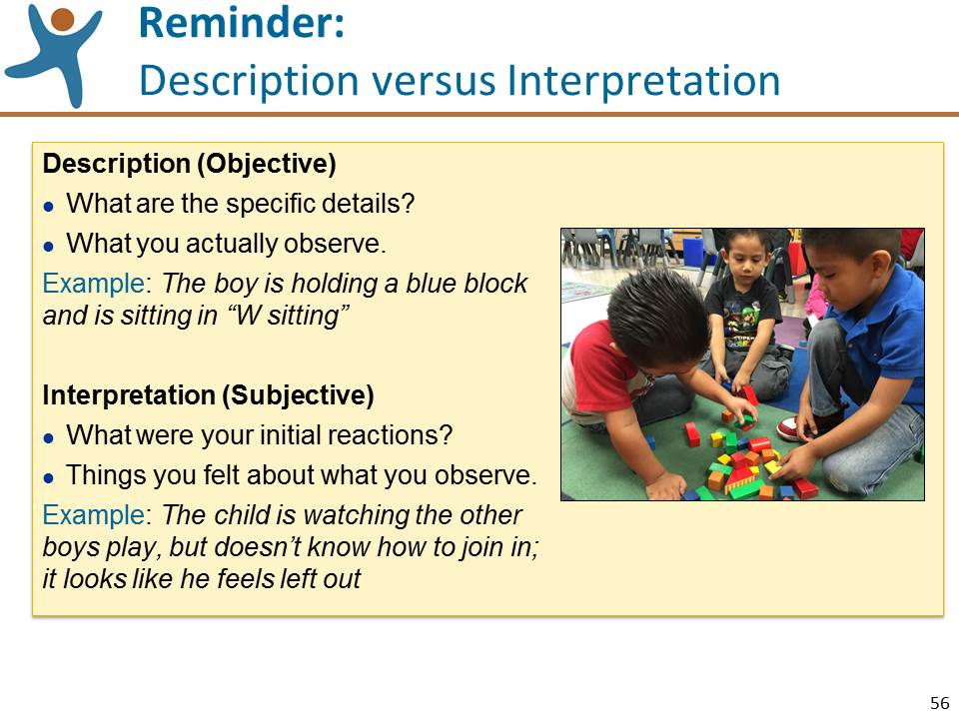 | Slide 56: Review the information on this slide and make these points:  - Ask the participants to label each of their partner’s observations with a “D” for the observations they consider being descriptive or “I” for the observations they consider to be interpretative.  - Remind the participants that the purpose of this activity is to become more aware of and refine our observation skills, not to judge anyone’s observations as inaccurate or inappropriate.  - Once they are finished labeling, ask the group for examples of observations that they labeled as descriptive then ask the large group for examples of notes that they labeled as interpretive.  - Lead a discussion about description versus interpretation. (Note: it may be useful to flip back to the photo on slide 55). If the following points are not made by the participants, bring them up:  - We often sense things so quickly that we initially interpret what we see.  - Good observation skills include the need for remaining objective and being specific, direct, and complete.
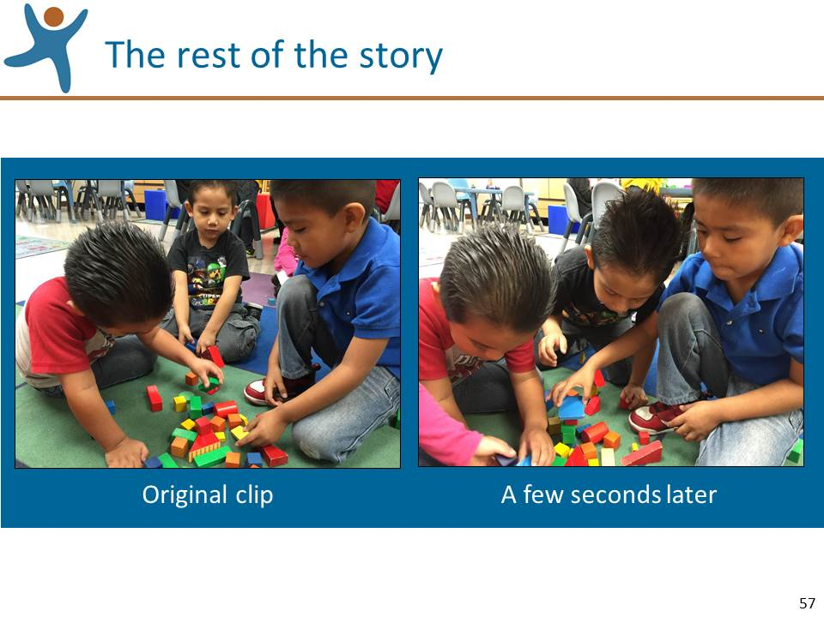 | Slide 57: Review the information on this slide and make these points:  - The photo on the left is the original photo that you observed. We do not have enough information to objectively know what the look on the child’s face might mean when the second the photo was taken, so we should avoid making interpretations such as the child was sad, or felt left out.  - The photo on the right was taken just moments later, and as we see, the child was fully engaged in play with the other boys. According to the photographer who took both photos, in the first photo the boy in the middle took a break from actively building with the blocks to observe the other boys for a few seconds and then he resumed playing.
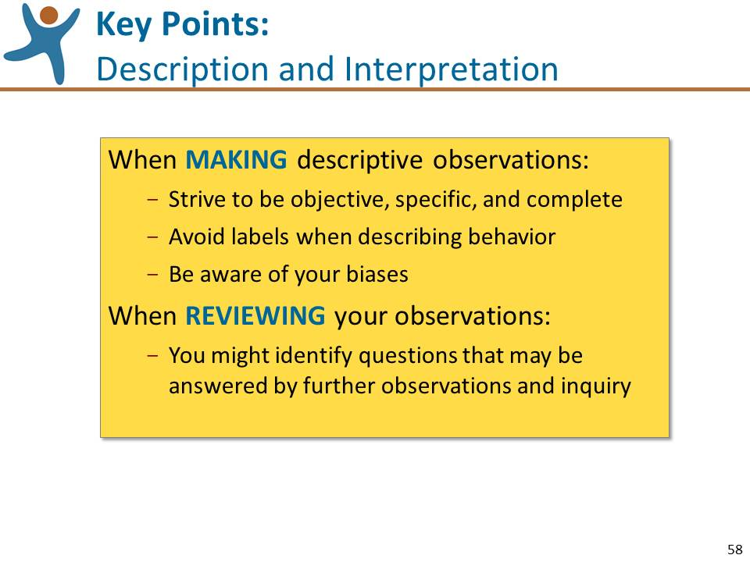 | Slide 58: Review the information on this slide and make these points:  - In order to keep our ratings of the DRDP (2015) objective, we should describe what we actually see and hear rather than what we infer or guess about what we observe.
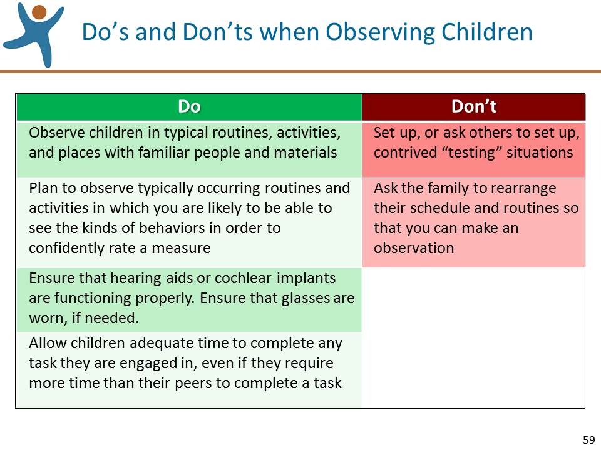 | Slide 59: Review the information on this slide and make these points:  - Before we move on to the next source of documentation, let’s take a moment to read through these do's and don'ts to keep in mind when observing children.
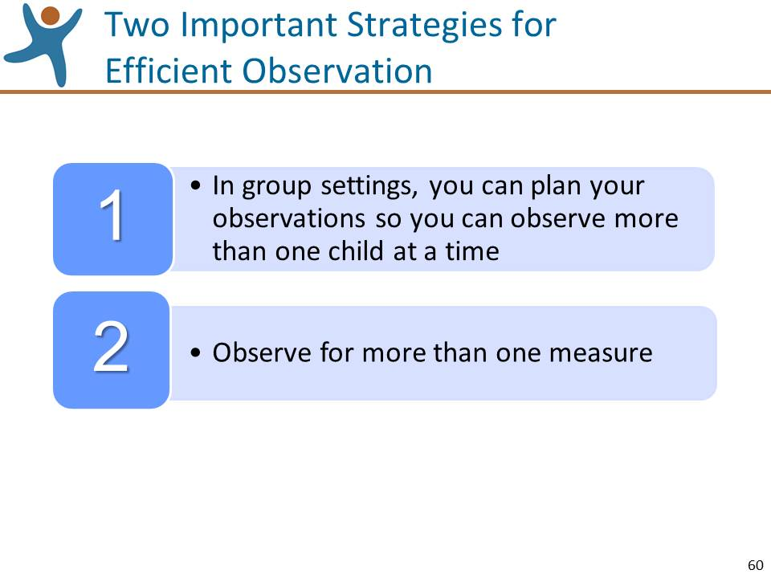 | Slide 60: Review the information on this slide and make these points:  - As you review the measures of the DRDP (2015), consider particular routines or activities during the day in group settings where you would be able to observe more than one child for a particular measure.  - Once you become familiar with the instrument, you will note how easily you may observe for more than one measure.
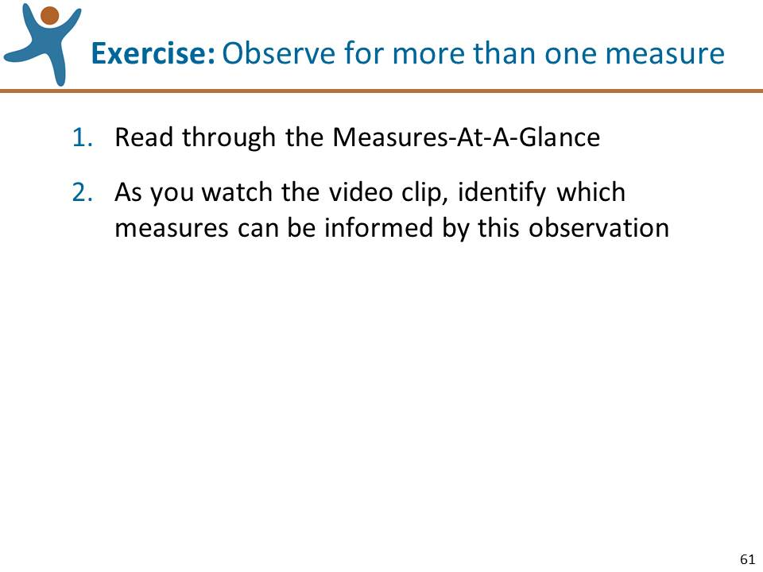 | Slide 61: Lead this exercise:  IMPORTANT NOTE: You can lead this activity using either a toddler or a preschooler as an example. If you want to focus on a toddler, use the video clip of Harper Playing on the Floor, the Infant/Toddler View, and slide 62; if you want to focus on a preschooler, use the clip of Aundon at Breakfast, the Preschool Fundamental View, and slide 63. NOTE: you may wish to move the slide that you won’t be showing to the end of the PPT slides.  - Tell the participants: Open your manuals to the Measures At-a-Glance Page (either the Infant/Toddler or Preschool Fundamental Views as indicated by the clip you will show) and briefly read through the names of all of the measures to familiarize yourselves with the scope of the instrument.  - After a minute or so, tell the participants to find a sheet of blank paper.  - Tell the participants: I’m going to show you a video clip of [Harper or Aundon]. As you watch, jot down the abbreviations for all of those measures that you think might this observation might help you rate.  - Show the video of either Harper or Aundon.  - When the video ends, tell the participants: Take a look at the Measures At-a-Glance Page again and add any measures that you might have missed.  - After a minute, tell the participants: Please share the measures that you think might be informed by what you observed.  - NOTE: If the participants share measure abbreviations, you may want to give the full name of the measure so everyone will know how it relates to the clip.
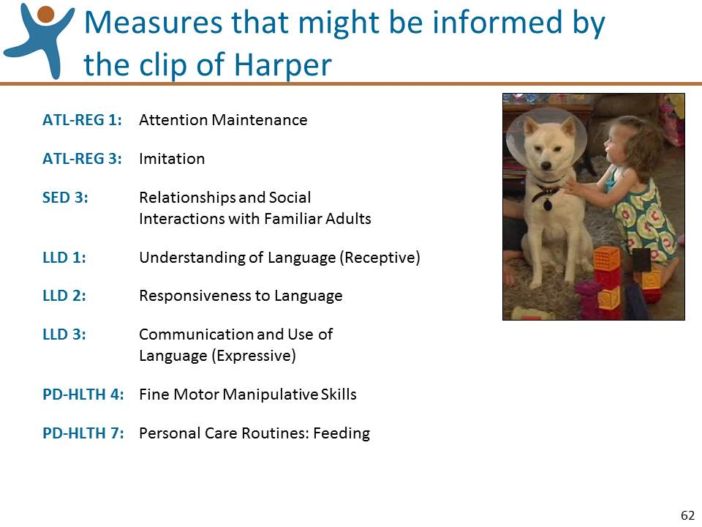 | Slide 62: Use this slide if you showed the video of Harper. Review the information on this slide and make these points:  - We looked through the DRDP (2015) and identified the measures on this slide. The ratings on these measures could be informed by the observations from the video clip.  - Remember: although observations of Harper in this clip could partially inform a rating, in actual practice, ratings must be based on multiple observations over time and across multiple settings.
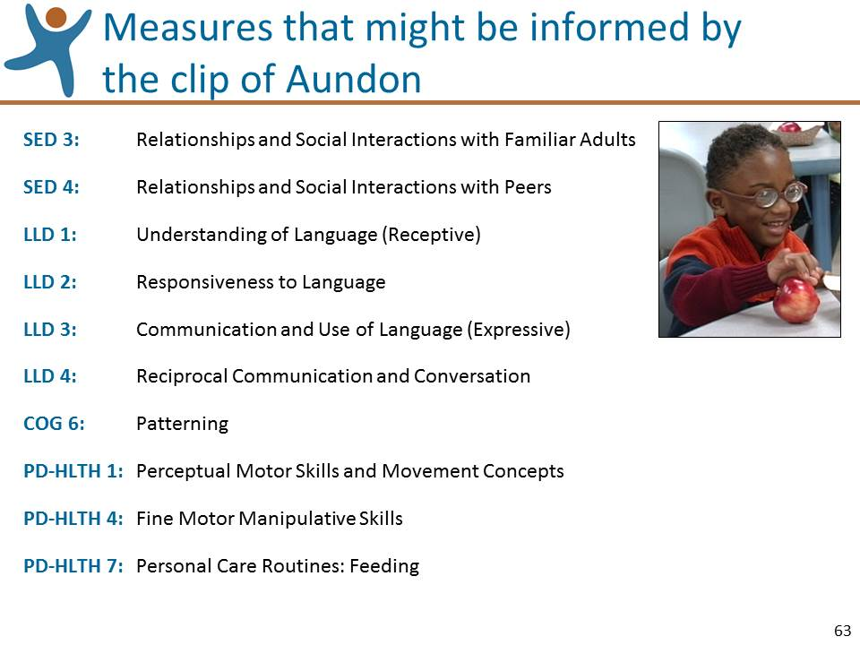 | Slide 63: Use this slide if you showed the video of Aundon. Review the information on this slide and make these points:  - We looked through the DRDP (2015) and identified the measures on this slide. The ratings on these measures could be informed by the observations from the video clip.  - Remember: although observations of Aundon in this clip could partially inform a rating, in actual practice, ratings must be based on multiple observations over time and across multiple settings.
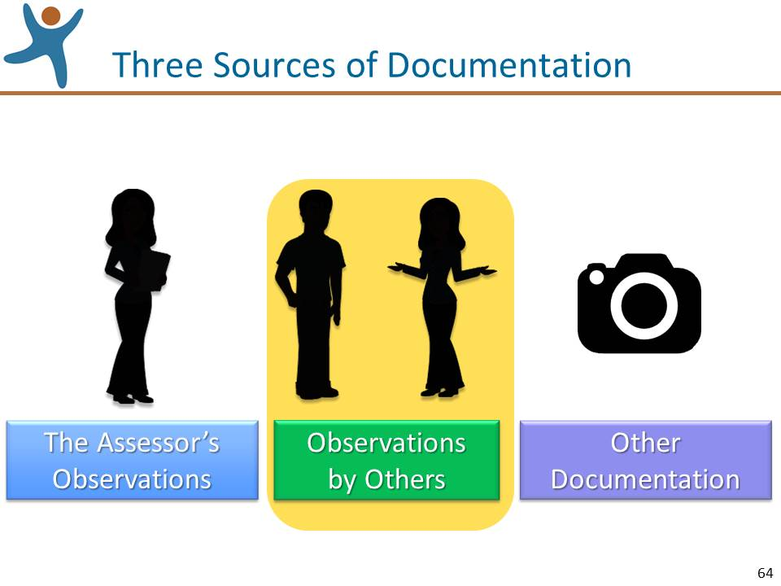 | Slide 64: Review the information on this slide and make these points:  - Let’s review the second primary source of information, the conversations where we can learn about what others who know the child well have observed.
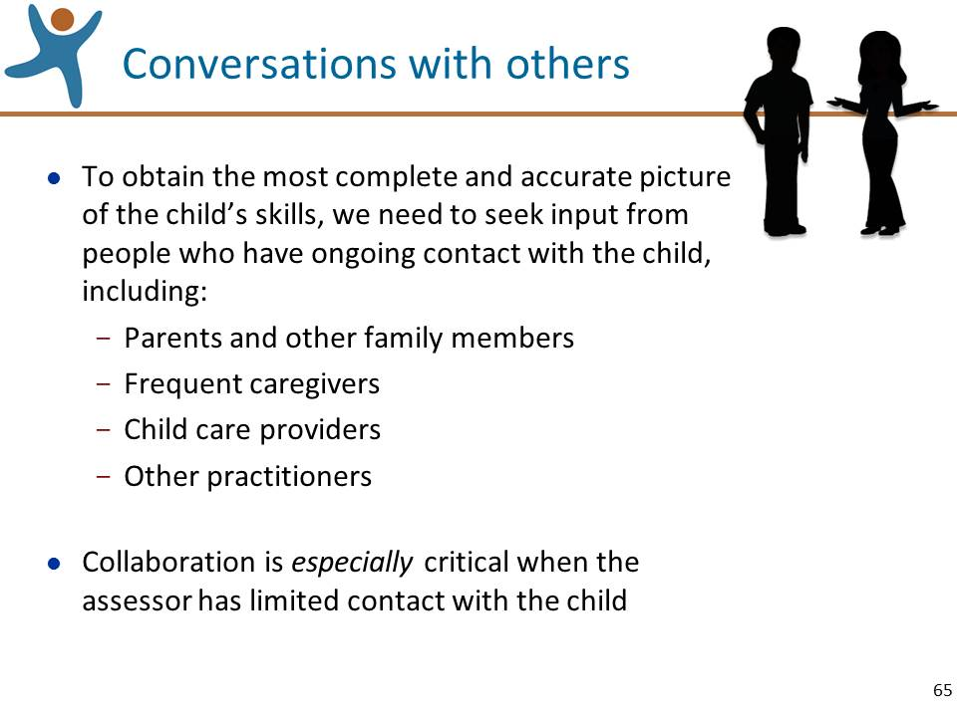 | Slide 65: Review the information on this slide and make these points:  - Keep in mind: Observations from parents are a valid and reliable source of information. Read: The Role of Family Observations in the DRDP (2015) Assessment at www.draccess.org
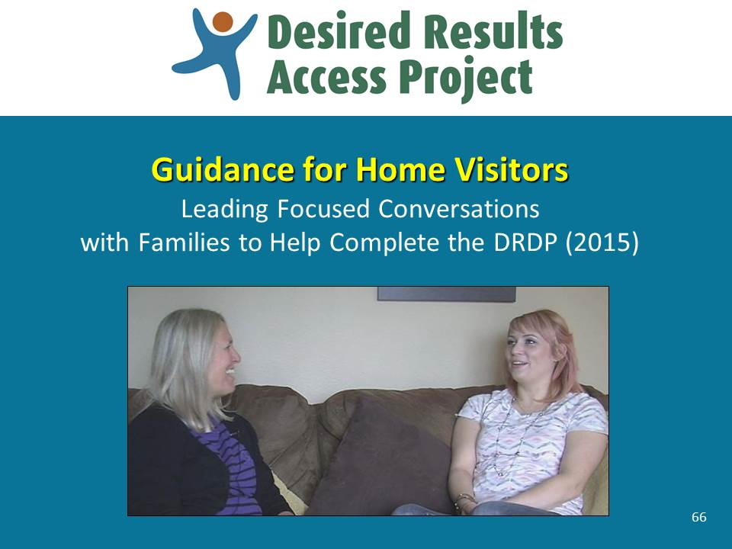 | Slide 66: Review the information on this slide and make these points:  - A new set of materials has been produced to assist home visitors with leading conversations with families.
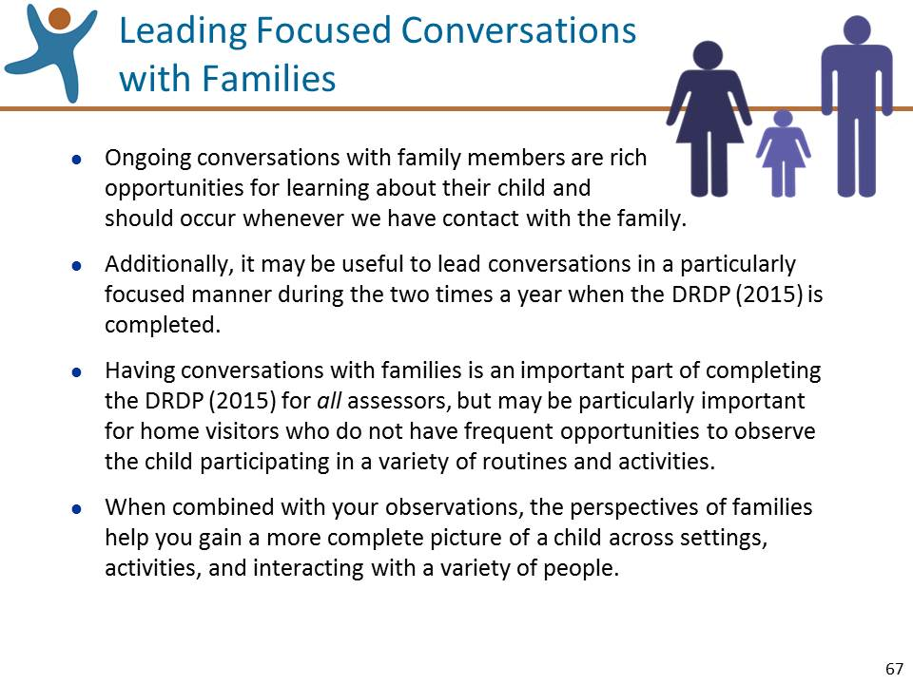 | Slide 67: Review the information on this slide and make these points:  - On the draccess.org site is a set of materials that will help assessors lead conversations with families.
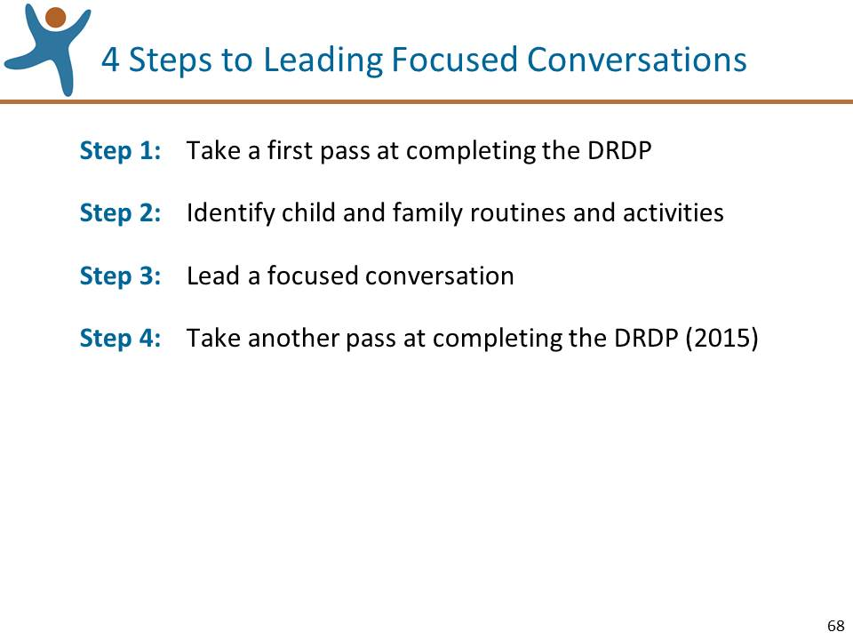 | Slide 68: Review the information on this slide and make these points:  - One document you’ll find at draccess.org is titled “Leading Focused Conversations with Families to Help Complete the DRDP (2015).” This handout describes in detail how to use these 4 steps.
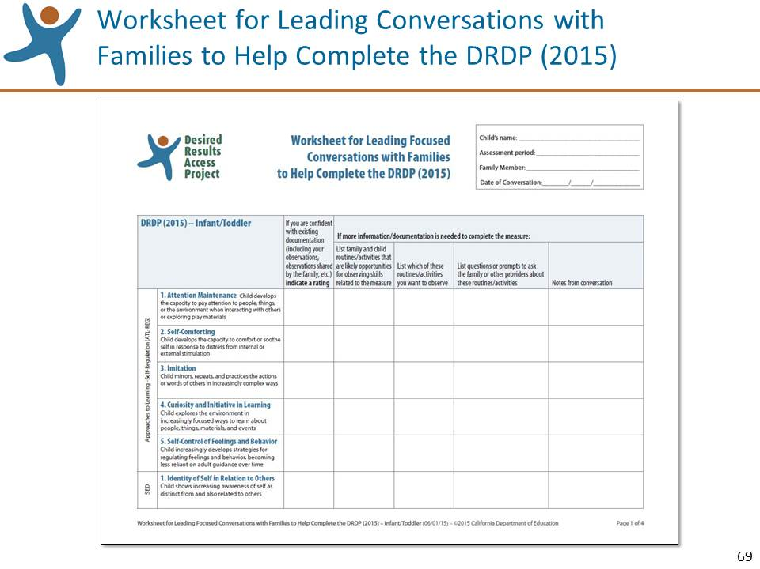 | Slide 69: Review the information on this slide and make these points:  - The “Worksheet for Leading Focused Conversations with Families to Help Complete the DRDP (2015)” can help you organize your thoughts and your notes as you use this 4 step process.
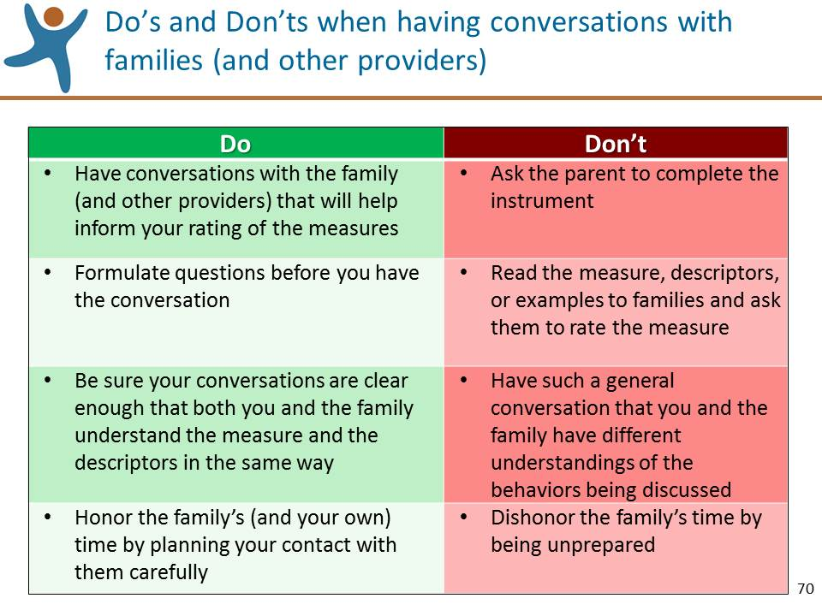 | Slide 70: Review the information on this slide and make these points:  - These Do’s and Don’ts apply to the observation and assessment of children with and without disabilities.
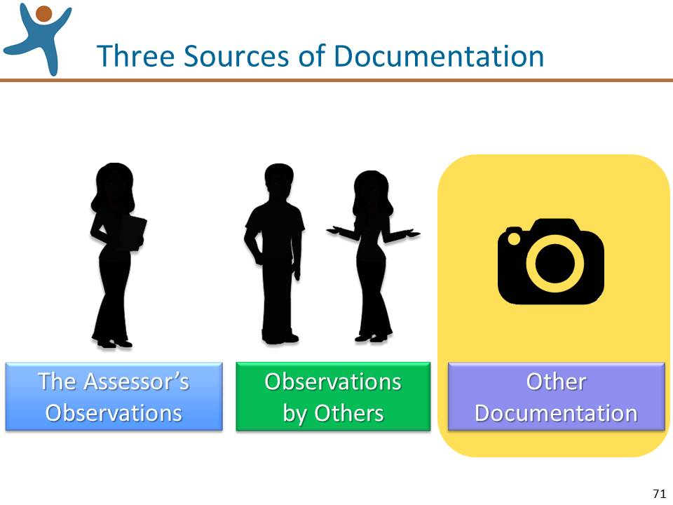 | Slide 71: Review the information on this slide and make these points:  - Let’s review the third primary source of information, other documentation.
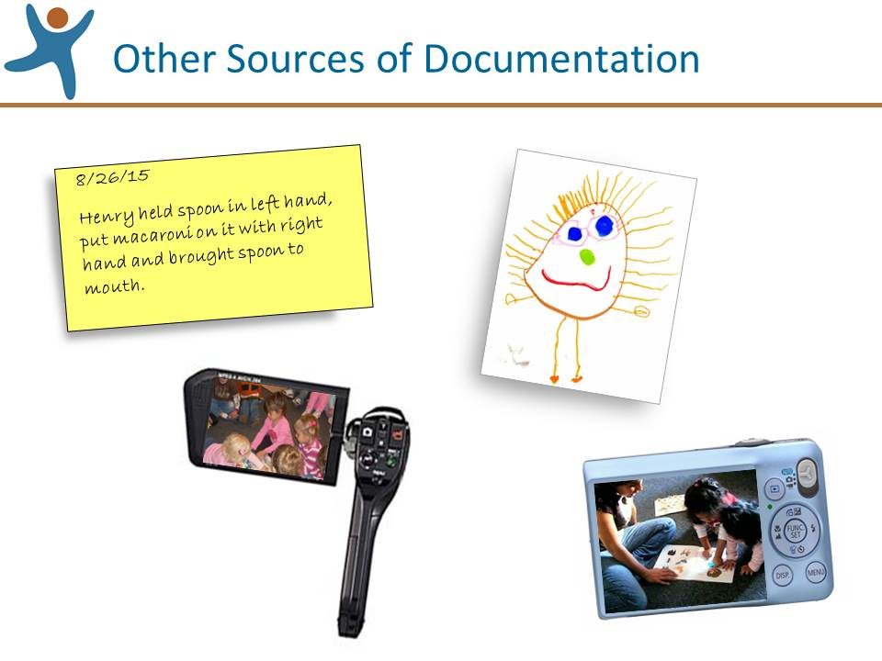 | Slide 72: Review the information on this slide and make these points:  - Observations can’t do us much good unless we can remember them. Fortunately, there are several ways to capture them. For instance, we can write a brief note, collect a sample of children’s work, take a picture, or video record our observations.  - These documentation strategies are described in the Appendices to the Assessment Manual.  - No documentation method works best for everyone, so be sure to use the ones that work for you.
Mute the projector | Mute the Projector:  Ask for questions specifically about collecting documentation and answer them. If questions are asked that will be addressed in upcoming sections of the workshop, acknowledge that the question will be addressed shortly.

Step 2: Rate the Measures (15 minutes)
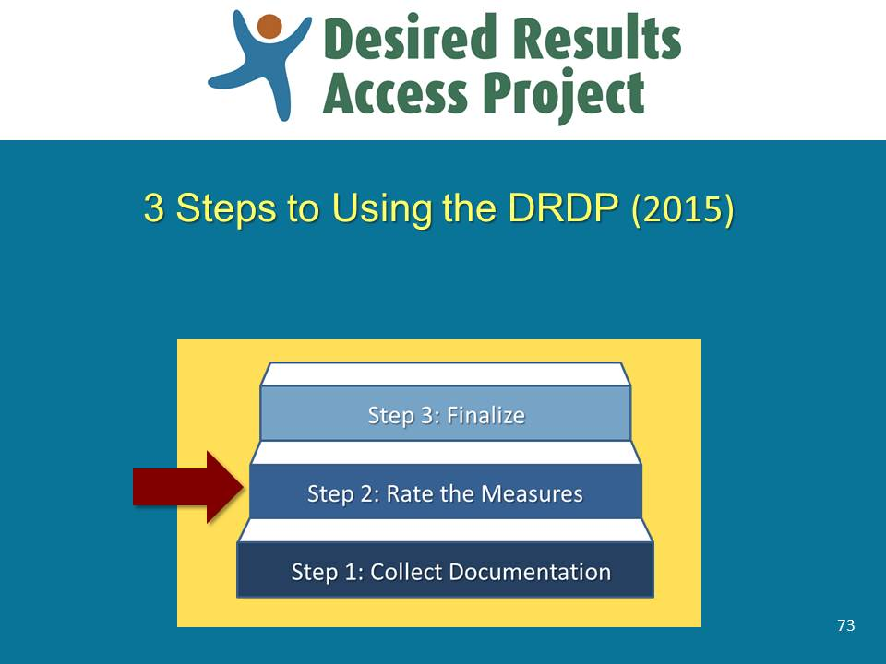 | Slide 73: Review the information on this slide and make these points:  - In this next section we’ll review the second step in using the instrument, rating the measures.  - The process that we’ll review for rating the measures is also described in the Manual.
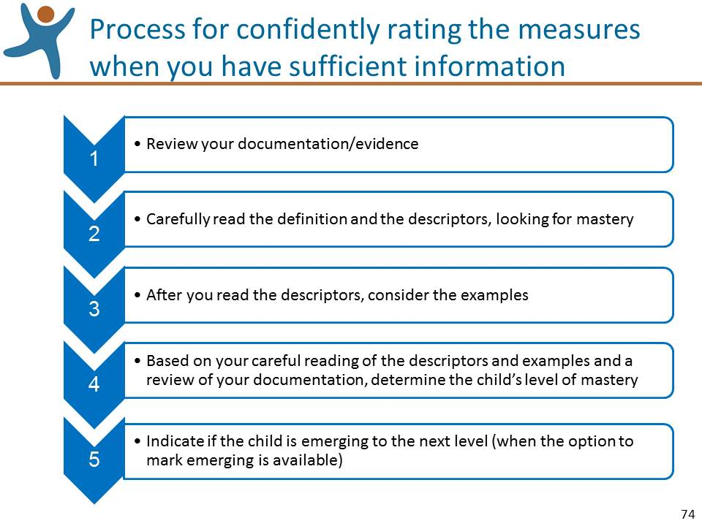 | Slide 74: Review the information on this slide and make these points:  - Assuming that you do have sufficient documentation to rate a measure, these are the steps for rating.
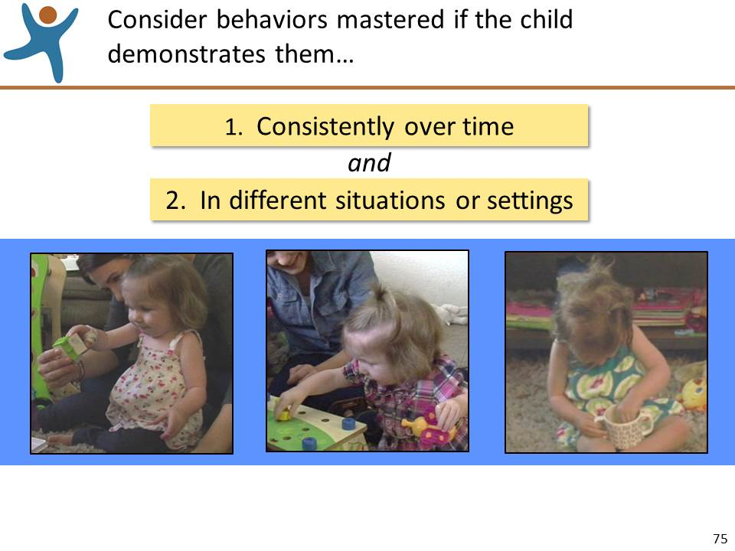 | Slide 75: Review the information on this slide and make these points:  - Mastery indicates that the child typically demonstrates the behaviors indicated by a descriptor consistently over time and in different situations and settings.  - On this slide, we see Harper at different times and activities demonstrating skills related to PD-HLTH 4: Fine Motor Manipulative Skills. In all three photos she uses her right hand to grasp and manipulate objects and in one photo she manipulates an object using both hands doing different movements.
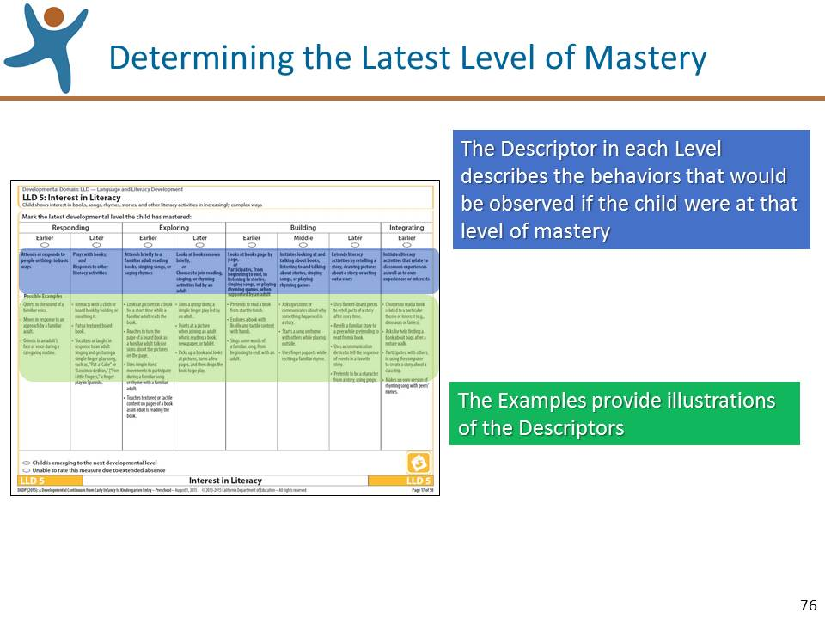 | Slide 76: Review the information on this slide and make these points:  - Keeping the two criteria for mastery in mind, determining the child's highest level of mastery on a measure should be a straightforward process.  - In determining the level of mastery we are assessing the child’s behaviors relative to the descriptor.  - The examples provide illustrations of each descriptor. Examples are useful, but you should not assess the examples. The examples are intended to help the assessor by illustrating the descriptors. Many of the behaviors that you observe that you consider indicative of mastery may not be included as examples.  - As you review the descriptors, carefully consider what you know about the child. As you reflect on your observations and other documentation that you've gathered, choose the descriptor that best depicts the child's highest level of mastery.  - You do not need to observe everything below the level of mastery.
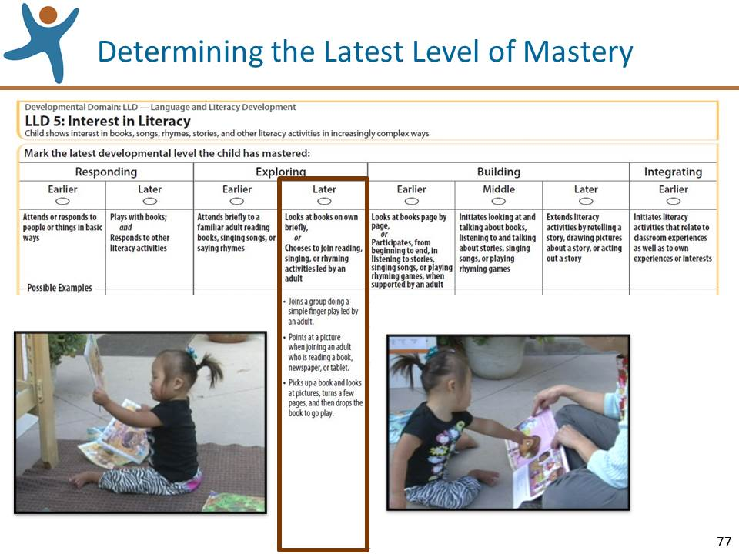 | Slide 77: Review the information on this slide and make these points:  - This slide illustrates how two pieces of photographic documentation taken during observations illustrate the Exploring Later descriptor for LLD 5: Interest in Literacy.  - On this slide, we see two photos of Morgan that illustrate the examples given for Exploring Later on LLD 5. However, in general, keep in mind that while the observations may fit the descriptor, you may not actually observe any or all of the examples given.
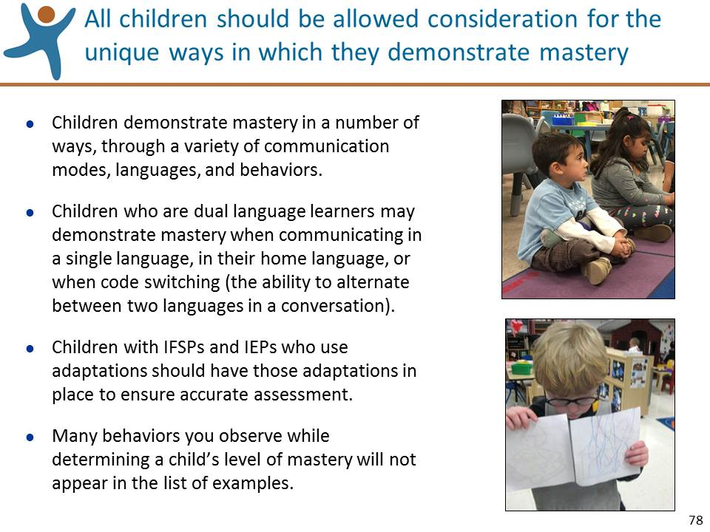 | Slide 78: Review the information on this slide and make these points:  - The top photo illustrates a child using a sensory roll as he attends to his teacher during circle time.  - The bottom photo illustrates a child who wears his glasses every day, and therefore, must be wearing them when we observe the child to inform our rating of the DRDP (2015).
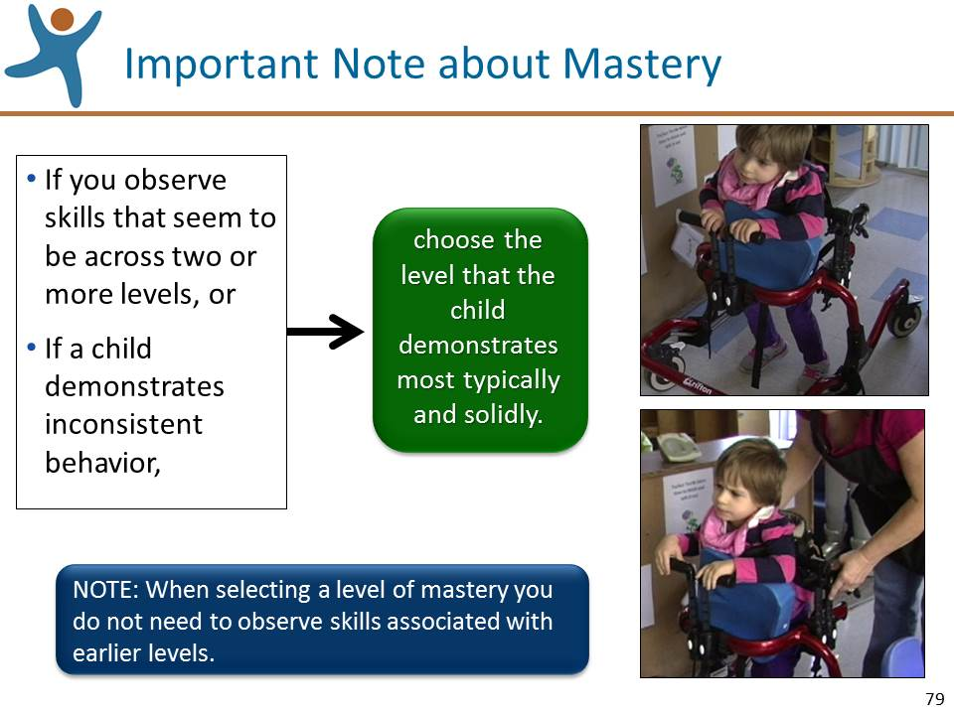 | Slide 79: Review the information on this slide and make these points:  - This guidance applies to rating a measure when mastery is less clear.  - The photos on this slide show that sometimes Miriam walks independently with her walker and other times with adult assistance. The teachers in the classroom, who know her well, will know which behavior Miriam most consistently demonstrates.
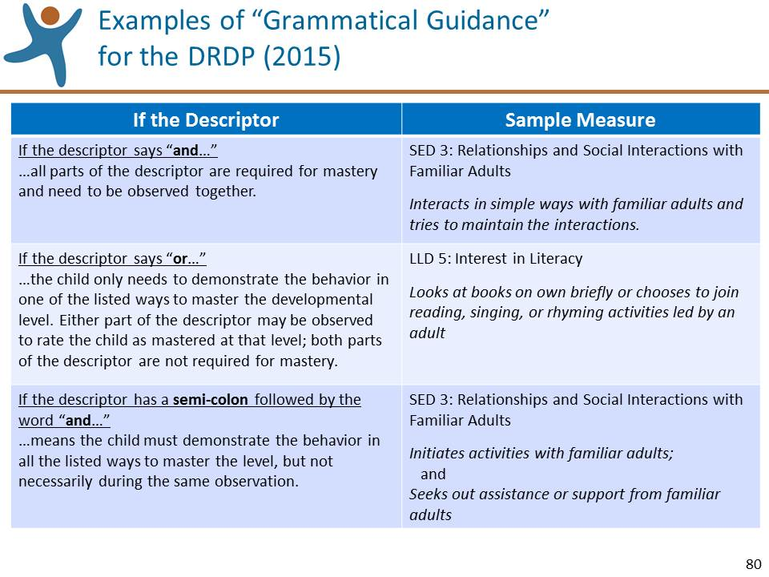 | Slide 80: Review the information on this slide and make these points:  - Most of the descriptors in a measure define discrete knowledge, skills, or behaviors. However, some descriptors include more than one behavior or skill, separated by “and,’ “or,” or a semicolon (;) followed by “and”.  - If the descriptor says “and,” all parts of the descriptor are required for mastery and need to be observed together.  - If the descriptor says “or,” either part of the descriptor may be observed.  - If the descriptor has a semi-colon followed by “and” the child must demonstrate the behavior in all the listed ways to master the level, but not necessarily during the same observation.  - This information appears in the introduction of the Manual.  - NOTE TO TRAINER: You may want to humorously let the participants know that you empathize with them having to learn and remember so many grammatical rules and at the same time highlight the importance of these rules. You can offer the example of “Let’s eat Grandma” vs. “Let’s eat, Grandma.”
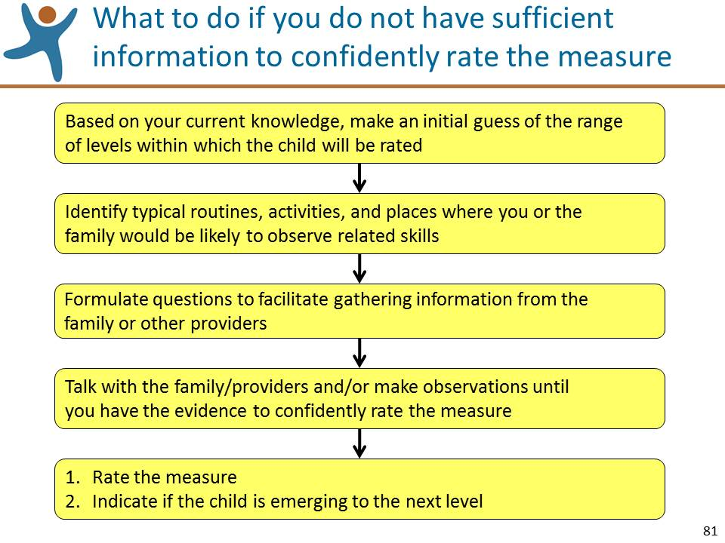 | Slide 81: Review the information on this slide and make these points:  - We just reviewed the rating process for when you have enough information to confidently rate a measure.  - This slide illustrates a process that you can use when you do not have sufficient information to confidently rate a measure.
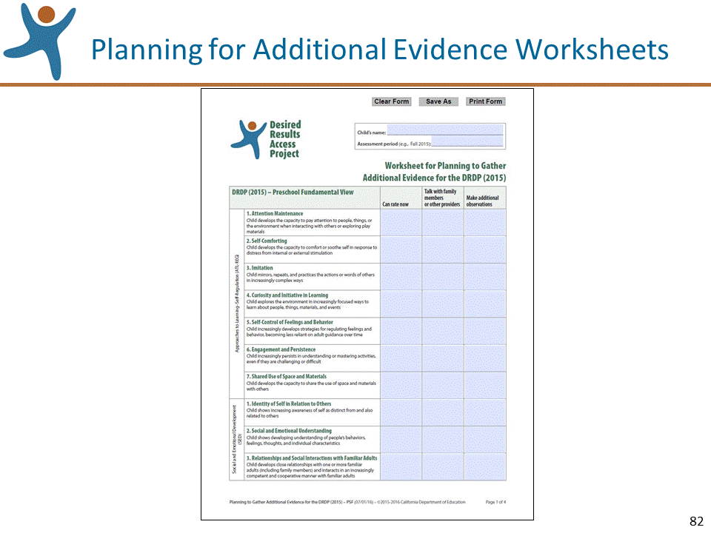 | Slide 82: Review the information on this slide and make these points:  - You should know about a very useful tool, the “Planning for Additional Evidence Worksheet,” available at draccess.org.  - This tool can help you keep track of and organize which measures you can confidently rate with your existing documentation, and which measures will need additional documentation.  - There are two versions of the worksheet, one for the Infant/Toddler View and one for the Preschool Fundamental View.
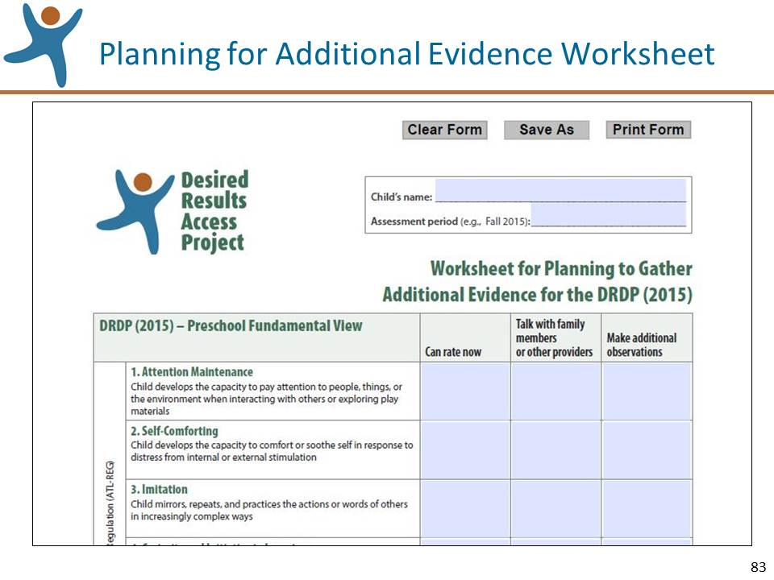 | Slide 83: Review the information on this slide and make these points:  - This slide shows a close-up of the Preschool Fundamental View of the “Planning for Additional Evidence Worksheet.”  - When you sit down to rate the measures, keep this worksheet handy along with all of your documentation, the Rating Record, and the Manual.  - As you rate each measure, review the relevant documentation. If you can confidently rate the measure indicate the rating in the “Can rate now” column or if you prefer, directly on the Rating Record. If you find that you need additional information to confidently rate the measure, jot down conversations you might want to have with others, or what additional observations you want to make.
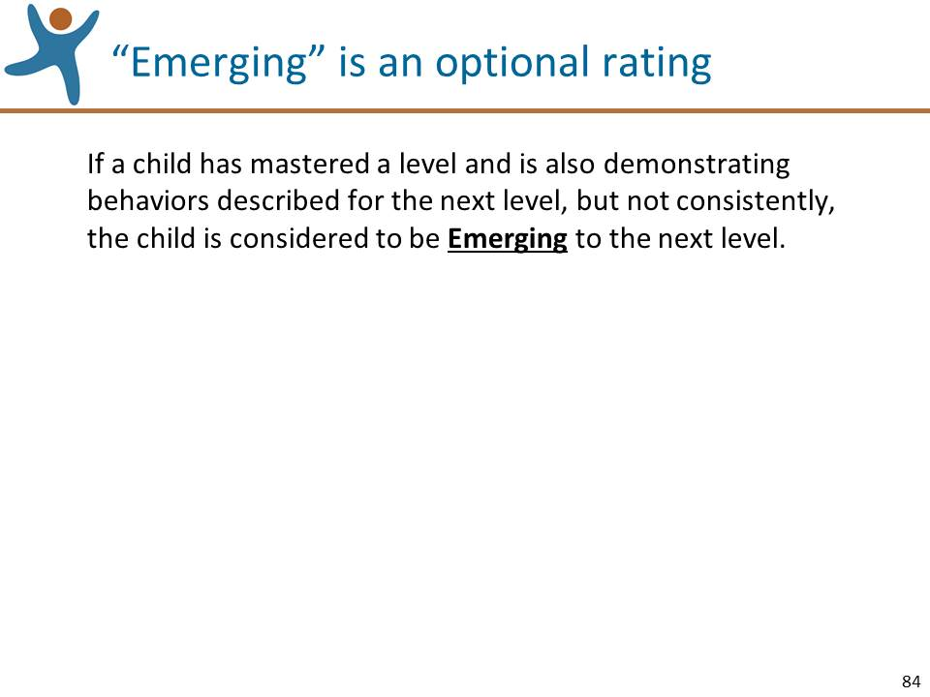 | Slide 84: Review the information on this slide and make these points:  - Emerging indicates that the child is at a certain level of mastery and is also demonstrating behaviors described for the next level, although not yet easily or consistently across settings.
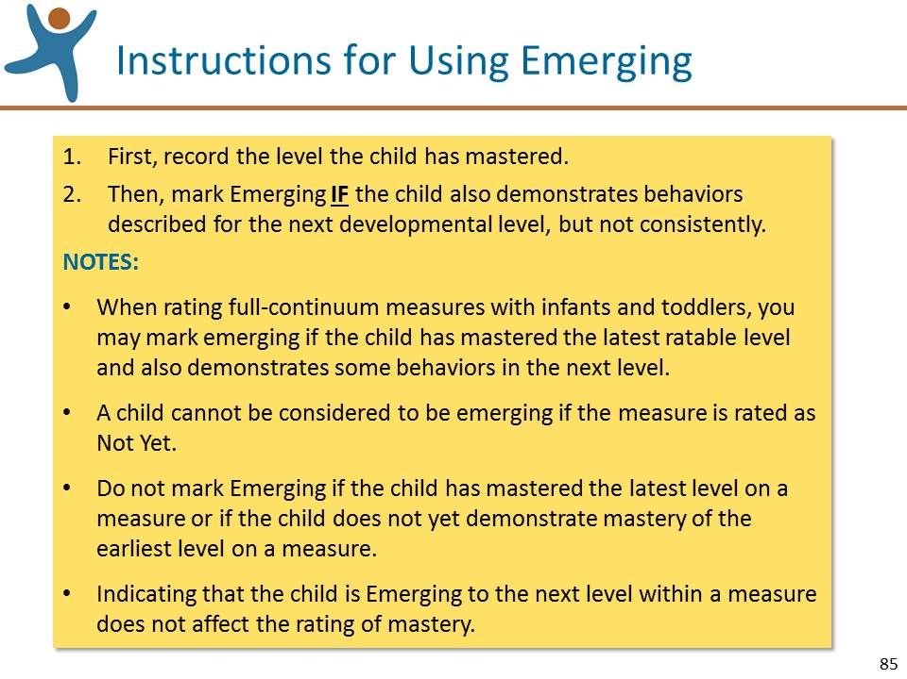 | Slide 85: Review the information on this slide and make these points:  - There is value in documenting observations of emerging behaviors. Not only will this be helpful in monitoring the child’s progress, but this information will be useful in conversations with families and others.
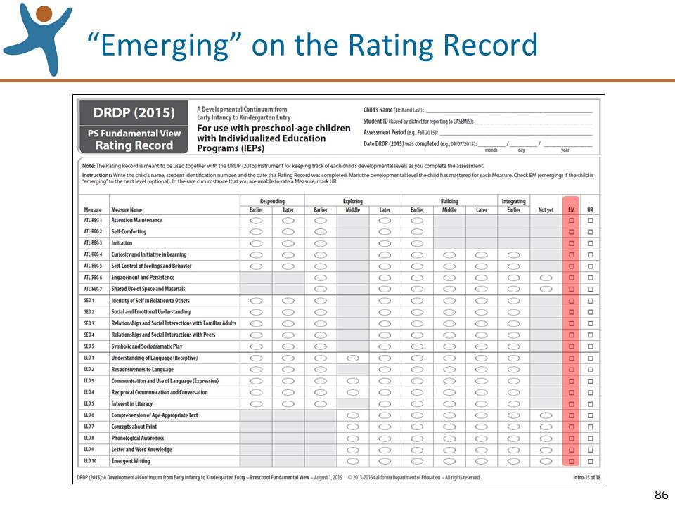 | Slide 86: Review the information on this slide and make these points:  - This slide illustrates where Emerging is indicated on the rating Record.
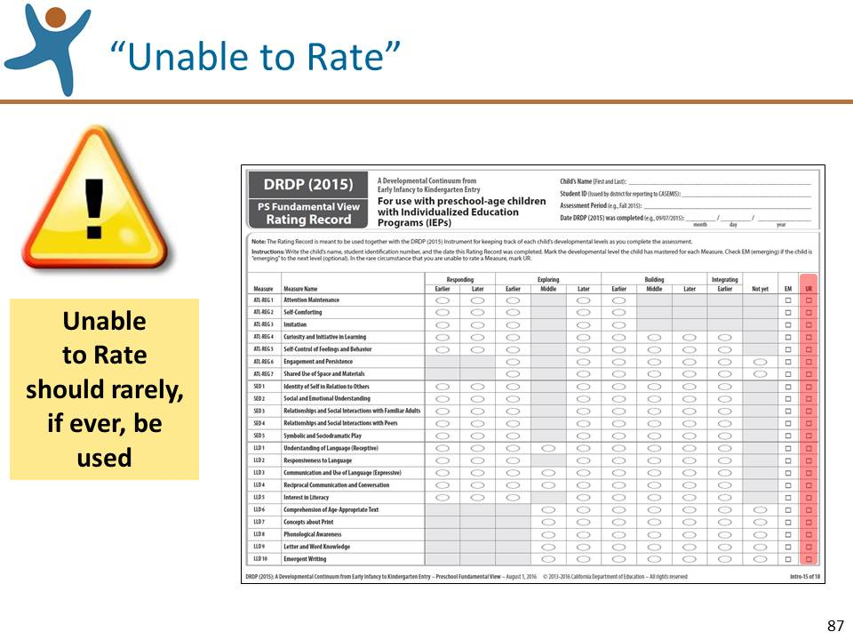 | Slide 87: Review the information on this slide and make these points:  - This slide illustrates where Unable to Rate is indicated on the Rating Record.
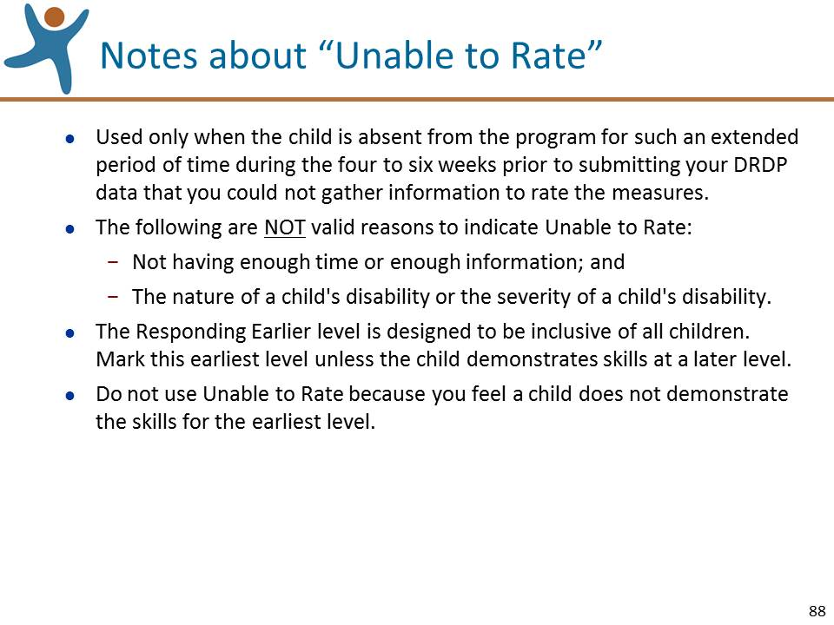 | Slide 88: Review the information on this slide and make these points:  - Note this new guidance about Responding Earlier.  - This earliest level is designed to include all children.  - If you cannot rate the measure at any higher level, mark Responding Earlier.  - Do not mark Unable to Rate, and do not leave the rating blank.
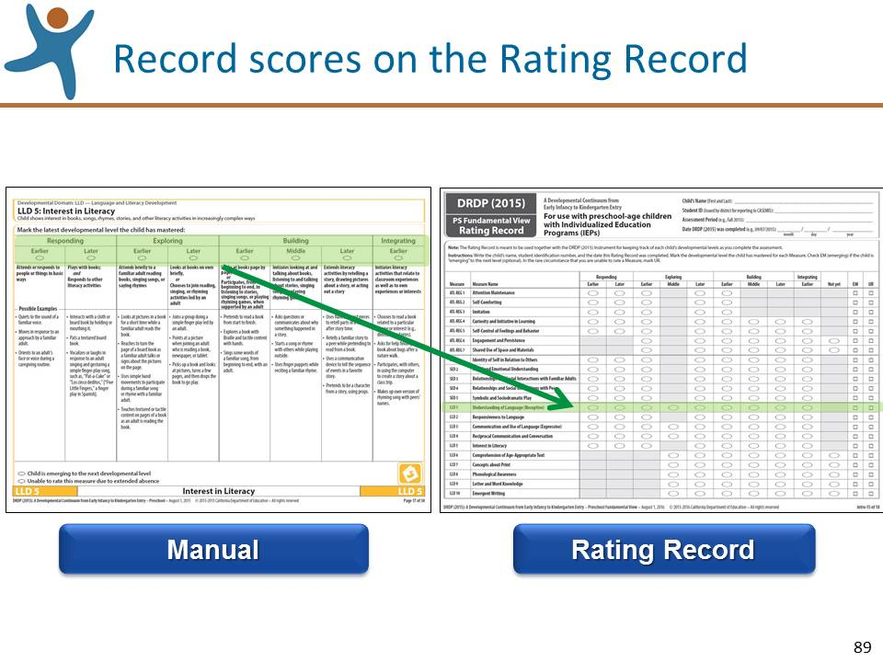 | Slide 89: Review the information on this slide and make these points:  - This slide illustrates on the Preschool Fundamental View Rating Record for Preschool Children with IEPs where you indicate your scores and serves as a reminder that no matter where you record your scores during the rating process, ultimately they will need to be transferred to the Rating Record.
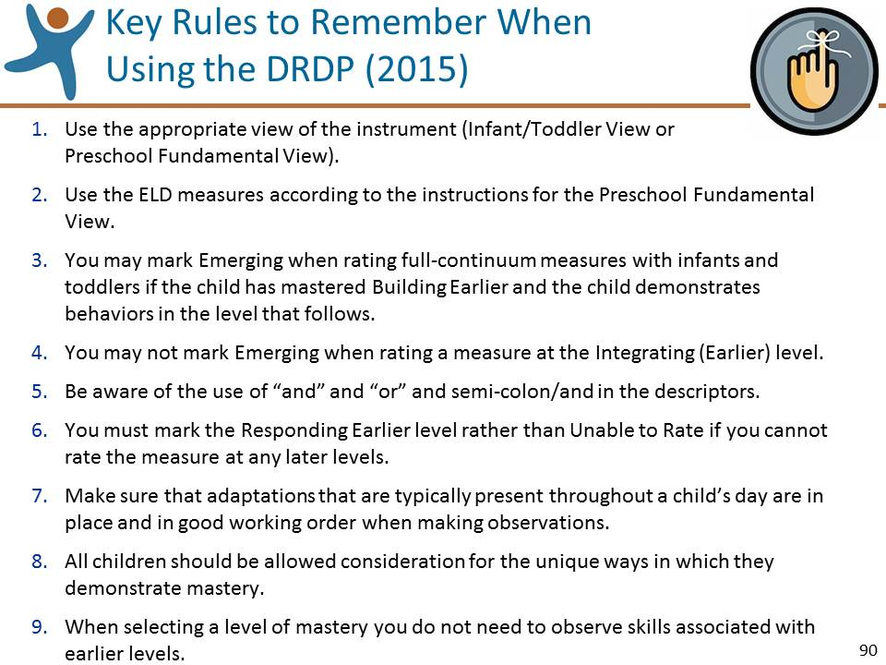 | Slide 90: Review the information on this slide and make these points:  - There is a handout in your packet of materials titled Key Rules to Remember When Using the DRDP (2015). Please keep it handy and follow along as we review these points.  - You will find all of this information in various sections in the Manual’s opening pages, but we’ve summarized it here to keep it all in one central place to help you remember.
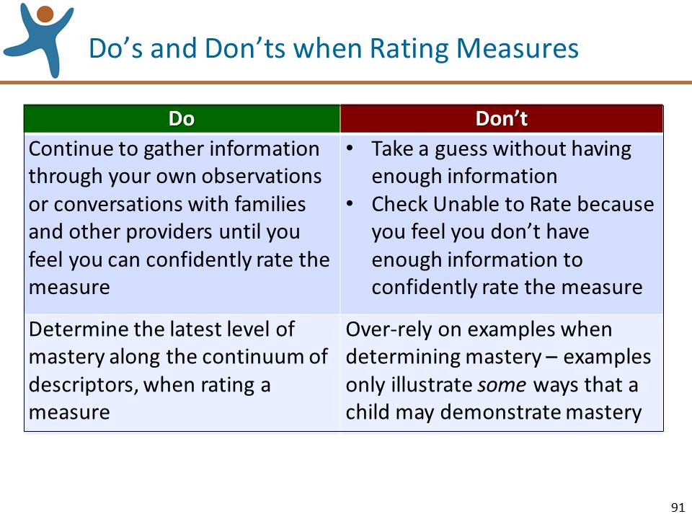 | Slide 91: Review the information on this slide and make these points:  - Before we move on to the next topic, let’s take a moment to read through these do's and don'ts to keep in mind when rating measures.

Rating Practice Exercise Parts 1 and 2 (30 minutes)
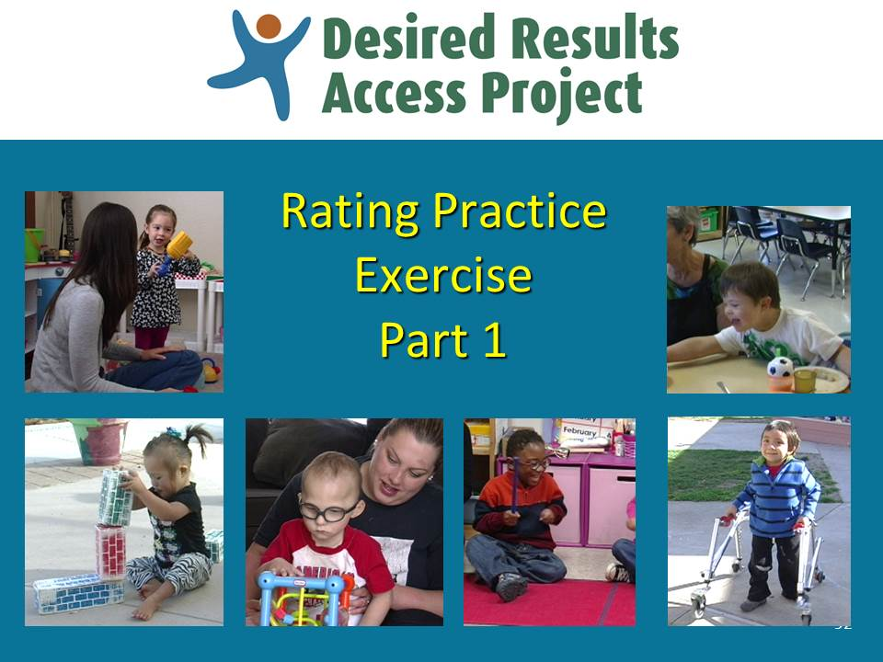 | Slide 92: Title slide for this activity  PREPARATION:  - You will need to select the child to focus on; you can lead Part 1 focusing on either a toddler (Lydia) or a preschooler (Said), depending on the interests of the training participants.  - To lead this activity, refer to the slides and instructions described in the “Procedures for Leading the Rating Practice Activities” in the last section of this guide.
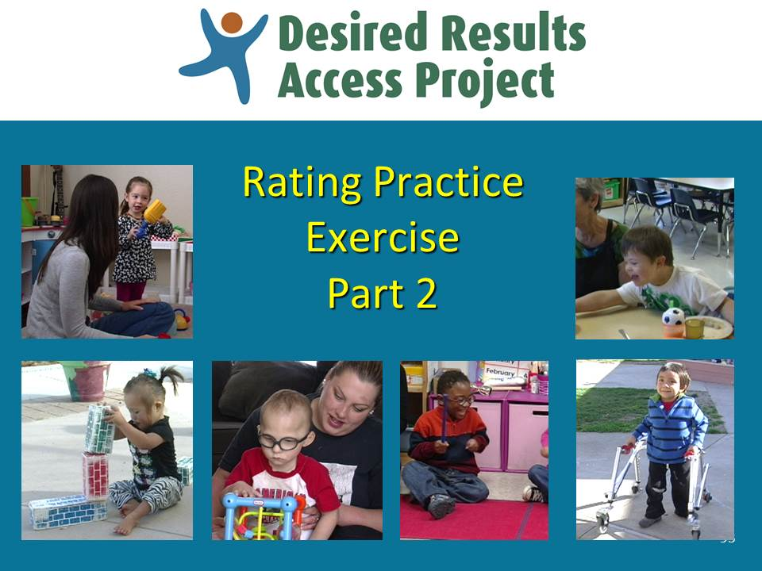 | Slide 93: Title slide for this activity  - As with Part 1, you will need to select the child to focus on; you can lead Part 2 focusing on either a toddler (Tylor) or a preschooler (Cody), depending on the interests of the training participants.  - To lead this activity, refer to the slides and instructions described in the “Procedures for Leading the Rating Practice Activities” in the last section of this guide.

Using Adaptations (15 minutes)
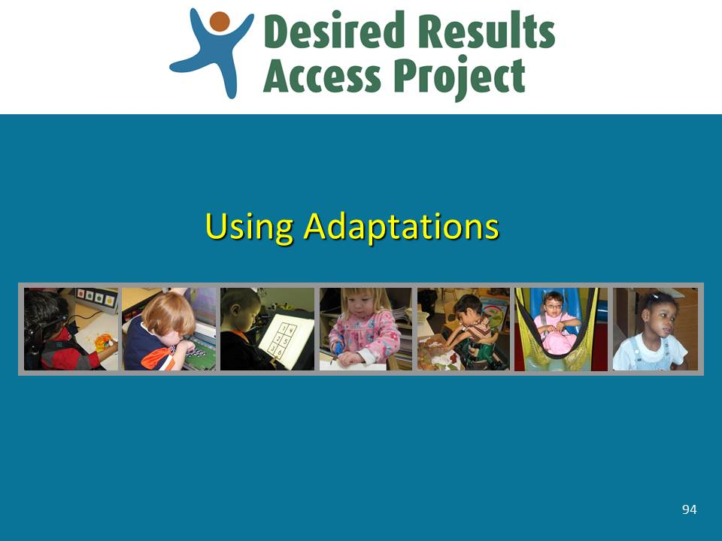 | Slide 94: Review the information on this slide and make these points:  - We’ll now explore the adaptations that are used with the DRDP (2015).  - The adaptations used in the DRDP (2015) are the same ones, used in the same way, as were used with the DRDP access.
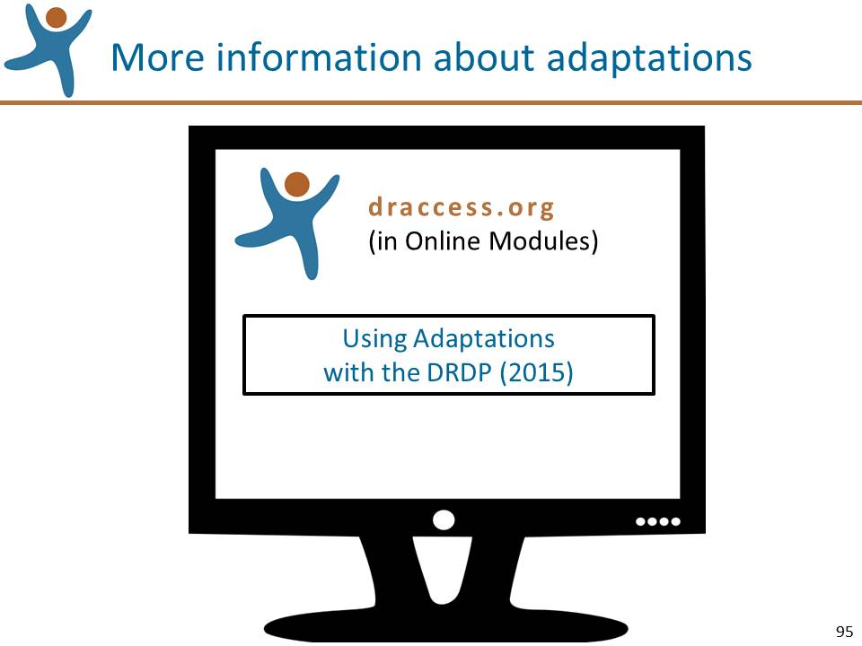 | Slide 95: Review the information on this slide and make these points:  - In this section, we’ll only briefly review the use of adaptations.  - Early this fall we will post an online module titled “Using Adaptations with the DRDP (2015)” that reviews the seven adaptations in greater detail and provides many illustrations and examples.  - This module will be available at www.draccess.org
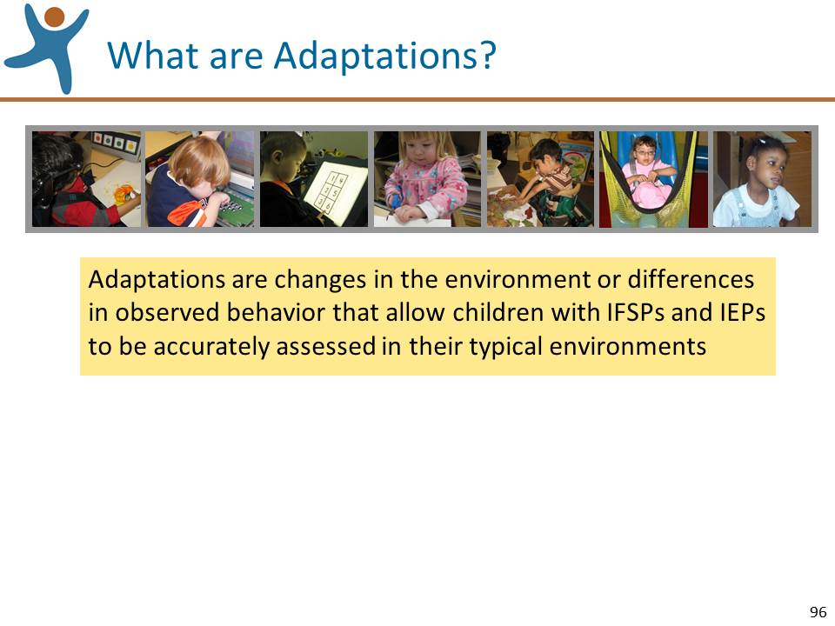 | Slide 96: Review the information on this slide and make these points:  - Let’s start by looking at a definition of adaptations in relation to the DRDP (2015) Assessment. As you see, adaptations help assessors most accurately assess children with IFSPs and IEPs.
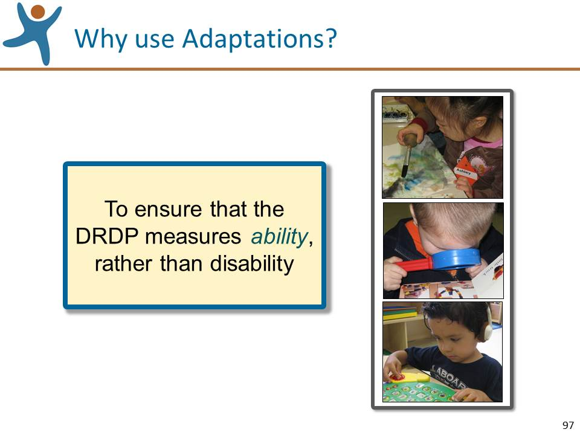 | Slide 97: Review the information on this slide and make these points:  - The adaptations for the DRDP (2015) serve a very important function – to ensure that the instrument measures a child’s ability rather than disability.  - Sometimes the presence of a disability prevents children from demonstrating particular skills. Adaptations that are used throughout the typical day enable children to have more control in interacting with their environment.  - Adaptations allow children to demonstrate their highest level of mastery. This, in turn, enables teachers and service providers to assess the child’s true level of ability. And this increases the validity of the assessment.  - Adaptations may be used in any educational setting.
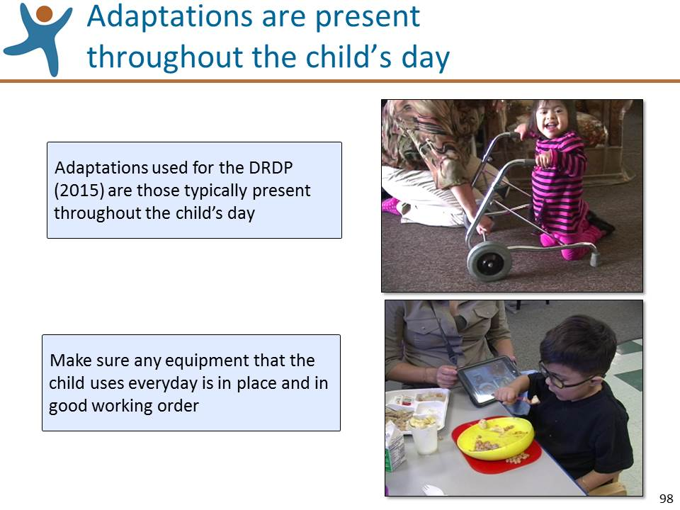 | Slide 98: Review the information on this slide and make these points:  - An important point to keep in mind is that adaptations should not be used only for the purpose of the assessment – they should be present throughout the child’s day and available for all routines and activities.  - Related to this, some children use equipment such as glasses and hearing aids every day. Make sure that these things are in place and working well. For example, make sure that the batteries for a child’s hearing aids are charged.
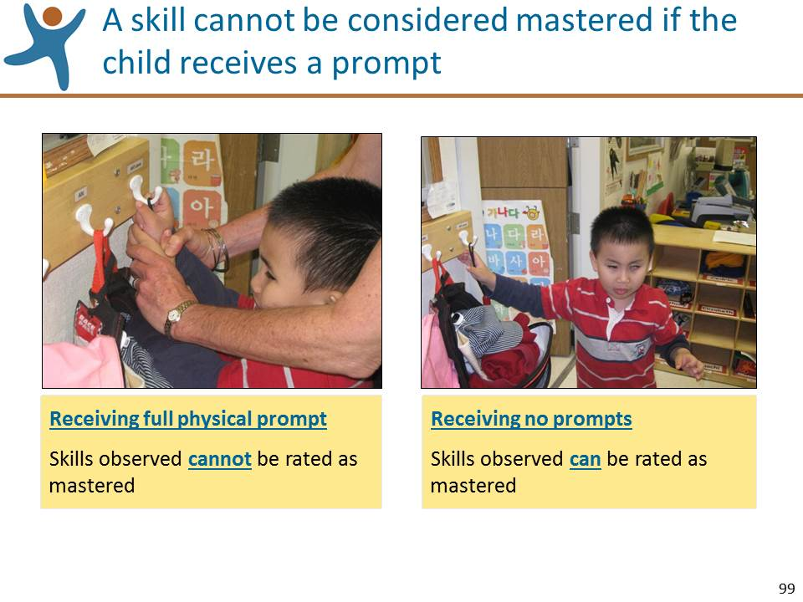 | Slide 99: Review the information on this slide and make these points:  - Another point to keep in mind is that instructional prompts are not the same as adaptations.  - In other words, instructional strategies such as providing verbal or gestural prompts, providing a model of the desired behavior, or using a partial or full physical prompt are not adaptations.  - Let’s look at an example. In this first picture, if we see this child hanging up his coat with hand-over-hand support from an adult. We have no way of knowing if the child can actually use these skills. In the second picture, this child is hanging up his coat independently with no prompting at all. We can clearly see that the child is demonstrating mastery of the skills involved in this task.
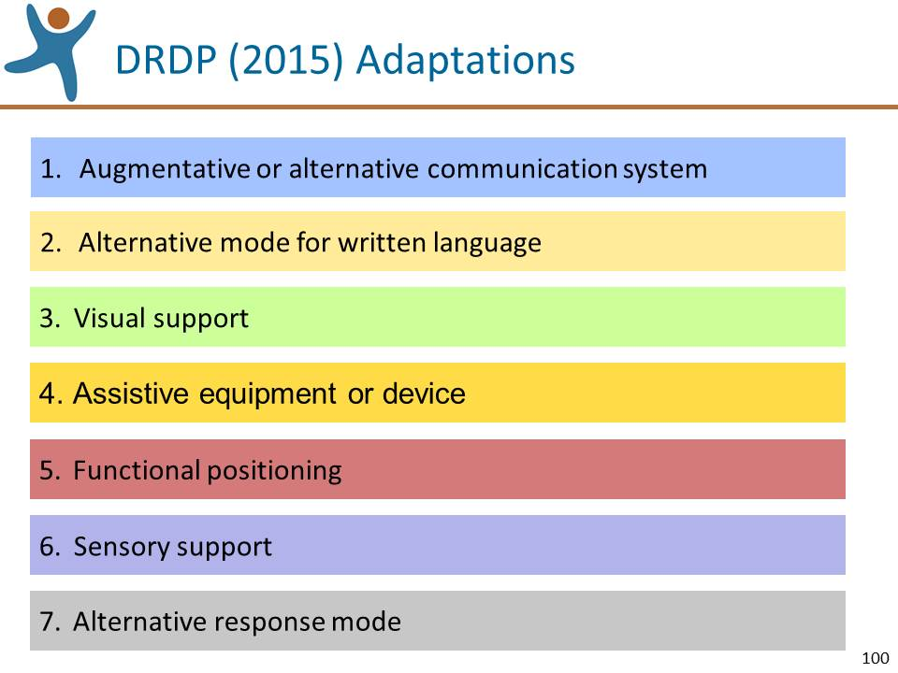 | Slide 100: Review the information on this slide and make these points:  - The descriptions of these adaptations can be found in the Introduction and Appendix sections of the Manual.  - Remember: adaptations must be in place for the child’s daily routines and activities, and not used just for the purpose of assessment.  - Let’s review each of the 7 adaptations.
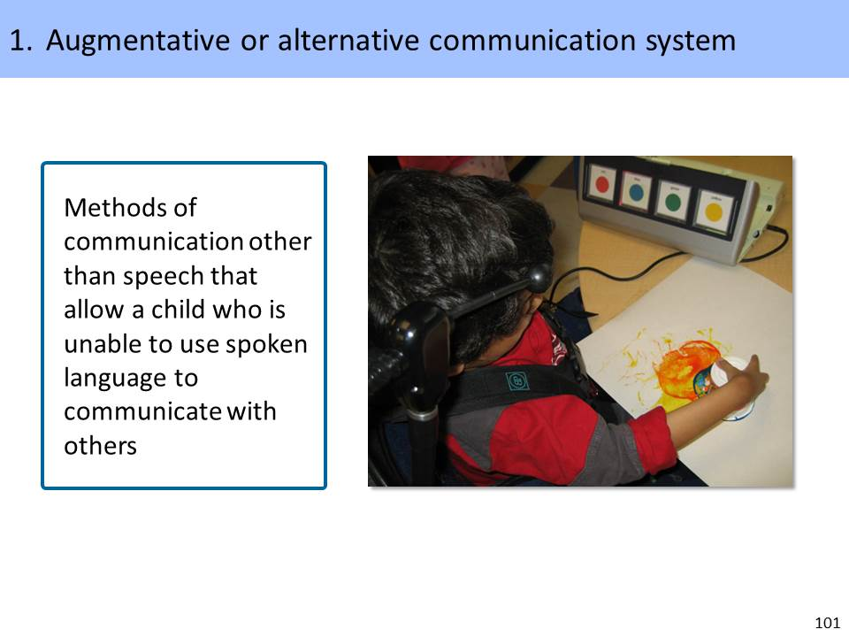 | Slide 101: Review the information on this slide and make these points:  - If a child cannot use spoken language, another system of communication should be used, e.g., picture cards, electronic communication devices, or sign language.  - Teachers and service providers should use these systems as part of the observation and not just to elicit responses.  - Teachers and service providers should observe the child using language in a natural context rather than contriving an adult-directed situation.  - In the picture on this slide we see a child use a switch to request the color of paint that he wants to use.
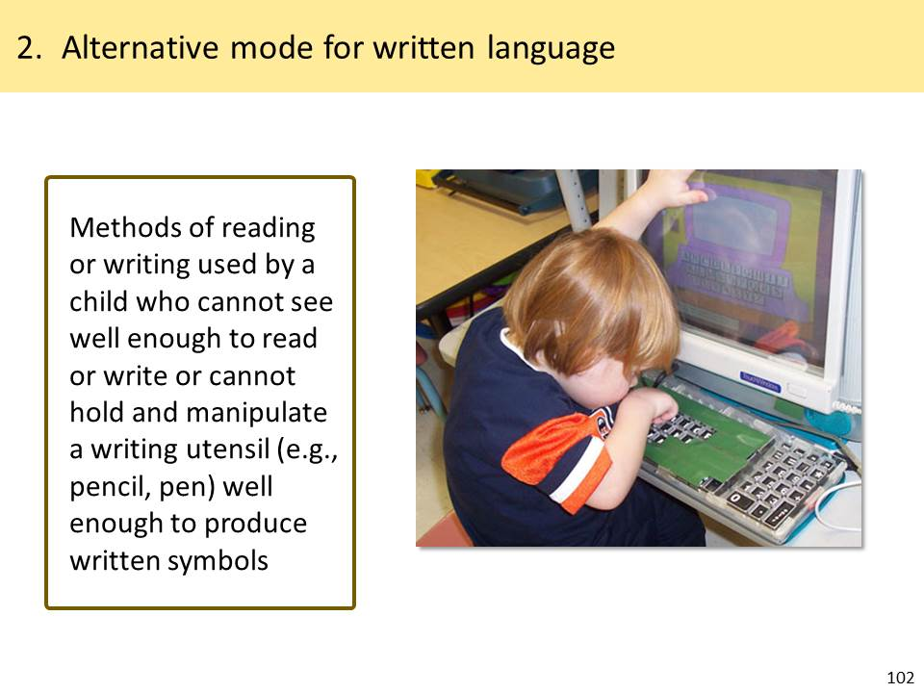 | Slide 102: Review the information on this slide and make these points:  - If a child cannot see or cannot hold a pencil or marker, an adaptation may be used to assist in reading or writing or emerging writing, e.g., Braillewriter, keyboard, or computer.  - Naturally, by preschool-age, children are not proficient at reading and writing. This adaptation allows for children to explore reading and writing and develop their skills in a developmentally appropriate manner as defined in the measures of the Language and Literacy domain.  - In the illustration on this slide, this child who cannot hold a pencil is using an adapted keyboard that helps him use a computer.
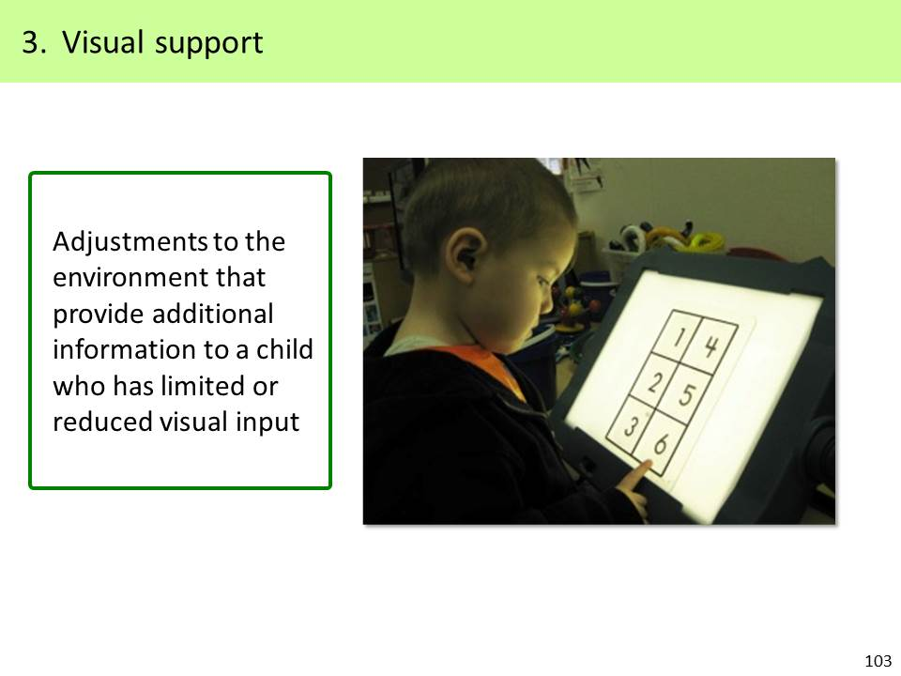 | Slide 103: Review the information on this slide and make these points:  - A child who does not see well might need visual supports.  - Any type of visual support is acceptable, including:  - adjustments in contrast  - adjustments in lighting  - distance from objects  - increased size of materials  - verbal description of events  - In this picture on this slide, a light box helps this young boy with a visual impairment see the numbers clearly.
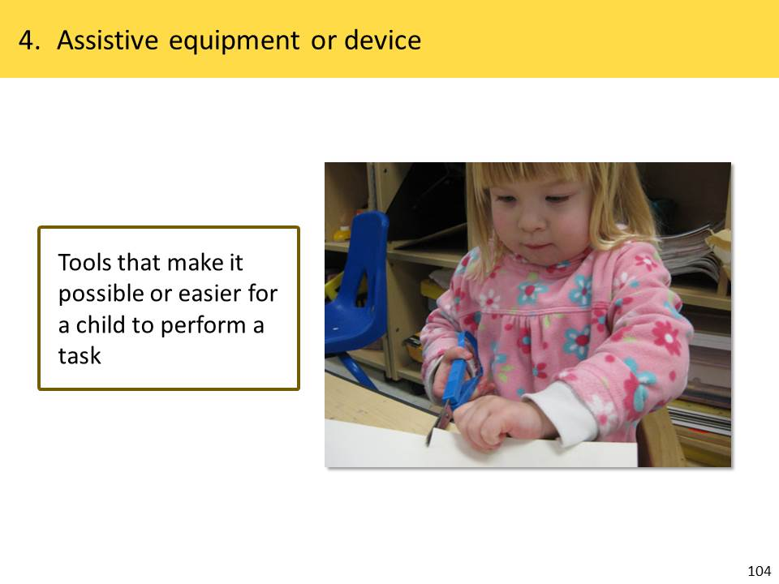 | Slide 104: Review the information on this slide and make these points:  - This adaptation includes any type of adaptive equipment or assistive device that the child knows how to use and uses regularly.  - Do not introduce any new device or equipment for observations intended to be used for the assessment.  - Teachers and service providers need to be familiar enough with the device to understand its features, how it is set up, how it is used without interfering with instructional time, and troubleshooting.  - Any type of adaptive equipment or assistive device that the child needs for mobility, positioning or manipulating objects is acceptable, including:  - walkers  - splints  - special utensils  - switches  - The picture on this slide is of adaptive scissors that enable this young girl with limited hand movement to cut paper independently.
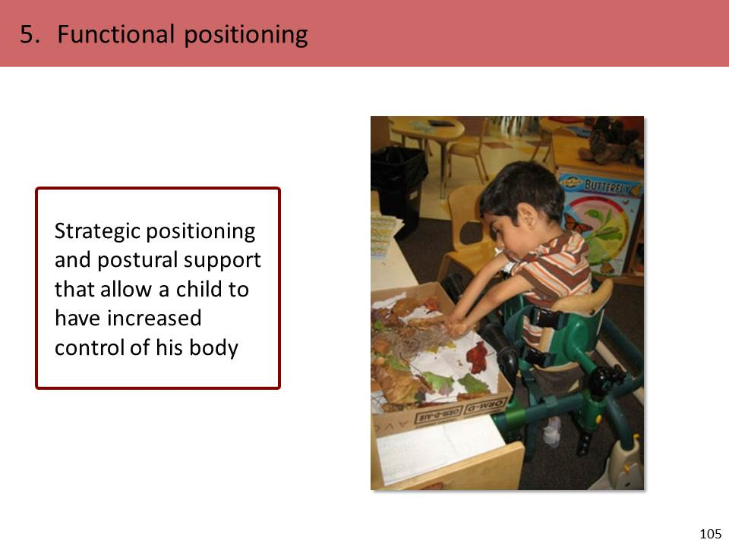 | Slide 105: Review the information on this slide and make these points:  - Functional positioning allows a child the necessary stability to control movements as much as possible and can enhance the child’s participation in typical routines and activities.  - It is important that positioning devices are available to the child across settings so that you can observe the child using them in a variety of daily routines and activities.  - In the picture on this slide, the stander enables this young boy to stand so that he can use his hands for playing.
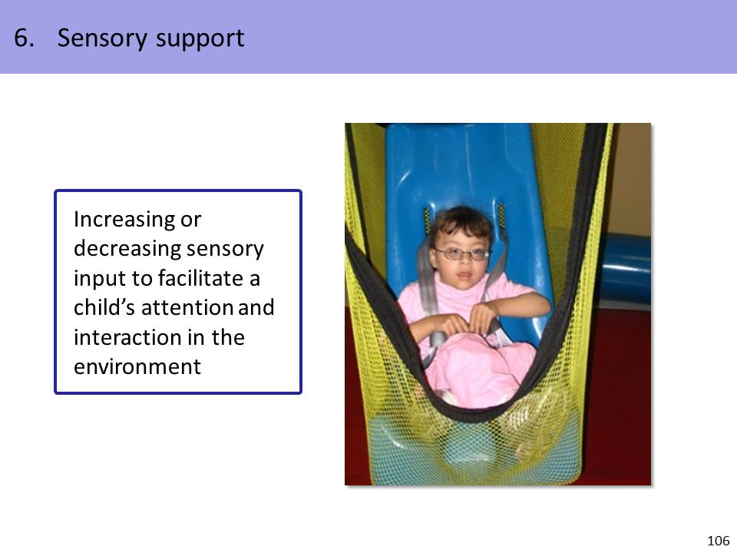 | Slide 106: Review the information on this slide and make these points:  - Sensory support may be needed to help a child focus attention and learn in the daily environment.  - Some children may need increased sensory input and others may need decreased input.  - Some children require different kinds of sensory support for different activities.  - Sensory support may include:  - reducing background noise  - adjusting tactile stimulation  - adjusting visual stimulation  - In this illustration, the child is positioned in a hammock swing. The swinging motion promotes calming and subsequent increased attention.
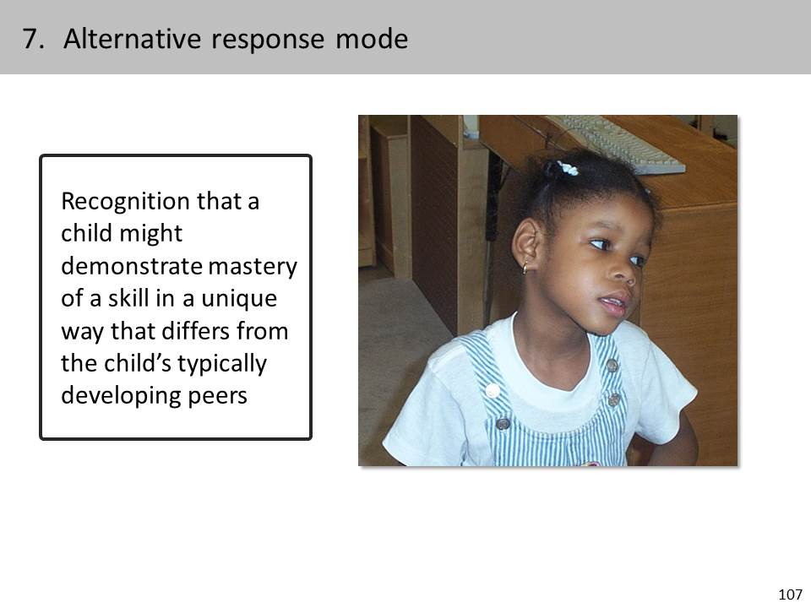 | Slide 107: Review the information on this slide and make these points:  - For this adaptation, we do not modify the environment as in the other adaptations. Rather, we look to the child’s unique yet consistent responses that may indicate the presence of a skill.  - Because teachers, service provides, and families are familiar with the child, they will know whether alternate responses are consistent responses and indicators of attention and engagement.  - The form of a child’s response may differ from that of his typical peers and still may demonstrate mastery. For example, a child with a physical impairment may demonstrate atypical movement patterns.  - In the picture on this slide, the child looks out of the corner of her eye instead of establishing direct eye contact. This unique, yet consistent response differs from that of her peers, but still may demonstrate mastery of a skill.
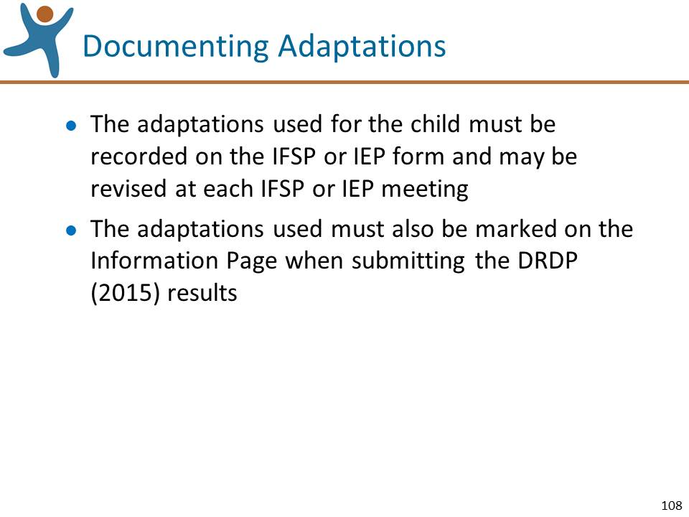 | Slide 108: Review the information on this slide and make this point:  - We’ll review more about the Information Page later in the session.
Mute the projector | Mute the Projector:  Ask for questions specifically about adaptations and answer them. If questions are asked that will be addressed in upcoming sections of the workshop, acknowledge that the question will be addressed shortly.

Step 3: Finalize the Instrument (10 minutes)
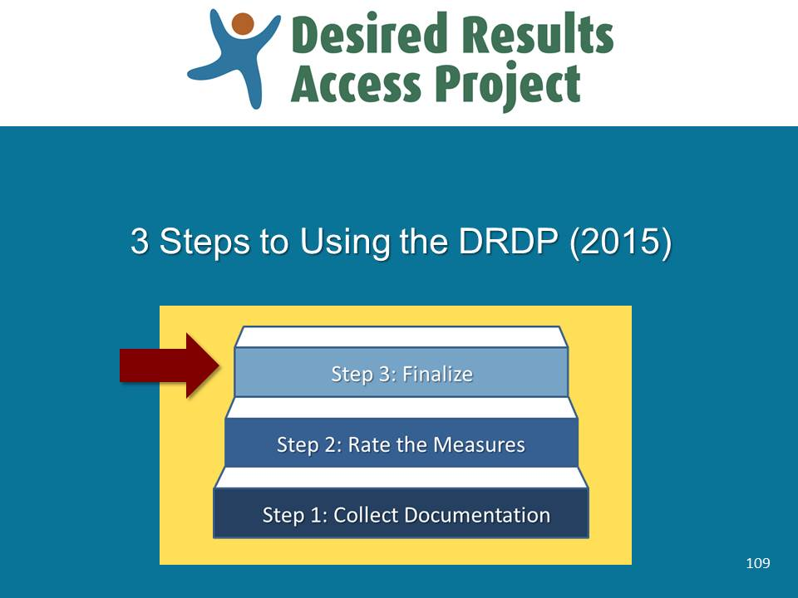 | Slide 109: Review the information on this slide and make these points:  - Finalizing the assessment is the third step in using the DRDP (2015).
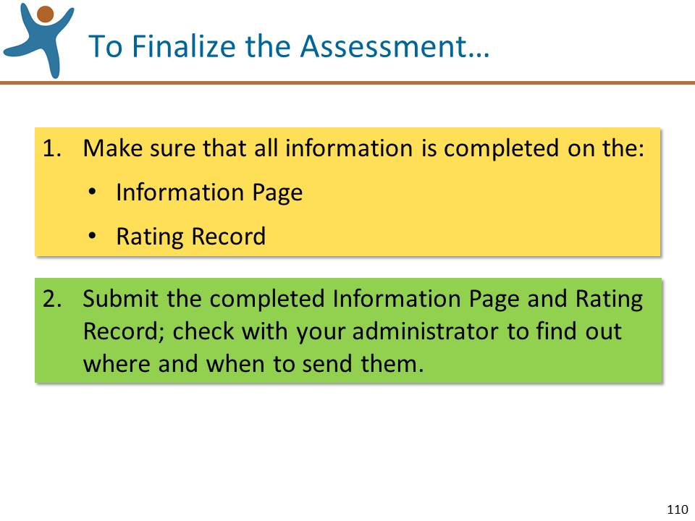 | Slide 110: Review the information on this slide and make these points:  - As you see, finalizing the assessment involves just two simple steps.
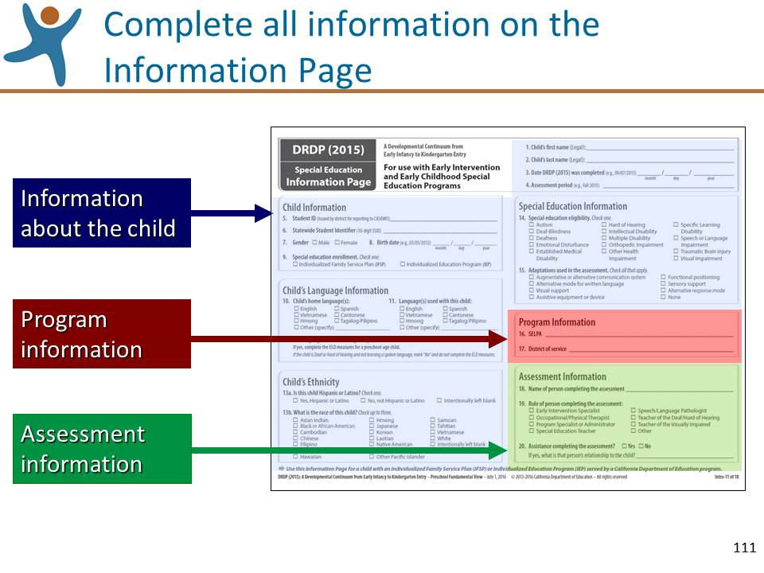 | Slide 111: Review the information on this slide and make these points:  - All fields of the Information Page must be completed for each child.  - Ask the participants to locate the Information Page.  - Note on #6 of the Child’s Information: Statewide Student Identifier.  - Check with your administrator to find out if these have been issued for your preschool students; they are now required.  - If the SSID has not yet been assigned, leave this space blank.  - Note on #12: If you answer yes to this question, complete the ELD measures for a preschool child. You do not need to use the ELD measures with a deaf child who is learning only ASL and not learning spoken language.
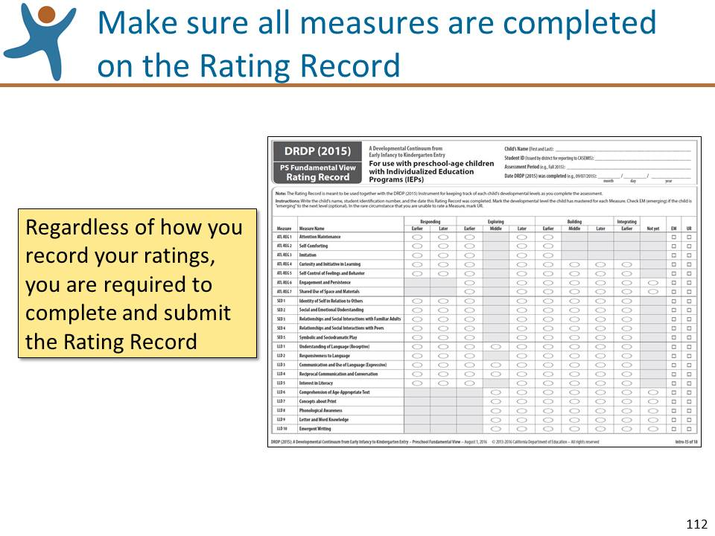 | Slide 112: Review the information on this slide and make these points:  - Work efficiently and avoid having to mark your ratings twice.  - Because you will eventually need to mark your ratings directly on the Rating Record, for efficiency you might want to use the Manual for reference as you determine your ratings, but mark your ratings directly on the Rating Record.  - When using the Preschool Fundamental View, be sure to use the Rating Record for preschoolers who have IEPs.
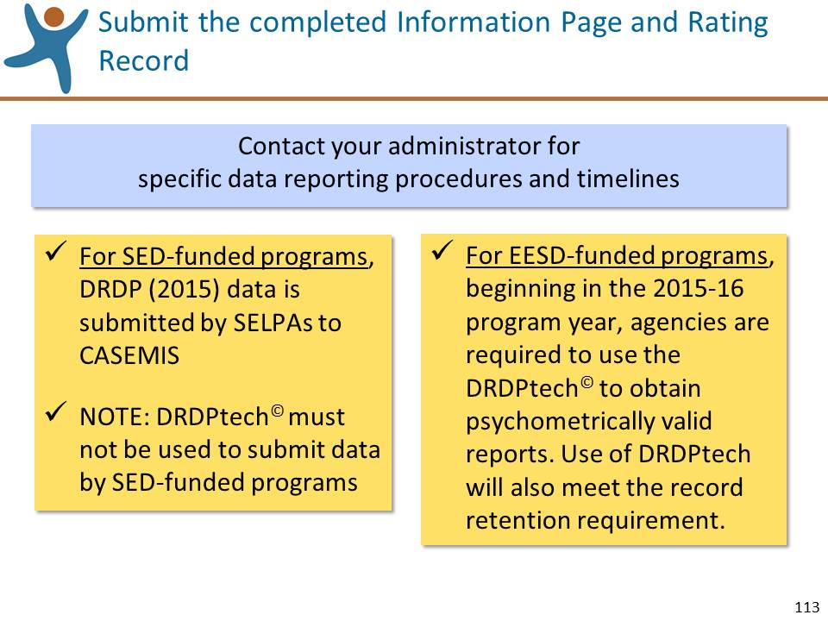 | Slide 113: Review the information on this slide and make these points:  - Check with your administrator to find out:  - How to enter your DRDP (2015) ratings (on a paper copy or into an Management Information System such as SEIS);  - Where you should send your completed Information Page/Rating Records, and  - The date by which you need to submit everything.  - The information on this slide for EESD does not affect special education directly, but because EESD and SED teachers and service providers may be collaborating on the assessment, it’s good to know how your EESD partners will be submitting their data.
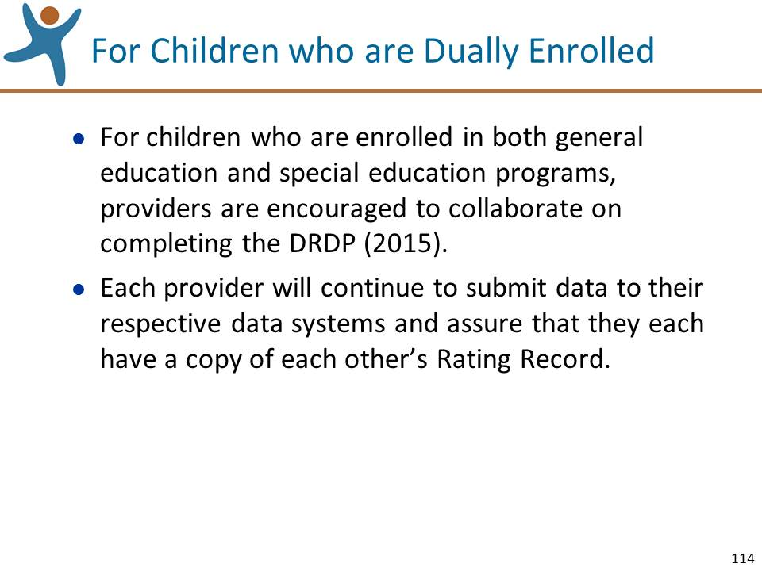 | Slide 114: Review the information on this slide and make these points:  - Children dually enrolled in SED and EESD programs will no longer need to be assessed on both the DRDP access and the DRDP (2010). They will be assessed using the DRDP (2015) instrument only.  - There should only be one assessment per child.  - Teachers and service providers should collaborate on this one assessment and assure that each person has a copy of the Rating Record.  - If timelines differ, the earlier timeline should be met.
Mute the projector | Mute the Projector:  Ask for questions specifically about finalizing the instruments and answer them. If questions are asked that will be addressed in upcoming sections of the workshop, acknowledge that the question will be addressed shortly

Resources and other Information (10 minutes)
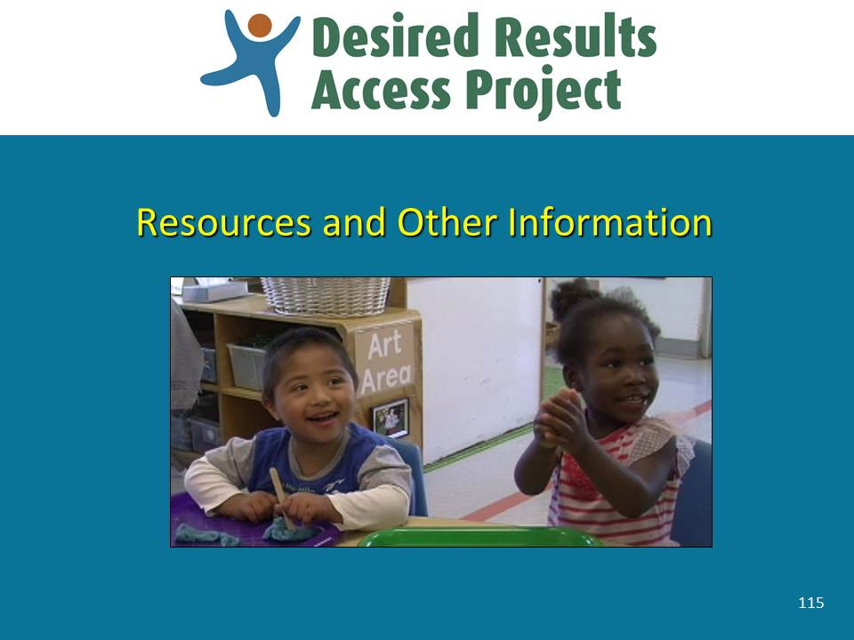 | Slide 115: Review the information on this slide and make these points:  - As mentioned earlier, draccess.org is the official site for the DRDP (2015) that offers an indispensable source of free resources.  - Be sure to visit the site periodically as new materials are being frequently added and updated.  - Let’s review some of the valuable resources available.
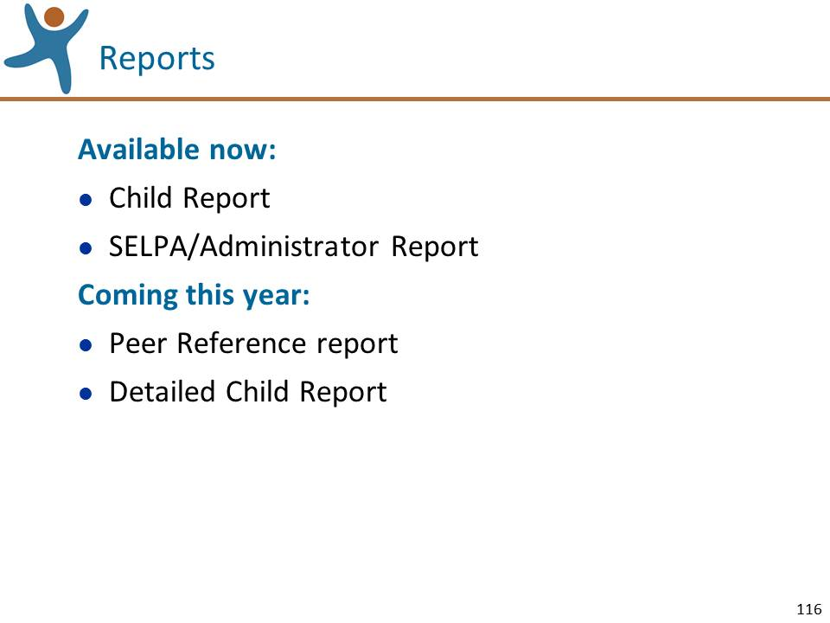 | Slide 116: Review the information on this slide and make these points:  - The Child Report and SELPA/Administrator Report s are currently available.  - The Child Report has been developed jointly with the EESD. It is available with accompanying guidance for teachers and families. Family guidance is available in Spanish.  - The Peer Reference Report and the Detailed Child Report will be available later this year.
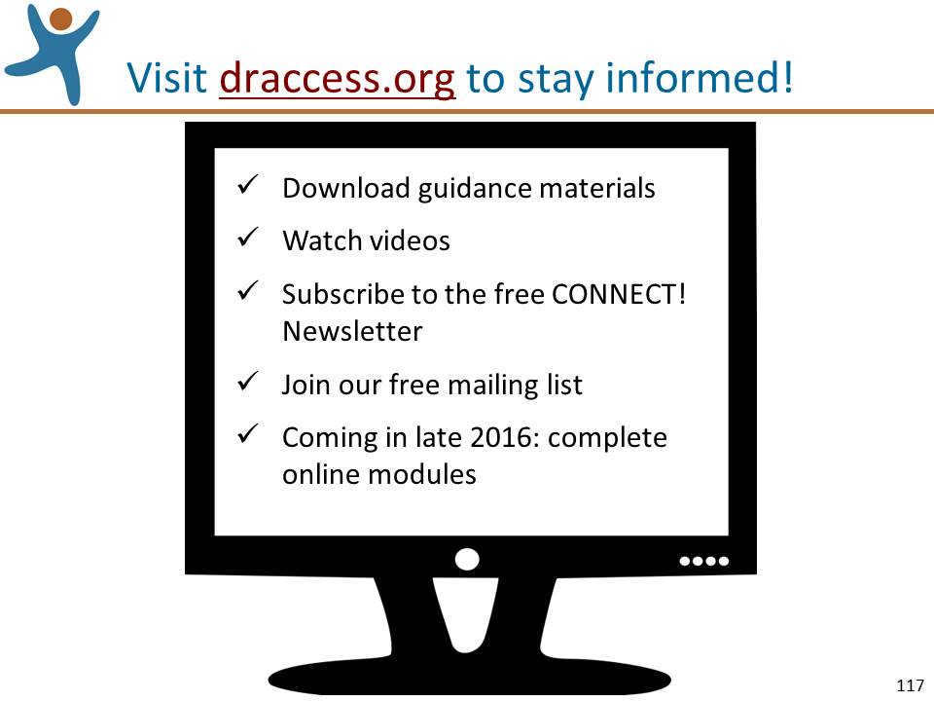 | Slide 117: Review the information on this slide and make these points:  - As we’ve been mentioning throughout the session, www.draccess.org is SED’s official site for information related to the DRDP (2015) for special education.  - On this site you can find answers to just about all of your questions, so please take some time to visit the site, look around, and bookmark it.  - On this site you can:  - Download the DRDP (2015) instrument and key guidance materials.  - Watch interesting videos; the Video Library has dozens of videos on topics such as gathering documentation, using digital video, family engagement, and more.  - To keep up with the most current news and resources, you can subscribe to subscribe to the listserv and subscribe to CONNECT!, the free email newsletter.  - Coming in late 2016 will be a series of online modules provides assessors with a convenient and effective way to learn how to use the DRDP (2015), reference key information, or refresh their memory.  Optional: Prepare a display of guidance documents available at www.draccess.org.
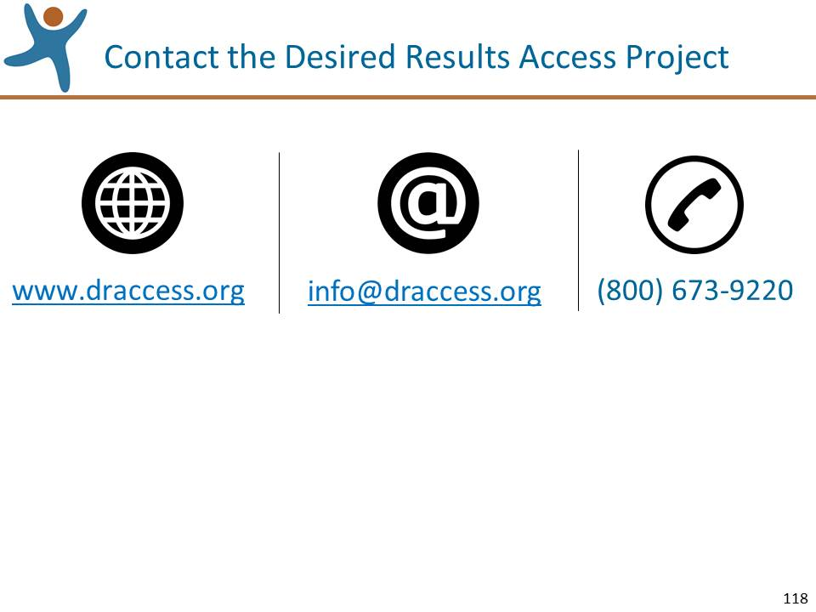 | Slide 118: Review the information on this slide and make these points:  - You are always welcome to contact the Desired Results Access Project for assistance by visiting our site, by email, or by phone..
Mute the projector | Mute the Projector:  Ask for questions specifically about resources available and answer them. If questions are asked that will be addressed in upcoming sections of the workshop, acknowledge that the question will be addressed shortly

Wrap Up (15 minutes)
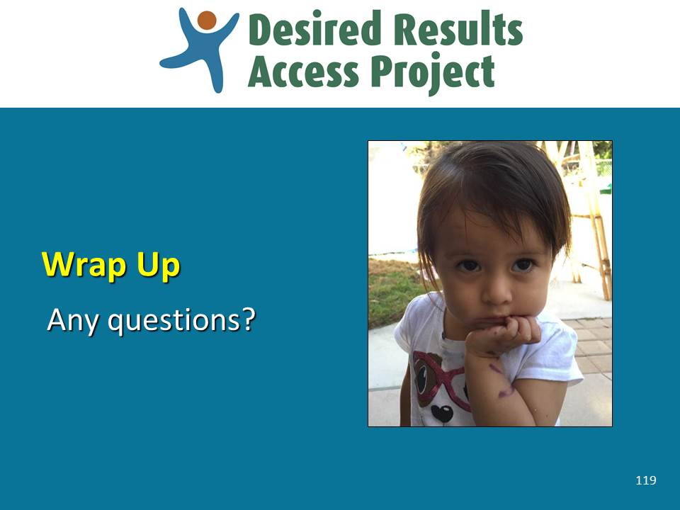 | Slide 119: Review the information on this slide and make these points:  Notes to trainer:  - This question and answer session has been included for two reasons. The first is to offer the participants one last opportunity to ask questions about the use of the instrument. The second reason is to offer a time buffer that you can use to compensate for time that may have been lost due to earlier activities take longer than expected, a late start to the day, or longer breaks than planned.  - If any questions cannot be answered during this session, offer to pose the questions to SELPA or district administrators, the Desired Results Access Project staff, or CDE, and then get back to the participants with the answers.
Mute the projector | Mute the Projector:  - Be prepared to go back to earlier slides that contain information that will help address questions that may be asked.
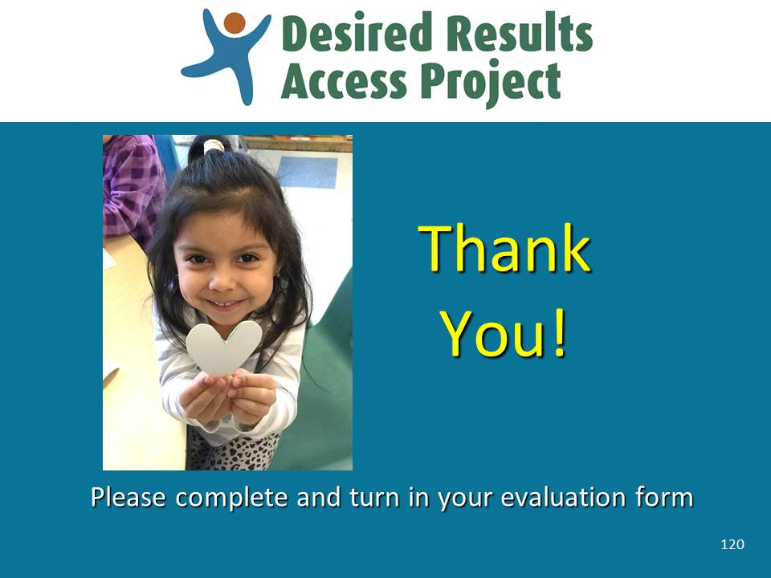 | Slide 120: Review the information on this slide and make these points:  - If time remains and you think it would be a good way to end the session, show the video “So Many Ways to Learn.” You can introduce it by sharing:  Let’s end the session by watching a video of some children illustrating the many ways in which children learn. Thanks to the children, parents and staff at the Napa Preschool Program for permission to use this video.
End of Session

Instructions for Leading the Rating Practice Exercises
The two Rating Practice Exercises that you will lead during this session are very important – our training evaluation data informs us that training participants find these exercises the most useful part of the training. These exercises help the participants become familiar with the DRDP (2015), practice using the rating procedures, and identify the kinds of information they need to collect in order to confidently rate the measures.
It is extremely important that you lead these exercises as described in these instructions in order to support teachers and service providers to learn how to use the instrument with fidelity and to help them achieve rater reliability.
In general, in each of the two Rating Practice Exercises, you will ask the participants to:
- Read a description of a child
- Review a specific measure on the DRDP (2015).
- Watch a video clip of the child.
- Read information shared by other people about the child.
- Rate the child’s skills on the measure.
- Have small group discussions
- Have a large group discussion.
Preparation:
- Carefully read the following instructions on leading the exercises.
- Preview all of the video clips for these exercises.
- Become familiar with all of the measures in the DRDP (2015), but become particularly knowledgeable with the measures that are used in these exercises.
- You can lead these exercises focusing on either toddlers or preschoolers, depending on the roles, needs, and interests of the training participants. If you are leading the training with participants who work in infant/toddler programs, we recommend that you use the video clips of toddlers. If leading the training with participants who work in preschool special education programs, we recommend that you use the video clips of preschoolers. If working with a mixed group, we recommend that you use a mixture of toddler and preschool examples.
- Depending on which children you choose for the exercises, you will use different video clips, slides, and Rating Practice Worksheets, so to prepare to lead these exercises, be sure to:
  - Select the video clips you will need and have them ready to play;
  - Make copies of the appropriate Rating Practice Worksheets for the participants; and
  - Move the slides that you will be using to the appropriate section of the PowerPoint slides, i.e., after slide 92.
- If possible, practice leading the exercises with a co-trainer or friend before leading them during an actual training session.

Rating Practice Exercise Part 1 – IT Focus (30 minutes)
Lydia in the Kitchen
Preparation:
- Become very familiar with the instructions below, the video clip “Lydia in the Kitchen,” and SED 5: Symbolic and Sociodramatic Play.
- Replace slide 92 with the 6 slides for Rating Practice Exercise 1 (IT) Lydia in the Kitchen.
- Have the video clip “Lydia in the Kitchen” ready to play.
- Make copies of the Rating Practice Exercise Worksheets for “Lydia in the Kitchen.”
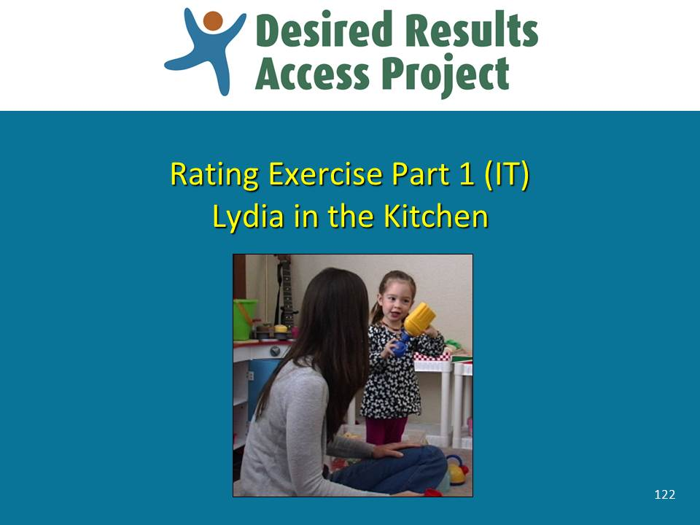 | Slide 122: Review the information on this slide and make these points:  - The purpose of this activity is to help you become familiar with the DRDP (2015), practice using the rating procedures, and identify the kinds of information that you need to collect in order to confidently rate the measures.  - In this exercise we will rate a measure for a particular child. We need to keep in mind that this practice exercise is an artificial simulation because we will see a video of the child one time in only one activity. We will not see the child in a wide variety of settings and we know that a child cannot be confidently rated on a measure based on only one observation – one sample of behavior does not provide enough information. To confidently rate a measure, we need to observe the child in a variety of different settings and tasks that will illustrate the range of possible skills, and/or collect observations from other people in the child’s life, e.g. family members and other providers. Why? During one observation, we may see the child demonstrate skills at one level. But just because the child did not demonstrate skills related to the next higher rating does not mean that the child doesn’t do them yet. It may be that this particular activity did not require that skill.  - We tried to compensate for this limitation by providing you not only with a video of the child, but also with information shared by people who know the child well, of observations that they made of the child in other activities and at other times. So despite the limitation of only directly observing the child one time and in one activity, we have rich information from others. And with both our observation and the information shared by others, we should be able to learn how to use the instrument and the rating process and arrive at a confident rating.
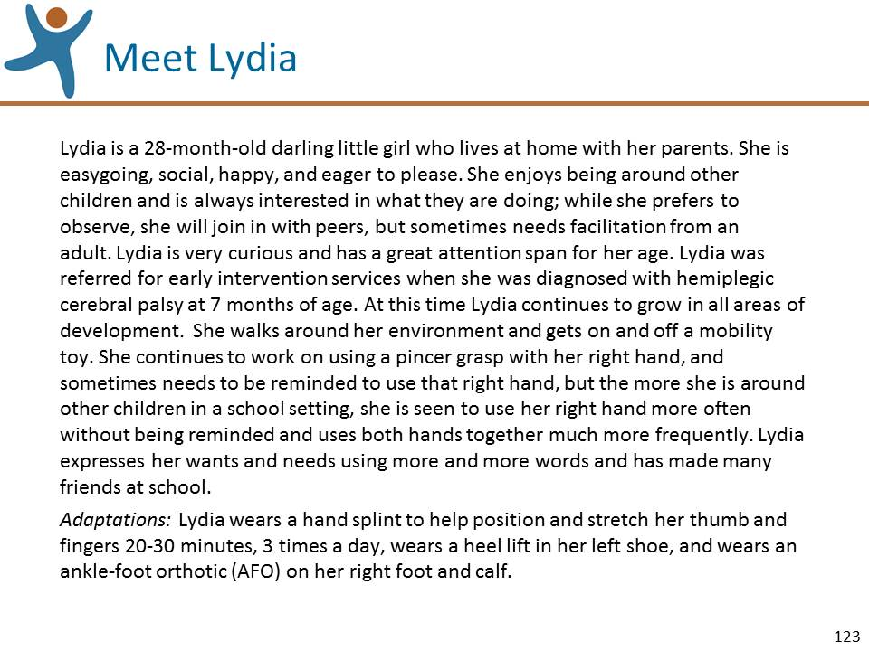 | Slide 123: Review the information on this slide and make these points:  - Read the description of Lydia provided by her mother. It is on the front page of the Rating Practice Exercise and on this slide.
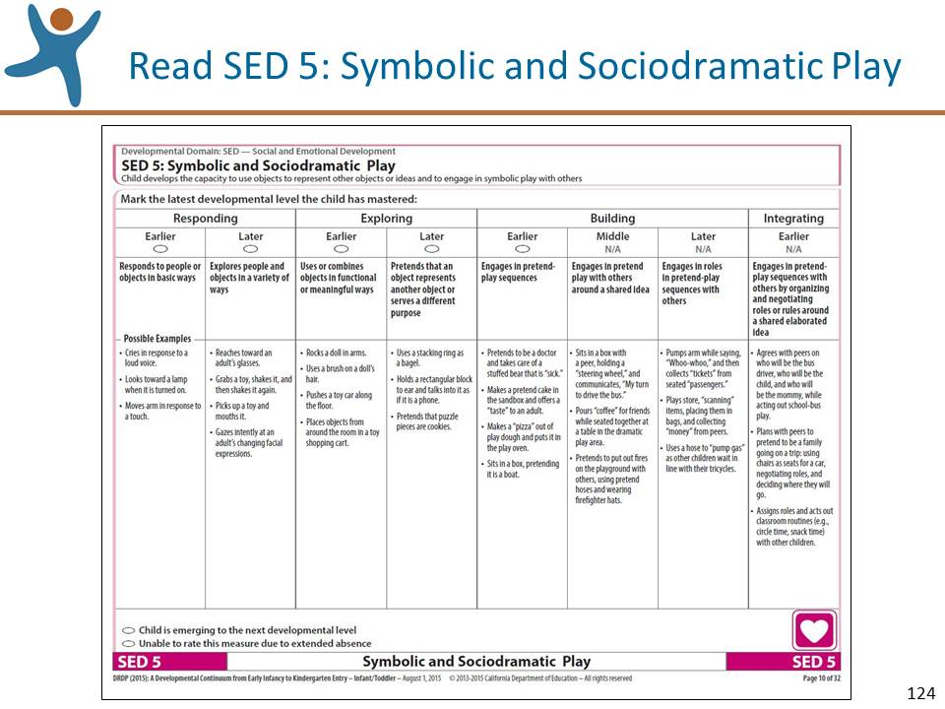 | Slide 124: Review the information on this slide and make these points:  - Read through the entire measure SED 5: Symbolic and Sociodramatic Play. You can find it in the DRDP (2015) Infant/Toddler View Assessment Manual, on the second page of the Rating Practice Exercise Worksheet, and on this slide.  - Tell the participants that you will be showing them a video clip and as they watch they should use the space at the top of the third page of the worksheet to jot down their observations of Lydia in relation to measure SED 5. Remind them not to rate the measure yet; just observe the video in relation to SED 5, as they will combine their observations with other information to rate the measure.  - Show the video clip.
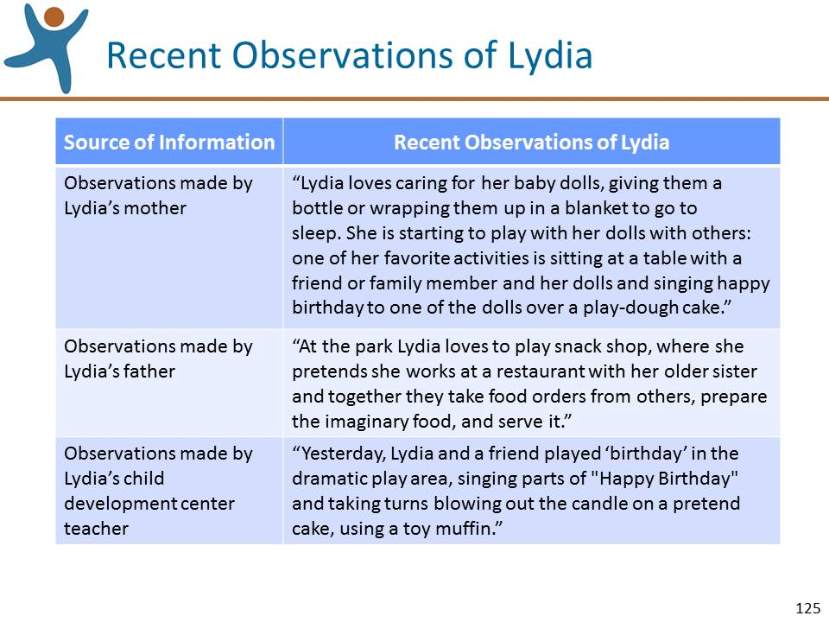 | Slide 125: Review the information on this slide and make these points:  - Once the video ends, ask the participants to read the additional observations made of Lydia. The observations can be found on the fourth page of the Rating Practice Exercise Worksheet and on this slide.  - After giving them enough time to read the additional observations, ask the participants to work individually to pencil in their “best first guess” of the highest level of mastery, based on both:  - the notes they made from the video clip; and  - the additional observations that they just read.  NOTE: If you find it helpful, you can go back to the previous slide and show the measure.

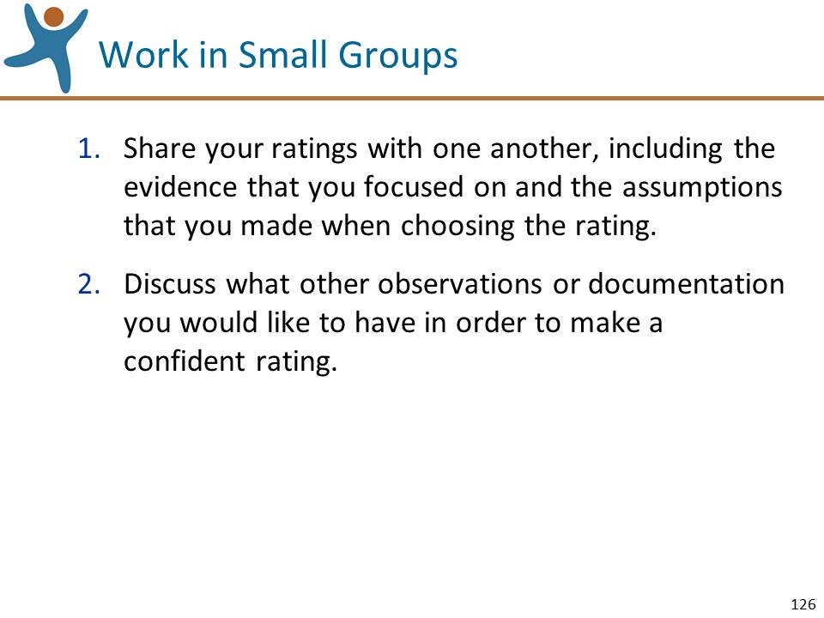 | Slide 126: Review the information on this slide and make these points:  - Ask the participants to work in small groups to:  - Share their ratings with one another, including the evidence that they focused on and the assumptions that they made in coming up with the rating. Ask them to be sure they understand how each person rated the measure and what evidence they focused on in determining their rating.  - Discuss what other observations or documentation they would have liked to have in order to make an accurate rating.
Mute the projector | LEAD A LARGE GROUP DISCUSSION OF THE RATINGS:  - Ask for a few volunteers to share their ratings and their rationale for the rating, pinpointing the evidence used. The purpose of the discussion is to come to a shared understanding of how each person rated the measure based on the evidence that they focused on and the assumptions they made.
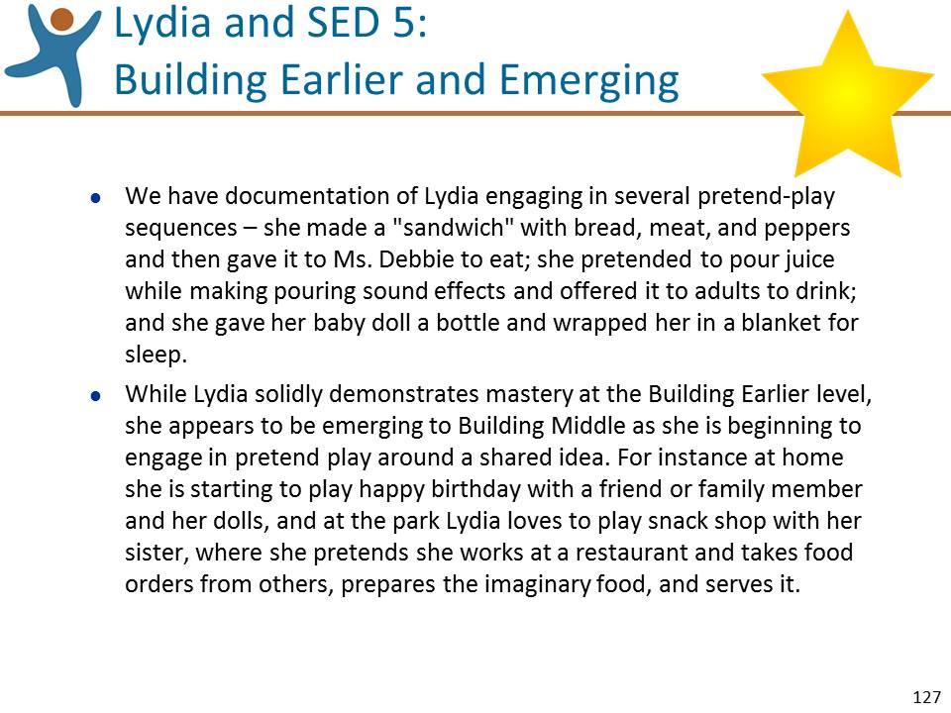 | Slide 127: Review the information on this slide and make these points:  - Let’s review the “Gold Star” rating derived from the DRDP (2015) research team.  - Although we do not personally see Lydia demonstrate the behavior consistently over time and in different settings, we were able to make one relevant observation and read three additional relevant observations. Based on the video observation and on the observations shared by others, Lydia demonstrates mastery at the Building Earlier level and is emerging to the next level.  - We have documentation of Lydia engaging in several pretend-play sequences – she made a "sandwich" with bread, meat, and peppers and then gave it to Ms. Debbie to eat; she pretended to pour juice while making pouring sound effects and offered it to adults to drink; and she gave her baby doll a bottle and wrapped her in a blanket for sleep. While Lydia solidly demonstrates mastery at the Building Earlier level, she appears to be emerging to Building Middle as she is beginning to engage in pretend play around a shared idea. For instance at home she is starting to play happy birthday with a friend or family member and her dolls, and at the park Lydia loves to play snack shop with her sister, where she pretends she works at a restaurant and takes food orders from others, prepares the imaginary food, and serves it.  - Summarize by reflecting on key points made during the discussion and mentioning:  - Remember how important it is to have multiple sources of documentation before rating a measure.  - Being able to describe why you have arrived at a particular rating, as we have demonstrated here, will help you reach an accurate rating.

Rating Practice Exercise Part 1 – PS Focus (30 minutes)
Said on the Playground
Preparation:
- Become very familiar with the instructions below, the video clip “Said on the Playground,” and PD-HLTH 2:
Gross Locomotor Movement Skills.
- Replace slide 92 with the 6 slides for Rating Practice Exercise 1 (PS) Said on the Playground.
- Have the video clip “Said on the Playground” ready to play.
- Make copies of the Rating Practice Exercise Worksheets for “Said on the Playground.”
- NOTE: Said is pronounced “Sah-eed”
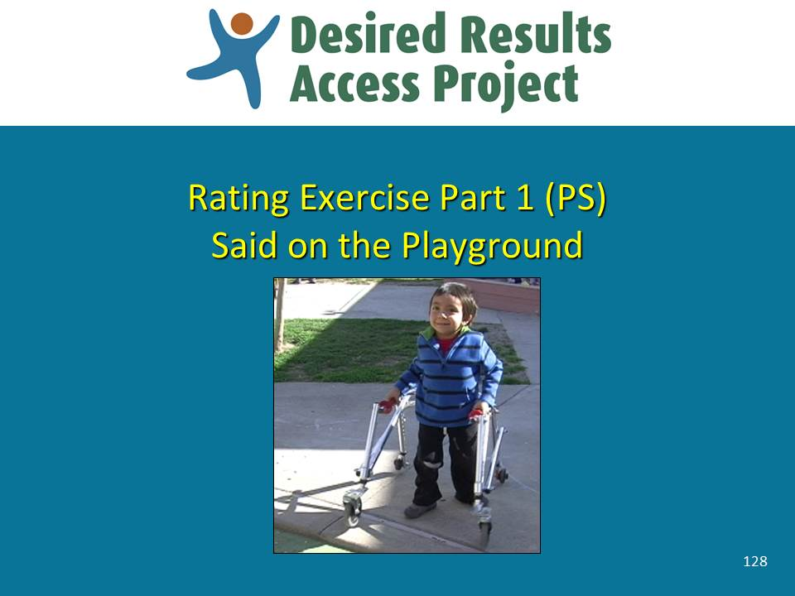 | Slide 128: Review the information on this slide and make these points:  - The purpose of this activity is to help you become familiar with the DRDP (2015), practice using the rating procedures, and identify the kinds of information that you need to collect in order to confidently rate the measures.  - In this exercise we will rate a measure for a particular child. We need to keep in mind that this practice exercise is an artificial simulation because we will see a video of the child one time in only one activity. We will not see the child in a wide variety of settings and we know that a child cannot be confidently rated on a measure based on only one observation – one sample of behavior does not provide enough information. To confidently rate a measure, we need to observe the child in a variety of different settings and tasks that will illustrate the range of possible skills, and/or collect observations from other people in the child’s life, e.g. family members and other providers. Why? During one observation, we may see the child demonstrate skills at one level. But just because the child did not demonstrate skills related to the next higher rating does not mean that the child doesn’t do them yet. It may be that this particular activity did not require that skill.  - We tried to compensate for this limitation by providing you not only with a video of the child, but also with information shared by people who know the child well, of observations that they made of the child in other activities and at other times. So despite the limitation of only directly observing the child one time and in one activity, we have rich information from others. And with both our observation and the information shared by others, we should be able to learn how to use the instrument and the rating process and arrive at a confident rating.
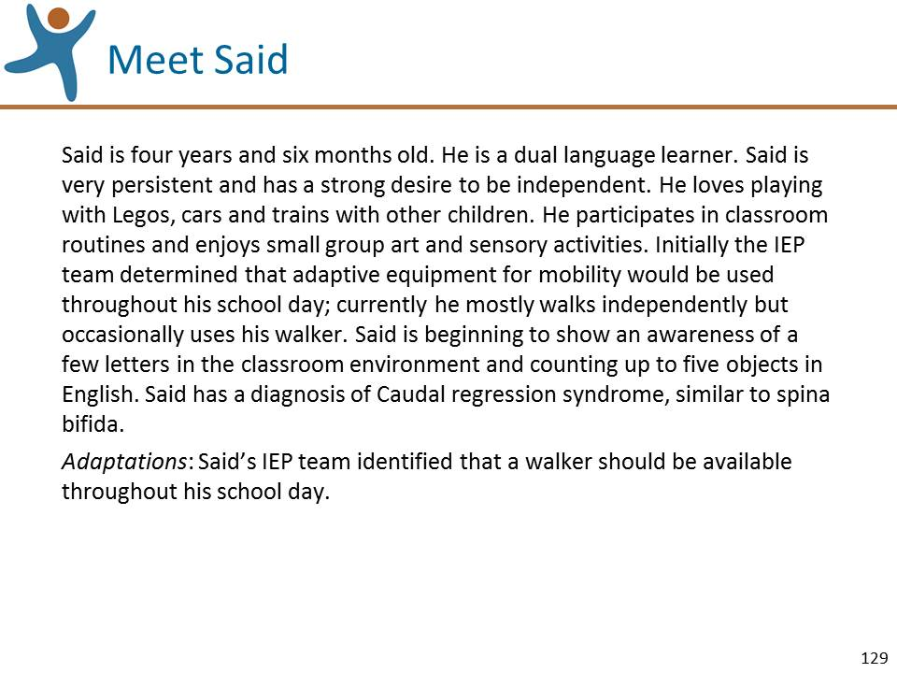 | Slide 129: Review the information on this slide and make these points:  - Read the description of Said provided by his teacher. It is on the front page of the Rating Practice Exercise and on this slide.
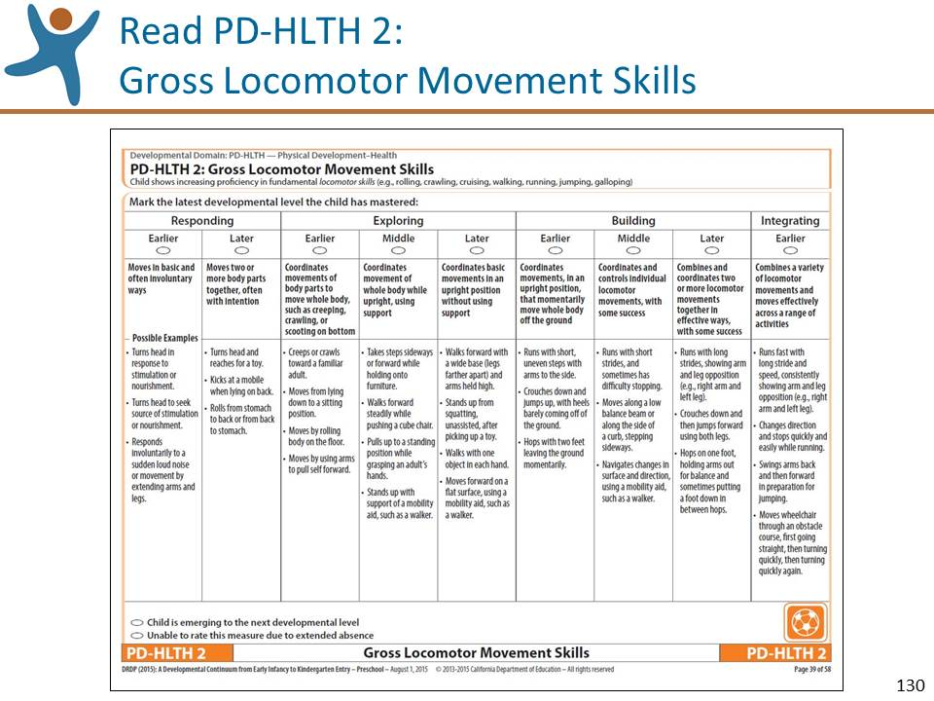 | Slide 130: Review the information on this slide and make these points:  - Read through the entire measure PD-HLTH 2:  Gross Locomotor Movement Skills. You can find it in the DRDP (2015) Preschool Fundamental View Assessment Manual, on the second page of the Rating Practice Exercise Worksheet, and on this slide.  - Tell the participants that you will be showing them a video clip and as they watch they should use the space at the top of the third page of the worksheet to jot down their observations of Said in relation to measure PD-HLTH 2. Remind them not to rate the measure yet; just observe the video in relation to PD-HLTH 2, as they will combine their observations with other information to rate the measure.  - Show the video clip.
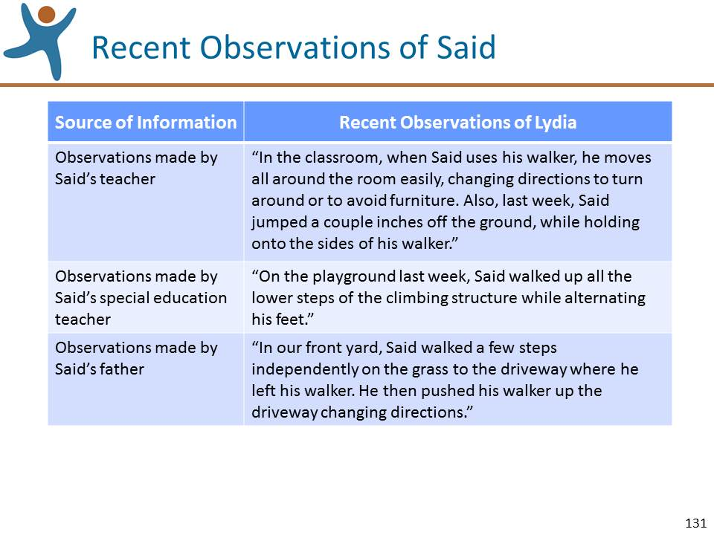 | Slide 131: Review the information on this slide and make these points:  - Once the video ends, ask the participants to read the additional observations made of Said. The observations can be found on the fourth page of the Rating Practice Exercise Worksheet and on this slide.  - After giving them enough time to read the additional observations, ask the participants to work individually to pencil in their “best first guess” of the highest level of mastery, based on both:  - the notes they made from the video clip; and  - the additional observations that they just read.  NOTE: If you find it helpful, you can go back to the previous slide and show the measure.

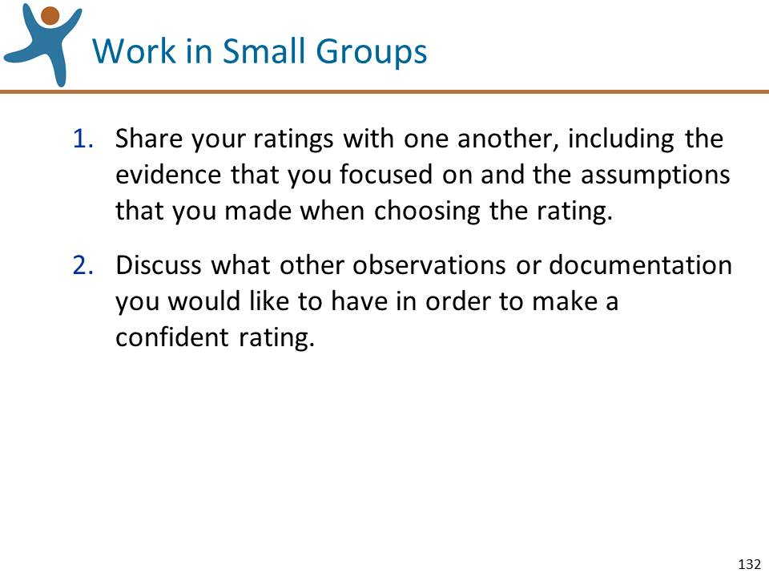 | Slide 132: Review the information on this slide and make these points:  - Ask the participants to work in small groups to:  - Share their ratings with one another, including the evidence that they focused on and the assumptions that they made in coming up with the rating. Ask them to be sure they understand how each person rated the measure and what evidence they focused on in determining their rating.  - Discuss what other observations or documentation they would have liked to have in order to make an accurate rating.
Mute the projector | LEAD A LARGE GROUP DISCUSSION OF THE RATINGS:  - Ask for a few volunteers to share their ratings and their rationale for the rating, pinpointing the evidence used. The purpose of the discussion is to come to a shared understanding of how each person rated the measure based on the evidence that they focused on and the assumptions they made.
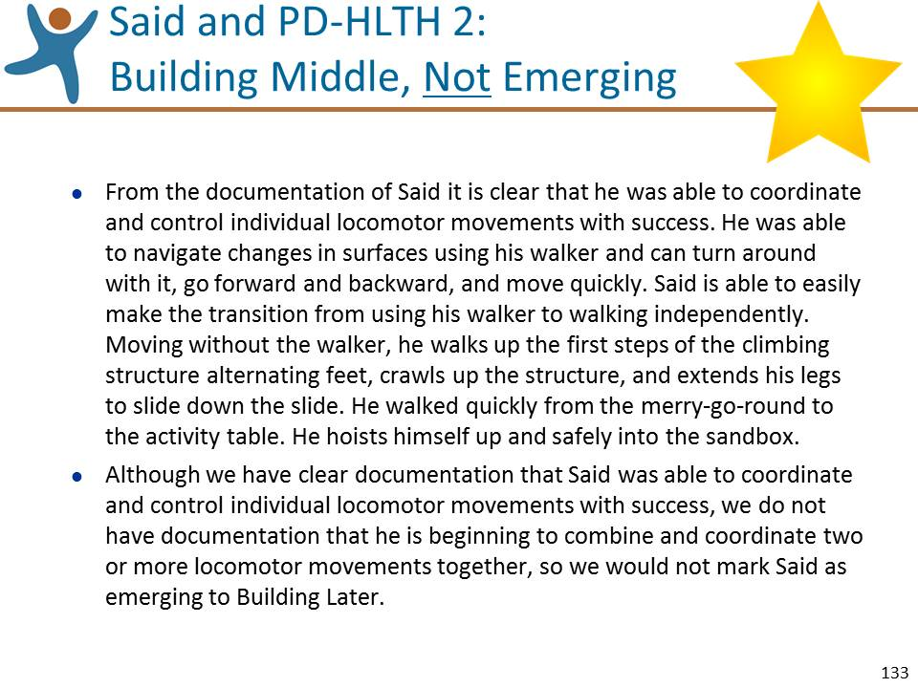 | Slide 133: Review the information on this slide and make these points:  - Let’s review the “Gold Star” rating derived from the DRDP (2015) research team.  - Although we do not personally see Said demonstrate the behavior consistently over time and in different settings, we were able to make one relevant observation and read three additional relevant observations. Based on the video observation and on the observations shared by others, Said demonstrates mastery at Building Middle and is not emerging to the next level  - From the documentation of Said it is clear that he was able to coordinate and control individual locomotor movements with success. He was able to navigate changes in surfaces using his walker and can turn around with it, go forward and backward, and move quickly. Said is able to easily make the transition from using his walker to walking independently. Moving without the walker, he walks up the first steps of the climbing structure alternating feet, crawls up the structure, and extends his legs to slide down the slide. He walked quickly from the merry-go-round to the activity table. He hoists himself up and safely into the sandbox. Although we have clear documentation that Said was able to coordinate and control individual locomotor movements with success, we do not have documentation that he is beginning to combine and coordinate two or more locomotor movements together, so we would not mark Said as emerging to Building Later.  - Summarize by reflecting on key points made during the discussion and mentioning:  - Remember how important it is to have multiple sources of documentation before rating a measure.  - Being able to describe why you have arrived at a particular rating, as we have demonstrated here, will help you reach an accurate rating.

Rating Practice Exercise Part 2 – IT Focus (30 minutes)
Tylor Playing on the Floor
Preparation:
- Become very familiar with the instructions below, the video clip “Tylor Playing on the Floor,” and PD-HLTH 4: Fine Motor Manipulative Skills.
- Replace slide 93 with the 6 slides for Rating Practice Exercise 2 (IT) Tylor Playing on the Floor.
- Have the video clip “Tylor Playing on the Floor” ready to play.
- Make copies of the Rating Practice Exercise Worksheets for “Tylor Playing on the Floor.”
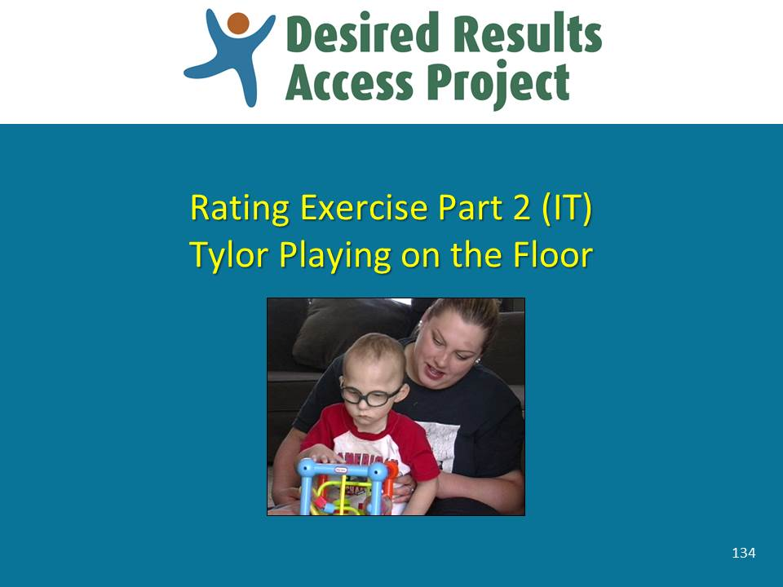 | Slide 134: Review the information on this slide and make these points:  - As you feel is needed, remind the participants of the introductory points that you made during Rating Practice Exercise Part 1.
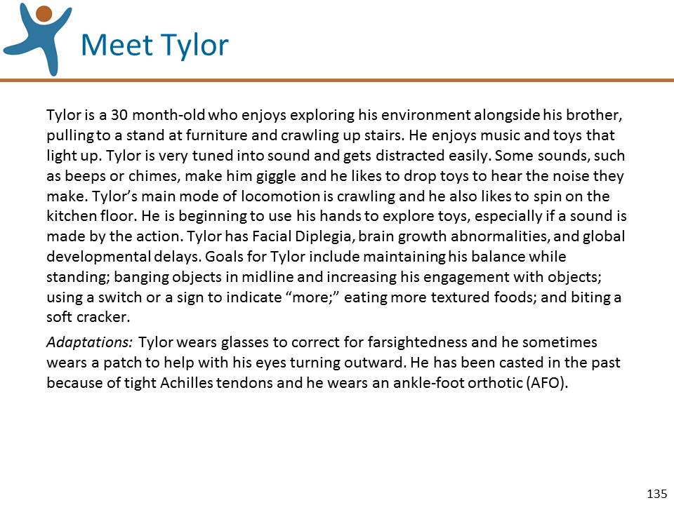 | Slide 135: Review the information on this slide and make these points:  - Read the description of Tylor provided by his early interventionist. It is on the front page of the Rating Practice Exercise and on this slide.
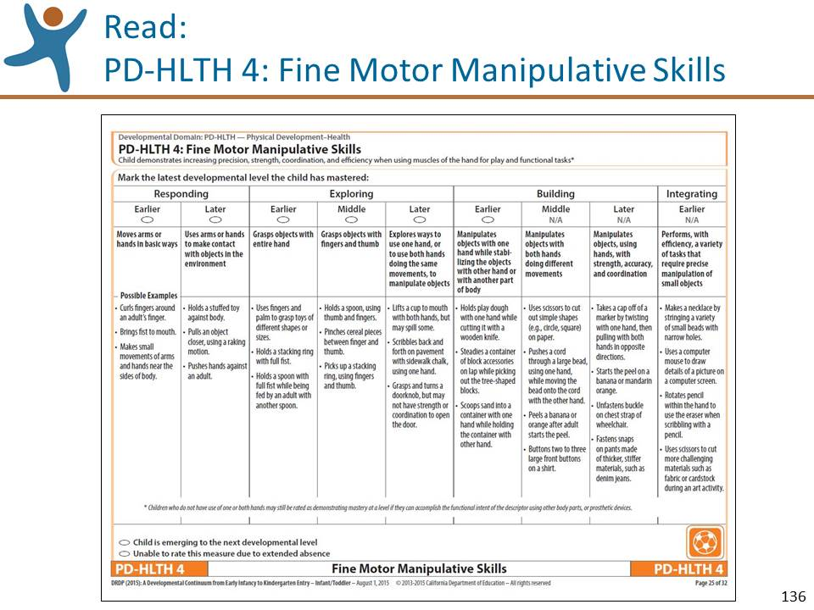 | Slide 136: Review the information on this slide and make these points:  - Read through the entire measure PD-HLTH 4: Fine Motor Manipulative Skills. You can find it in the DRDP (2015) Infant/Toddler Assessment Manual, on the second page of the Rating Practice Exercise Worksheet, and on this slide.  - Tell the participants that you will be showing them a video clip and as they watch they should use the space at the top of the third page of the worksheet to jot down their observations of Tylor in relation to measure PD-HLTH 4. Remind them not to rate the measure yet; just observe the video in relation to PD-HLTH 4, as they will combine their observations with other information to rate the measure.  - Show the video clip.
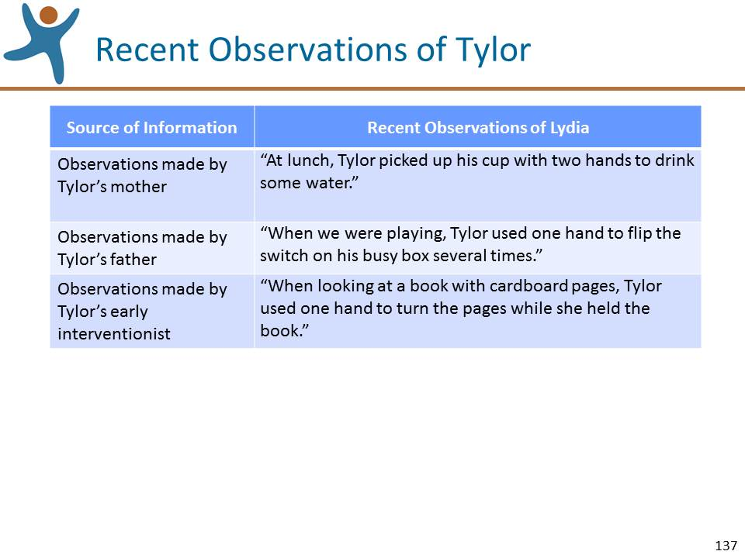 | Slide 137: Review the information on this slide and make these points:  - Once the video ends, ask the participants to read the additional observations made of Tylor. The observations can be found on the fourth page of the Rating Practice Exercise Worksheet and on this slide.  - After giving them enough time to read the additional observations, ask the participants to work individually to pencil in their “best first guess” of the highest level of mastery, based on both:  - the notes they made from the video clip; and  - the additional observations that they just read.  NOTE: If you find it helpful, you can go back to the previous slide and show the measure.
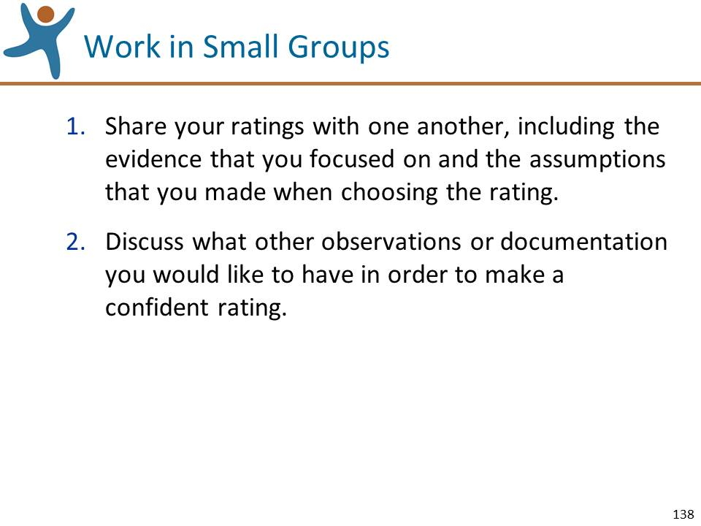 | Slide 138: Review the information on this slide and make these points:  - Ask the participants to work in small groups to:  - Share their ratings with one another, including the evidence that they focused on and the assumptions that they made in coming up with the rating. Ask them to be sure they understand how each person rated the measure and what evidence they focused on in determining their rating.  - Discuss what other observations or documentation they would have liked to have in order to make an accurate rating.
Mute the projector | LEAD A LARGE GROUP DISCUSSION OF THE RATINGS:  - Ask for a few volunteers to share their ratings and their rationale for the rating, pinpointing the evidence used. The purpose of the discussion is to come to a shared understanding of how each person rated the measure based on the evidence that they focused on and the assumptions they made.
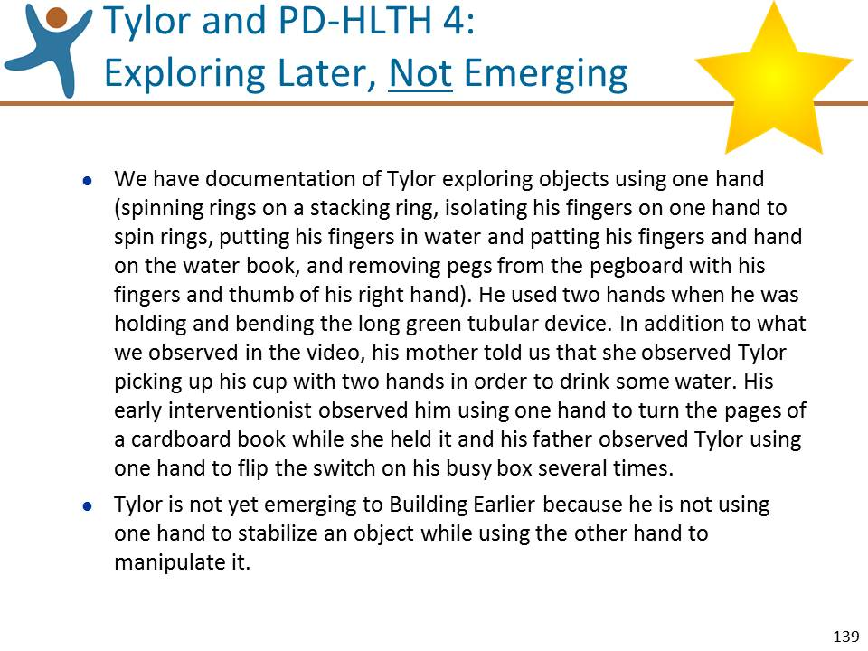 | Slide 139: Review the information on this slide and make these points:  - Let’s review the “Gold Star” rating derived from the DRDP (2015) research team.  - Although we do not personally see Tylor demonstrate the behavior consistently over time and in different settings, we were able to make one relevant observation and read three additional relevant observations. Based on the video observation and on the observations shared by others, Tylor demonstrates mastery at Exploring Later and is not emerging to the next level.  - We have documentation of Tylor exploring objects using one hand (spinning rings on a stacking ring, isolating his fingers on one hand to spin rings, putting his fingers in water and patting his fingers and hand on the water book, and removing pegs from the pegboard with his fingers and thumb of his right hand). He used two hands when he was holding and bending the long green tubular device. In addition to what we observed in the video, his mother told us that she observed Tylor picking up his cup with two hands in order to drink some water. His early interventionist observed him using one hand to turn the pages of a cardboard book while she held it and his father observed Tylor using one hand to flip the switch on his busy box several times. Tylor is not yet emerging to Building Earlier because he is not using one hand to stabilize an object while using the other hand to manipulate it.  - Summarize by reflecting on key points made during the discussion and mentioning:  - Remember how important it is to include the observations of others as part of your documentation.

Rating Practice Exercise Part 2 – PS Focus (30 minutes)
Cody at Breakfast
Preparation:
- Become very familiar with the instructions below, the video clip “Cody at Breakfast,” and PD-HLTH 7: Personal Care Routines: Feeding.
- Replace slide 93 with the 6 slides for Rating Practice Exercise 2 (PS) Cody at Breakfast.
- Have the video clip “Cody at Breakfast” ready to play.
- Make copies of the Rating Practice Exercise Worksheets for “Cody at Breakfast.”
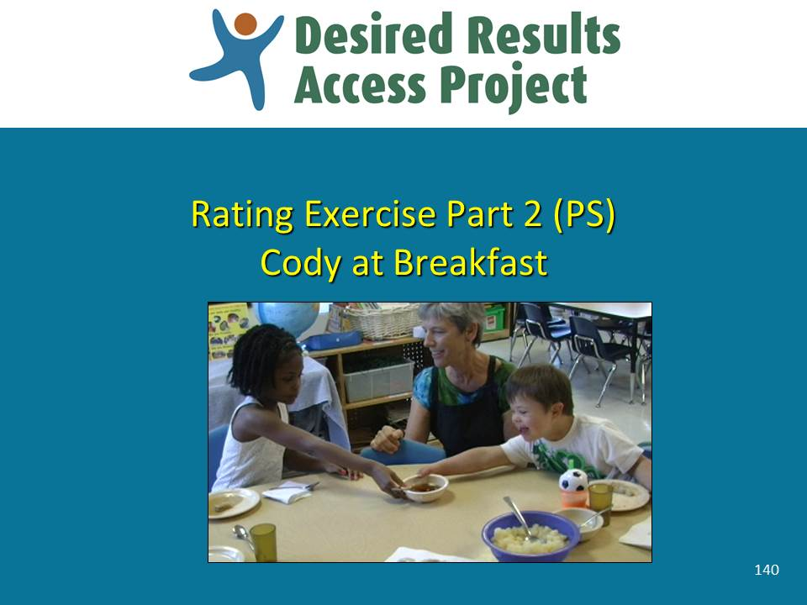 | Slide 140: Review the information on this slide and make these points:  - As you feel is needed, remind the participants of the introductory points that you made during Rating Practice Exercise Part 1.
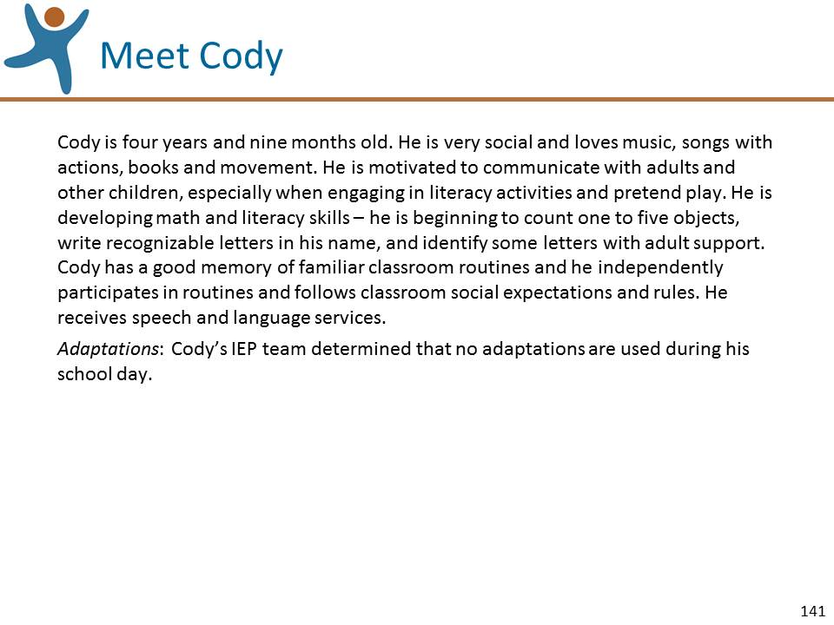 | Slide 141: Review the information on this slide and make these points:  - Read the description of Cody provided by his teacher. It is on the front page of the Rating Practice Exercise and on this slide.
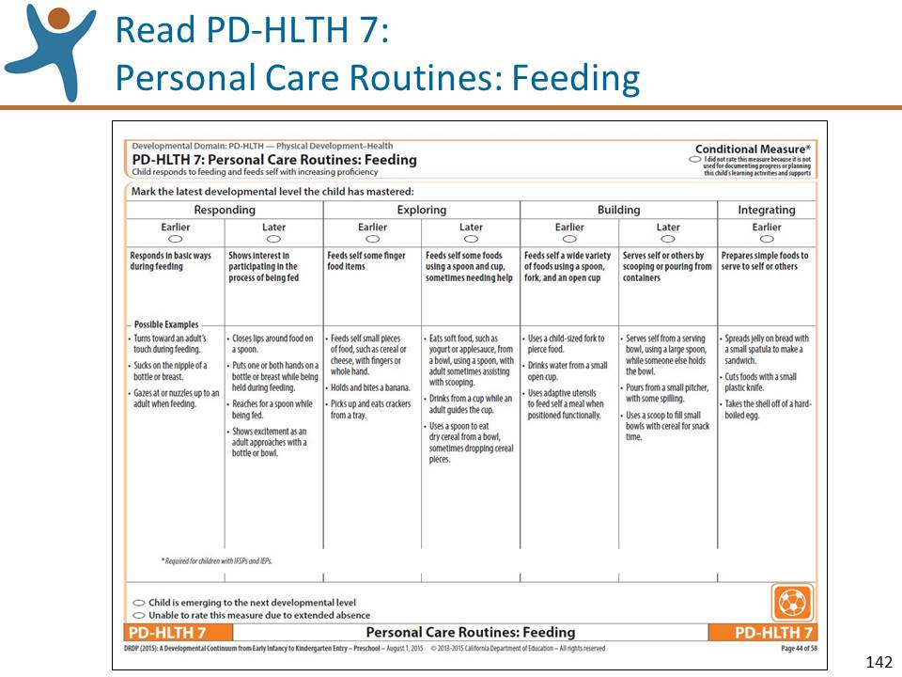 | Slide 142: Review the information on this slide and make these points:  - Read through the entire measure PD-HLTH 7: Personal Care Routines: Feeding. You can find it in the DRDP (2015) Preschool Fundamental View Assessment Manual, on the second page of the Rating Practice Exercise Worksheet, and on this slide.  - This is an example of a Conditional Measure and must be rated for special education.  - Tell the participants that you will be showing them a video clip and as they watch they should use the space at the top of the third page of the worksheet to jot down their observations of Cody in relation to measure PD-HLTH 7. Remind them not to rate the measure yet; just observe the video in relation to PD-HLTH 7, as they will combine their observations with other information to rate the measure.  - Show the video clip.
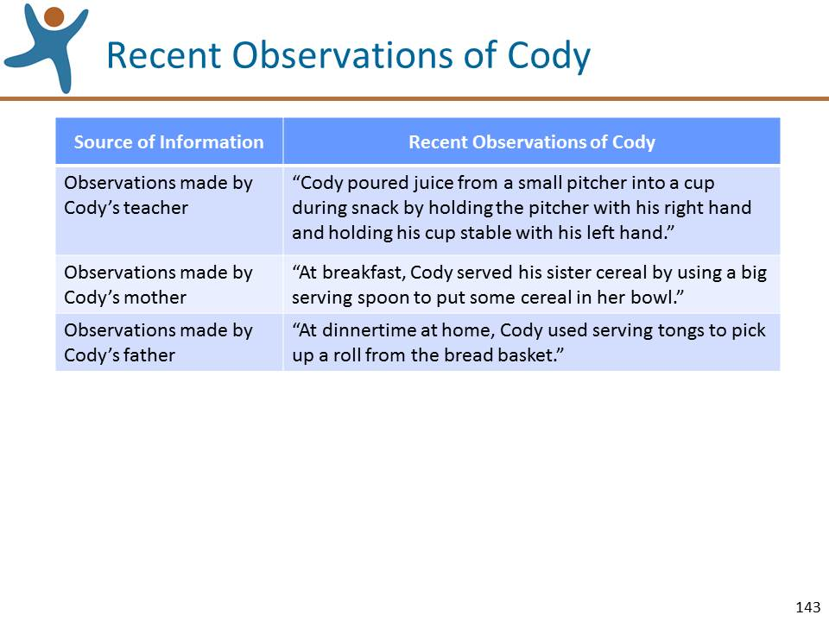 | Slide 143: Review the information on this slide and make these points:  - Once the video ends, ask the participants to read the additional observations made of Cody. The observations can be found on the fourth page of the Rating Practice Exercise Worksheet and on this slide.  - After giving them enough time to read the additional observations, ask the participants to work individually to pencil in their “best first guess” of the highest level of mastery, based on both:  - the notes they made from the video clip; and  - the additional observations that they just read.  NOTE: If you find it helpful, you can go back to the previous slide and show the measure.
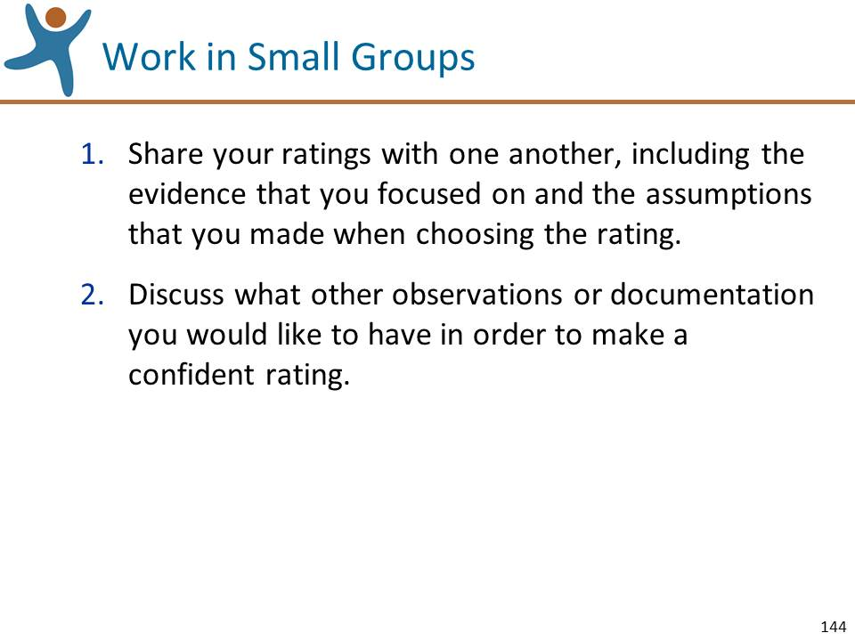 | Slide 144: Review the information on this slide and make these points:  - Ask the participants to work in small groups to:  - Share their ratings with one another, including the evidence that they focused on and the assumptions that they made in coming up with the rating. Ask them to be sure they understand how each person rated the measure and what evidence they focused on in determining their rating.  - Discuss what other observations or documentation they would have liked to have in order to make an accurate rating.
Mute the projector | LEAD A LARGE GROUP DISCUSSION OF THE RATINGS:  - Ask for a few volunteers to share their ratings and their rationale for the rating, pinpointing the evidence used. The purpose of the discussion is to come to a shared understanding of how each person rated the measure based on the evidence that they focused on and the assumptions they made.
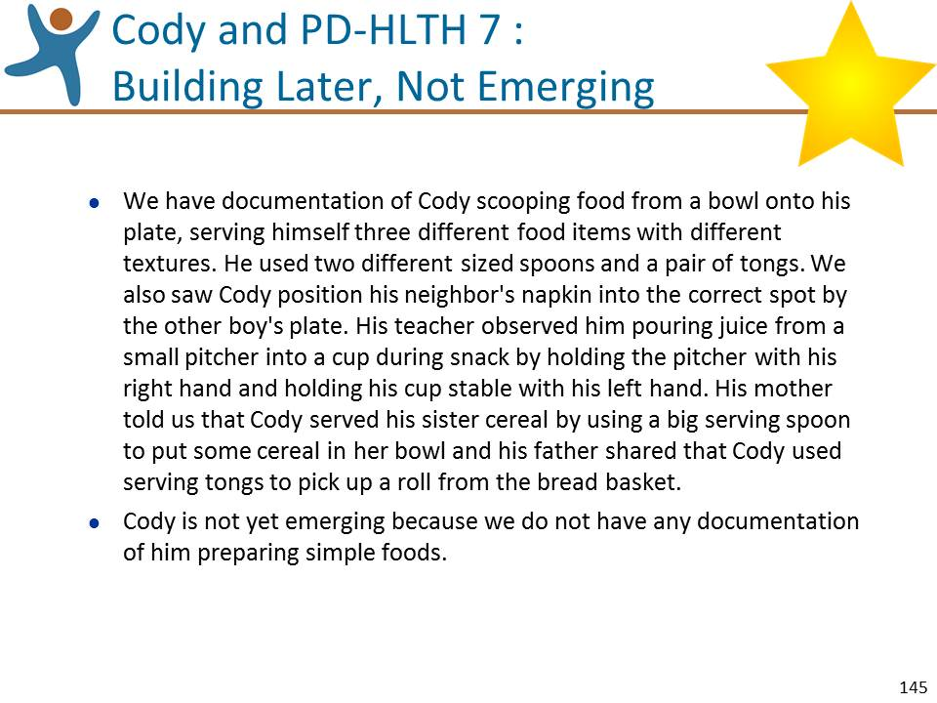 | Slide 145: Review the information on this slide and make these points:  - Let’s review the “Gold Star” rating derived from the DRDP (2015) research team.  - Although we do not personally see Cody demonstrate the behavior consistently over time and in different settings, we were able to make one relevant observation and read three additional relevant observations. Based on the video observation and on the observations shared by others, Cody demonstrates mastery at Building Later and is not emerging to the next level.  - We have documentation of Cody scooping food from a bowl onto his plate, serving himself three different food items with different textures. He used two different sized spoons and a pair of tongs. We also saw Cody position his neighbor's napkin into the correct spot by the other boy's plate. His teacher observed him pouring juice from a small pitcher into a cup during snack by holding the pitcher with his right hand and holding his cup stable with his left hand. His mother told us that Cody served his sister cereal by using a big serving spoon to put some cereal in her bowl and his father shared that Cody used serving tongs to pick up a roll from the bread basket. Cody is not yet emerging because we do not have any documentation of him preparing simple foods.  - Summarize by reflecting on key points made during the discussion and mentioning:  - Cody may demonstrate skills at a higher level than we determined today, but we did not have the opportunity to observe him preparing food. Be sure to consider the next higher levels above mastery and make sure you have had the opportunity to observe a child’s skills for either Emerging or mastery.

Optional Rating Practice Exercise 3 – IT Focus (30 minutes)
Morgan Playing with Blocks
Preparation:
- Become very familiar with the instructions below, the video clip “Morgan Playing with Blocks,” and ATL-REG 1: Attention Maintenance.
- Place the 6 slides for Optional Rating Practice Exercise 3 (IT) Morgan Playing with Blocks where needed.
- Have the video clip “Morgan Playing with Blocks,” ready to play.
- Make copies of the Rating Practice Exercise Worksheets for “Morgan Playing with Blocks.”
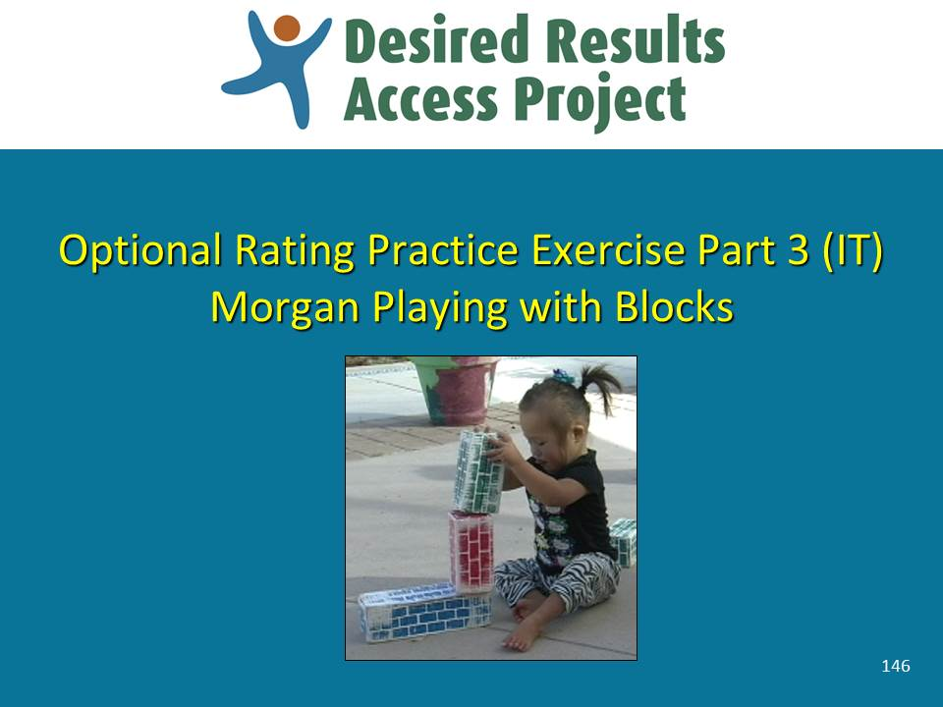 | Slide 146: Review the information on this slide and make these points:  - As you feel is needed, remind the participants of the introductory points that you made during Rating Practice Exercise Part 1.
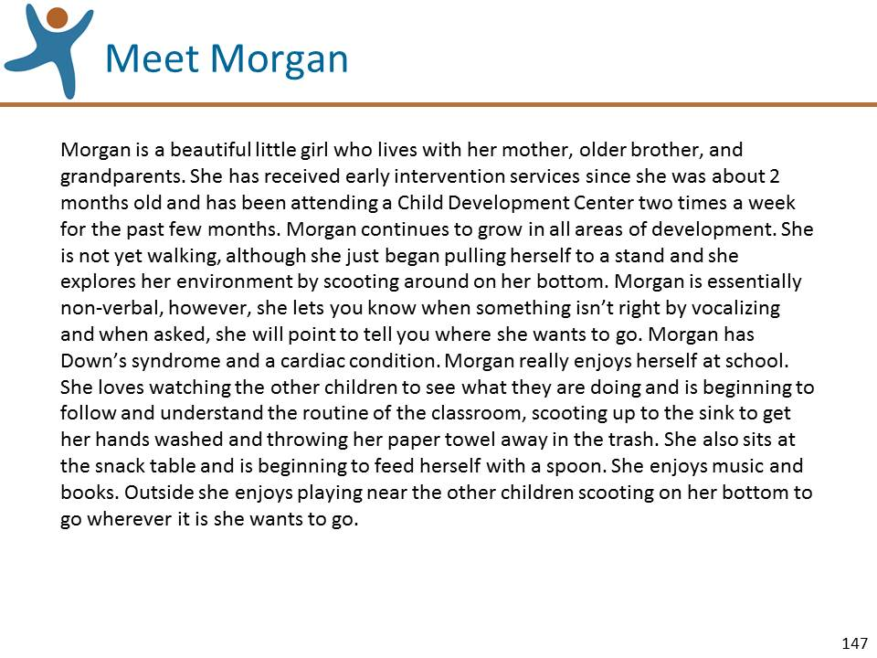 | Slide 147: Review the information on this slide and make these points:  - Read the description of Morgan provided by her teacher and early interventionist. It is on the front page of the Rating Practice Exercise and on this slide.
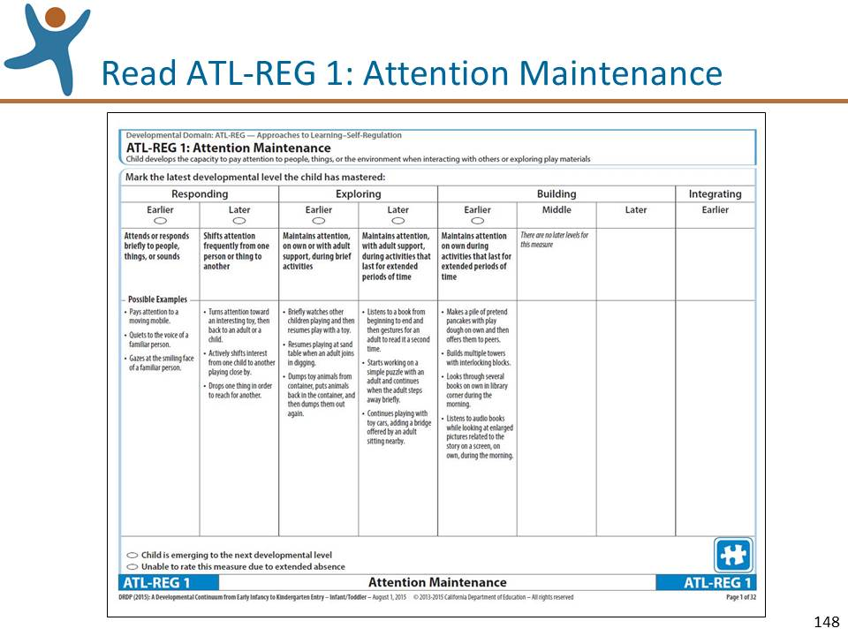 | Slide 148: Review the information on this slide and make these points:  - Read through the entire measure ATL-REG 1: Attention Maintenance. You can find it in the DRDP (2015) Infant/Toddler View Assessment Manual, on the second page of the Rating Practice Exercise Worksheet, and on this slide.  - Tell the participants that you will be showing them a video clip and as they watch they should use the space at the top of the third page of the worksheet to jot down their observations of Morgan in relation to measure ATL -REG 1. Remind them not to rate the measure yet; just observe the video in relation to ATL -REG 1, as they will combine their observations with other information to rate the measure.  - Show the video clip.
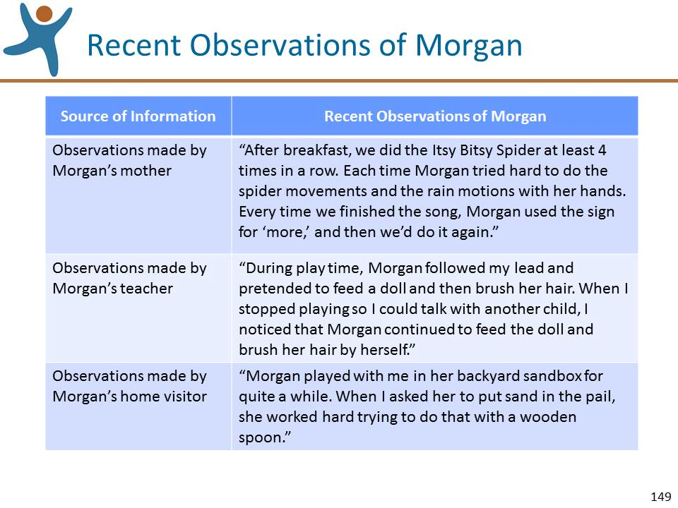 | Slide 149: Review the information on this slide and make these points:  - Once the video ends, ask the participants to read the additional observations made of Morgan. The observations can be found on the fourth page of the Rating Practice Exercise Worksheet and on this slide.  - After giving them enough time to read the additional observations, ask the participants to work individually to pencil in their “best first guess” of the highest level of mastery, based on both:  - the notes they made from the video clip; and  - the additional observations that they just read.  NOTE: If you find it helpful, you can go back to the previous slide and show the measure.
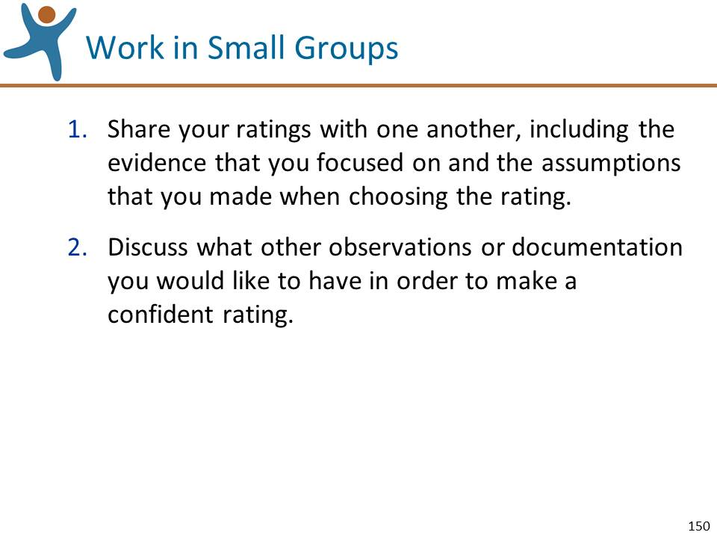 | Slide 150: Review the information on this slide and make these points:  - Ask the participants to work in small groups to:  - Share their ratings with one another, including the evidence that they focused on and the assumptions that they made in coming up with the rating. Ask them to be sure they understand how each person rated the measure and what evidence they focused on in determining their rating.  - Discuss what other observations or documentation they would have liked to have in order to make an accurate rating.
Mute the projector | LEAD A LARGE GROUP DISCUSSION OF THE RATINGS:  - Ask for a few volunteers to share their ratings and their rationale for the rating, pinpointing the evidence used. The purpose of the discussion is to come to a shared understanding of how each person rated the measure based on the evidence that they focused on and the assumptions they made.
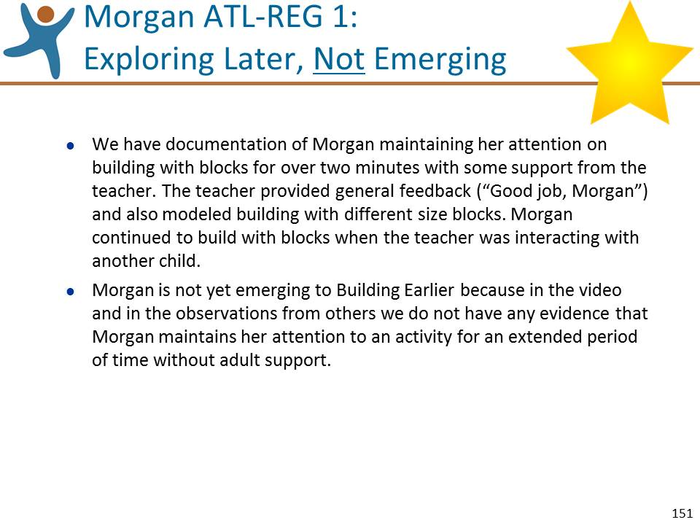 | Slide 151: Review the information on this slide and make these points:  - Let’s review the “Gold Star” rating derived from the DRDP (2015) research team.  - Although we do not personally see Morgan demonstrate the behavior consistently over time and in different settings, we were able to make one relevant observation and read three additional relevant observations. Based on the video observation and on the observations shared by others, Morgan demonstrates mastery at Exploring Later, and is not emerging to the next level.  - We have documentation of Morgan maintaining her attention on building with blocks for over two minutes with some support from the teacher. The teacher provided general feedback (“Good job, Morgan”) and also modeled building with different size blocks. Morgan continued to build with blocks when the teacher was interacting with another child. Morgan is not yet emerging to Building Earlier because in the video and in the observations from others we do not have any evidence that Morgan maintains her attention to an activity for an extended period of time without adult support.  - Summarize by reflecting on key points made during the discussion and mentioning:  - We observed Morgan’s attention to the blocks. We might want to observe her attention across a greater range of activities.

Optional Rating Practice Exercise 3 – PS Focus (30 minutes)
Angel Playing with Playdough
Preparation:
- Become very familiar with the instructions below, the video clip “Angel Playing with Playdough,” and SED 4: Relationships and Social Interactions with Peers.
- Place the 6 slides for Optional Rating Practice Exercise 3 (PS) Angel Playing with Playdough where needed.
- Have the video clip “Angel Playing with Playdough,” ready to play.
- Make copies of the Rating Practice Exercise Worksheets for “Angel Playing with Playdough.”
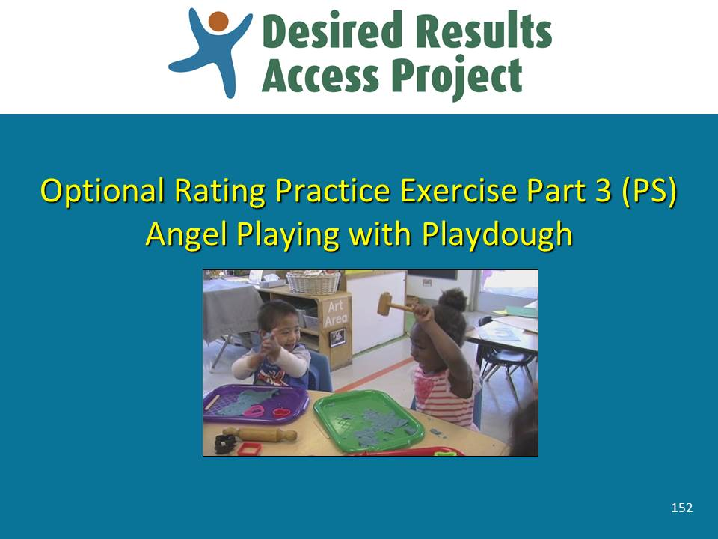 | Slide 152: Review the information on this slide and make these points:  - As you feel is needed, remind the participants of the introductory points that you made during Rating Practice Exercise Part 1.
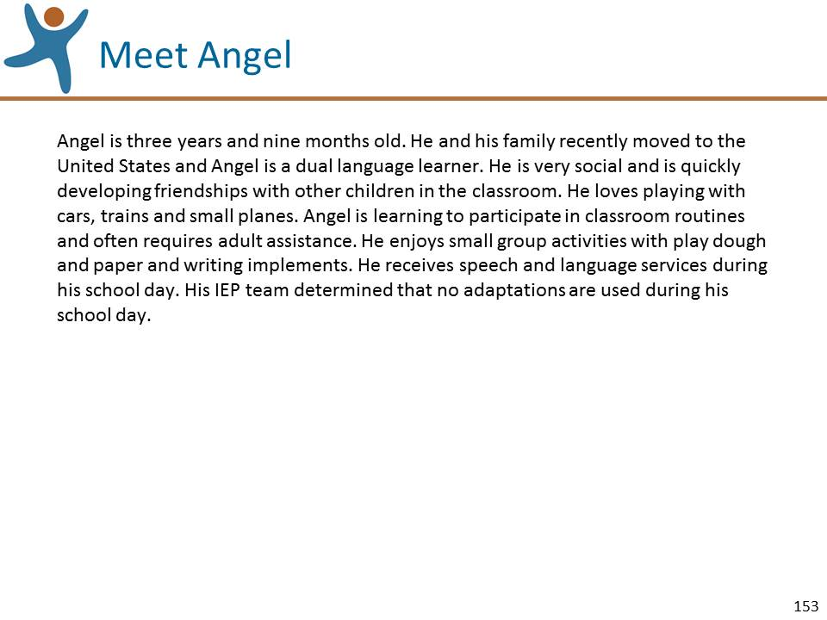 | Slide 153: Review the information on this slide and make these points:  - Read the description of Angel (pronounced “Ahnhell”) provided by his teacher. It is on the front page of the Rating Practice Exercise and on this slide.
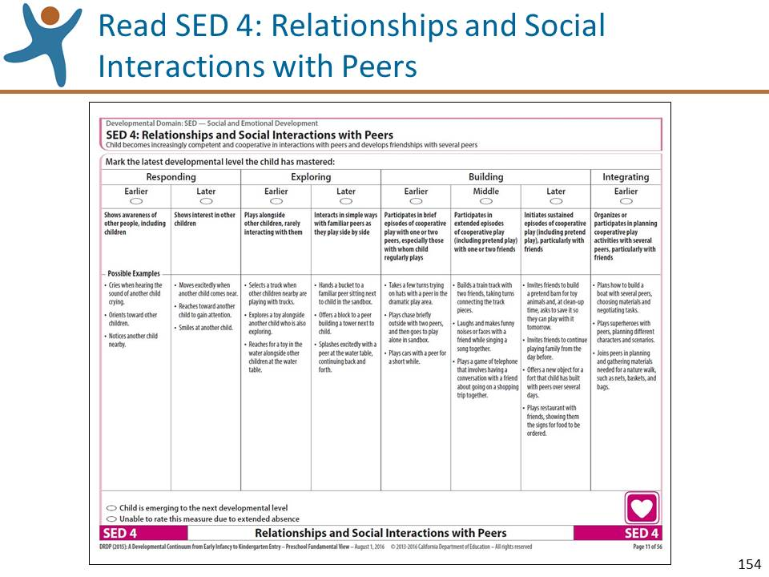 | Slide 154: Review the information on this slide and make these points:  - Read through the entire measure SED 4: Relationships and Social Interactions with Peers. You can find it in the DRDP (2015) Preschool Fundamental View Assessment Manual, on the second page of the Rating Practice Exercise Worksheet, and on this slide.  - Tell the participants that you will be showing them a video clip and as they watch they should use the space at the top of the third page of the worksheet to jot down their observations of Angel in relation to measure SED 4: Relationships and Social Interactions with Peers. Remind them not to rate the measure yet; just observe the video in relation to VPA 4: Dance, as they will combine their observations with other information to rate the measure.  - Show the video clip.
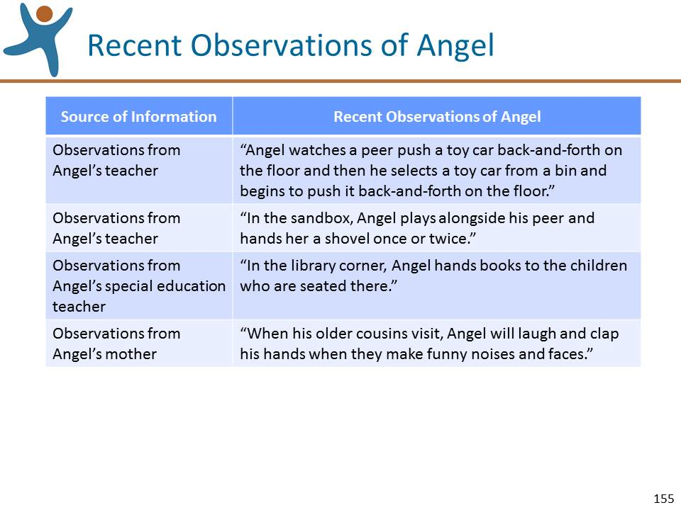 | Slide 155: Review the information on this slide and make these points:  - Once the video ends, ask the participants to read the additional observations made of Angel. The observations can be found on the fourth page of the Rating Practice Exercise Worksheet and on this slide.  - After giving them enough time to read the additional observations, ask the participants to work individually to pencil in their “best first guess” of the highest level of mastery, based on both:  - the notes they made from the video clip; and  - the additional observations that they just read.  NOTE: If you find it helpful, you can go back to the previous slide and show the measure.
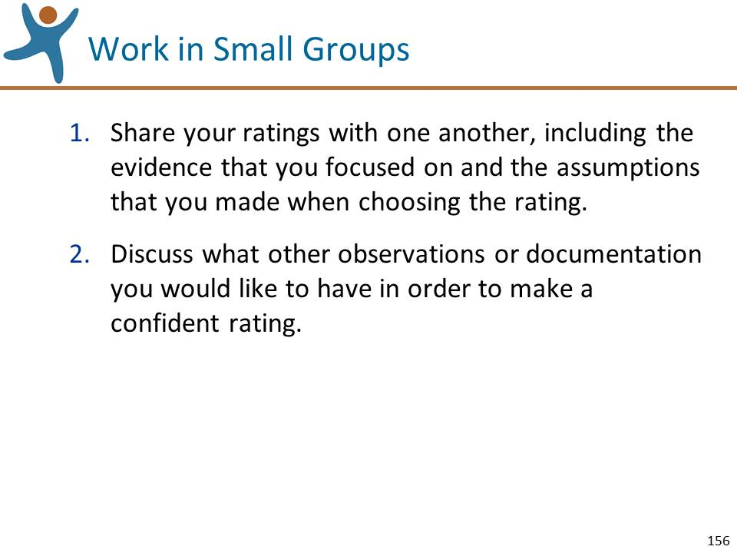 | Slide 156: Review the information on this slide and make these points:  - Ask the participants to work in small groups to:  - Share their ratings with one another, including the evidence that they focused on and the assumptions that they made in coming up with the rating. Ask them to be sure they understand how each person rated the measure and what evidence they focused on in determining their rating.  - Discuss what other observations or documentation they would have liked to have in order to make an accurate rating.
Mute the projector | LEAD A LARGE GROUP DISCUSSION OF THE RATINGS:  - Ask for a few volunteers to share their ratings and their rationale for the rating, pinpointing the evidence used. The purpose of the discussion is to come to a shared understanding of how each person rated the measure based on the evidence that they focused on and the assumptions they made.
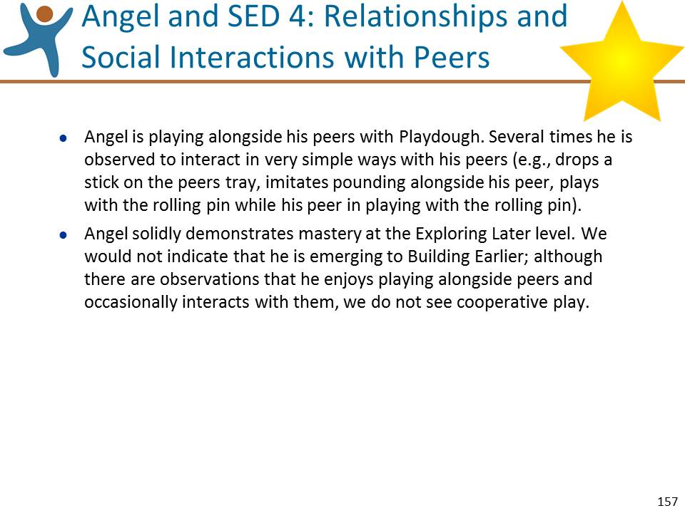 | Slide 157: Review the information on this slide and make these points:  - Let’s review the “Gold Star” rating derived from the DRDP (2015) research team.  - Angel is playing alongside his peers with Playdough. Several times he is observed to interact in very simple ways with his peers (e.g., drops a stick on the peers tray, imitates pounding alongside his peer, plays with the rolling pin while his peer in playing with the rolling pin).  - Angel solidly demonstrates mastery at the Exploring Later level. We would not indicate that he is emerging to Building Earlier; although there are observations that he enjoys playing alongside peers and occasionally interacts with them, we do not see cooperative play.  - Summarize by reflecting on key points made during the discussion and mentioning:  - Assessor’s need to be sure to base their ratings on descriptive observations rather than on interpretation.

